

Input System Manual

*MedlinePlus Go Local Input System Manual*

October 2008

[U.S. National Library of Medicine](http://www.nlm.nih.gov/)

[National Institutes of Health](http://www.nih.gov/)

8600 Rockville Pike, Bethesda, MD 20894

# Contents

Contents i

1. Introduction *(Updated August 27, 2008)* 1

1.1 MedlinePlus Go Local Goal 1

1.1.1 What is Go Local? 1

1.1.2 What is the relationship between MedlinePlus and Go Local? 1

1.1.3 Go Local area coverage 2

1.2 Technical Background Information 2

1.2.1 Go Local Input System 2

1.2.2 Technical requirements for the Go Local Input System 3

1.2.3 Set Internet Options 3

1.2.4 ActiveX Settings: 3

1.2.5 Special Considerations for Macromedia Flash: 4

1.3 Functions within the Go Local Input System 6

1.3.1 What do I do in the system? 6

1.3.2 What NLM does in the system 6

1.3.3 What other information do I need to know? 6

2. Setting Up the Go Local Area *(Updated September 18, 2008*) 7

2.1 Creating the Designated Local Area 7

2.2 Map Local Area 8

2.2.1 Map Organization 8

2.2.2 GEO Text Link 14

2.3 User Accounts 16

2.3.1 Types of User Accounts 16

2.3.2 Creating User Accounts 17

2.3.3 Sample suggested schemes for creating Login Names: 17

3. Creating, Editing, and Managing Health Services Records *(Updated October 23, 2008)* 19

3.1 Logging In 19

3.1.1 Troubleshooting Login Error Messages 20

3.1.2 System Timeout 20

3.2 Menu Options 21

3.2.1 Expanded menu options: 21

3.3 Creating Site Records 25

3.3.1 Go Local Site Record Input Screen 25

3.3.2 Fields and Descriptors: 26

3.3.3 Site Identifying Information 29

3.3.4 Change Case Utilities 29

3.3.5 Language Indicator 30

3.3.6 Assignment of Top Languages Display 30

3.3.7 Indicating the Languages Spoken on a Site Record 33

3.3.8 Languages Spoken Public Display 35

3.3.9 Turning on the Languages Feature in the Public Display 35

3.3.10 Searching for Records that have Indexed Languages 37

3.3.11 Service Area 38

3.3.12 Display Status 40

3.3.13 Topics 40

3.3.14 Topic Mappings 40

3.3.15 Selecting local service terms and local health topics 43

3.3.16 Assign Local Organizations 47

3.3.17 Comments 48

3.3.18 Local ID 48

3.3.19 Submitting the Site Record 48

3.4 Shared Records 49

3.4.1 Creating a Shared Record 49

3.4.2 Allowing an Existing Record in Your Area to be Shared 50

3.4.3 Changing the Status of a Record from Your Area to Unshared 51

3.4.4 Selecting a Shared Record from Another Area 52

3.4.5 Identifying Shared Records in Normal Displays 55

3.4.6 Managing Shared Records using List Actively Shared Records 57

3.5 Identifying Similar and Duplicate Records 60

3.5.1 Find Similar Records when creating a New Record 60

3.5.2 Find Duplicate Records when creating a New Record 61

3.5.3 Duplicate records not identified as duplicates 62

3.6 Incomplete Records 63

3.7 Pending Records 64

3.7.1 Pending Live 67

3.8 Search Records: in My Area or in All Other Local Records 68

3.8.1 Search Records in My Area 69

3.8.2 Editing a record from the search results: 70

3.8.3 Search All Other Local Records 70

3.9 Auditing Module 71

3.9.1 Set Audit Profile 71

3.9.2 Assign Audit Records 72

3.9.3 List My Audit Records 75

3.9.4 Updating the Audit Date from Edit 76

4. Customization Module *(Updated September 18, 2008)* 77

4.1 Header 77

4.1.1 Complete Banner 78

4.1.2 Changing the Search Label Color or Banner Background Color 79

4.1.3 Upload a banner 80

4.2 Footer 80

4.3 Color Scheme 81

4.3.1 Hexadecimal Color Codes 82

4.4 Image Management 82

4.5 About Us 85

4.6 Sponsorship Page 86

4.7 Contact Us 88

4.7.2 Feedback and Suggest a Resource public pages 92

4.8 Home Page 93

4.8.1 Add Announcement Link 93

4.8.2 Google Events Calendar 94

4.8.3 Miscellaneous Announcement Link 100

4.8.4 Edit Category Helper Text 103

4.8.5 Featured Site - (Required) 105

4.8.6 List Featured Sites 107

4.8.7 Promoting changes 108

4.8.8 Promotion Notification 109

5. Reports *(Updated October 21, 2008)* 110

5.1 Link Checker Report 110

5.1.1 Corrective Actions 111

5.2 Web Stat Report 112

6. Data Import/Batch Update/Export Profile *(Updated October 22, 2008)* 115

6.1 Data Import 115

6.1.1 Technical: 115

6.1.2 Format: 115

6.1.3 System Provided Data: 117

6.1.4 Accessing the Data Import Feature 117

6.1.5 Data Import Module: 117

6.2 Error Reports Module 122

6.3 Batch Update of Modified Data 123

6.3.1 Creating the CSV File 123

6.3.2 Importing Modified Data 125

6.4 Troubleshooting 126

6.5 Loading Data created with an editor 127

6.6 Export Profile 128

6.6.1 Add Export File 128

6.6.2 List Export Profiles 130

6.6.3 Troubleshooting Export Errors 131

6.6.4 Deleting an Export Profile 132

6.7 Data in XML Format 132

7. Other System Functions 133

7.1 Global Update of Records 133

7.1.1 Search 134

7.1.2 Results 134

7.1.3 Current Group Selection 134

7.1.4 Editing: 135

7.1.5 Confirmation: 136

7.1.6 Data Revert: 137

7.1.7 System Generated Messages: 137

7.2 Organization Name Module 138

7.2.1 Add Organization 139

7.2.2 List Organizations 139

7.2.3 Approve Organizations 140

7.3 Preview Module 141

7.3.1 Internal Preview 141

7.3.2 Public Preview 141

7.4 Changing Text Size 143

7.5 Deleting Records 144

8. Appendix 1: User Privileges *(Updated August 12, 2008)* 145

8.1 User Privileges Listed by Menu Item 145

8.2 User Privileges by Site Records Menu Functions 147

9. Appendix 2: Selection Guidelines & Vocabulary Changes *(Updated September 25, 2008)* 148

9.1 Selection Guidelines 148

9.1.1 Authority of source 148

9.1.2 Content 148

9.1.3 Audience 149

9.1.4 Local Relevance 149

9.1.5 Other issues 150

9.2 Requesting Changes to Vocabulary 150

9.2.1.1 Kinds of things we can change 150

10. Appendix 3: Style Guide *(Updated August 12, 2008)* 151

11. Appendix 4: Future Enhancements to the Manual *(Updated May 6, 2008)* 152

11.1 Planned additions for the future 152

List of Figures:

Figure 1‑1: NLM-Supported Go Local Flowchart 1

Figure 1‑2: Go Local Input System 2

Figure 1‑3: Internet Options Screen 3

Figure 1‑4: Go Local Flash update message 4

Figure 1‑5: Locate Flash Player Settings 4

Figure 1‑6: Adjust Flash Player Settings 5

Figure 2‑1: Designated Local Area for Central Texas 7

Figure 2‑2: Map Organization Screen for Central Texas 7

Figure 2‑3: Default Map Organization settings by County for New Jersey 8

Figure 2‑4: Public Display of Default Map Organization by County for New Jersey 8

Figure 2‑5: Map Organization Menu Option 9

Figure 2‑6: Defining Your Own Region 9

Figure 2‑7: Add New Region 9

Figure 2‑8: Region Name List 10

Figure 2‑9: Select Open Zip Codes Window 10

Figure 2‑10: Select Region to Assign 11

Figure 2‑11: Assigning Zip Codes to the Northeast Region in the District of Columbia 11

Figure 2‑12: Completed Assigned Regions by Zip Codes 12

Figure 2‑13: Error Message for Incomplete Map Organization Record 13

Figure 2‑13: Confirmation for Completed Map Organization Record 13

Figure 2‑15: Public Display of Self-Defined Regions (by Zip Code) for the District of Columbia 14

Figure 2‑16: Sample Region-Defined Image Map for the District of Columbia 14

Figure 2‑17: GEO Text Link Menu Option 14

Figure 2‑18: GEO Text Link input screen with selected cities 15

Figure 2‑19: Public site listing designated city text links 15

Figure 2‑20: Add a User Menu 17

Figure 2‑21: New User Record 18

Figure 2‑22: Add User Confirmation 18

Figure 2‑23: List Users Menu 18

Figure 3‑1: Go Local Login Screen 19

Figure 3‑2: Go Local Login Welcome Screen 19

Figure 3‑3: ActiveX Error Message 20

Figure 3‑4: Macromedia Flash Error Message 20

Figure 3‑5: Input System Timed Out Screen 20

Figure 3‑6: Main menu for local administrator 21

Figure 3‑7: Main menu for selector and reviewer 21

Figure 3‑8: Site Records Menu - expanded 21

Figure 3‑9: Organizations Menu – Expanded 21

Figure 3‑10: Customize Menu - expanded 22

Figure 3‑11: Admin Account Menu - expanded 22

Figure 3‑12: Admin Audit Menu - expanded 22

Figure 3‑13: Admin Map Menu - expanded 23

Figure 3‑14: Admin Language Menu - expanded 23

Figure 3‑15: Admin Data Export menu – expanded 23

Figure 3‑16: Admin Data Import Menu - expanded 23

Figure 3‑17: Admin Reports Menu - expanded 24

Figure 3‑18: Preview Menu - expanded 24

Figure 3‑19: Text size menu - expanded 24

Figure 3‑20: Go Local Site Record Input Screen 25

Figure 3‑21: Fill out New Form - Site Identifying Information 29

Figure 3‑22: Change Case Utility 29

Figure 3‑23: Change Case Results 30

Figure 3‑24: Assign Top Languages Menu Item 31

Figure 3‑25: Assign Top Languages Window 31

Figure 3‑26: Moving a Language from the Languages List 32

Figure 3‑27: Moving a Language to the Top Languages List 33

Figure 3‑28: Open Languages Window 33

Figure 3‑29: Assign Languages 34

Figure 3‑30: Languages Associated with a Record 34

Figure 3‑31: Site Record Public Display of Languages Spoken 35

Figure 3‑32: English Not Spoken Public Display 35

Figure 3‑33: Set Language Public Display Menu 36

Figure 3‑34: Set Language Confirm 36

Figure 3‑35: Promote Language Public Display Menu 37

Figure 3‑36: Language Search Options 37

Figure 3‑37: Service Area Selection – Public Display 39

Figure 3‑38: Display Status 40

Figure 3‑39: Local Service Term Flowchart 41

Figure 3‑40: Local Services and Diseases & Health Issues Flowcharts 42

Figure 3‑41: Open Local Service Terms Window button 43

Figure 3‑42: Assign local service terms window 43

Figure 3‑43: Automatic local service term mapping 44

Figure 3‑44: Browse other local health topics screen 45

Figure 3‑45: Completed mapped window for Assisted Living 46

Figure 3‑46: Assign local organizations input fields 47

Figure 3‑47: List of local organizations 47

Figure 3‑48: Comments field with data 48

Figure 3‑49: Submit, Save or Cancel record 48

Figure 3‑50: Creating a Record that Can Be Shared 50

Figure 3‑51: Edit an Existing Record So that it Can Be Shared 51

Figure 3‑52: Search All Other Local Records Menu Option 52

Figure 3‑53: Searching for Shared Records 53

Figure 3‑54: Results of Search for Shared Records 53

Figure 3‑55: Mouse-Over Displaying Designated Areas That Share a Record 54

Figure 3‑56: Select a Record that is Available to be Shared 54

Figure 3‑57: Notification that you are Sharing the Record 55

Figure 3‑58: Shared Record in Approved Records List 56

Figure 3‑59: Shared Record Details Link 56

Figure 3‑60: Shared Record Details Box 57

Figure 3‑61: View Site Record – Shared Record Field 57

Figure 3‑62: List Actively Shared Records Menu Item 57

Figure 3‑63: List of Actively Shared Records 58

Figure 3‑64: Split Record Comments Field 59

Figure 3‑65: Shared Records Created by My Area 59

Figure 3‑66: Similar Records Check Warning Message 60

Figure 3‑67: Similar Records Menu Bar 60

Figure 3‑68: Similar Records Found 61

Figure 3‑69: Duplicate Record Error Message 62

Figure 3‑70: Save as Incomplete button 63

Figure 3‑71: List Incomplete Records 63

Figure 3‑72: Pending Review Menu Option 64

Figure 3‑73: Records Pending Review 64

Figure 3‑74: Pending Record Comments Field 65

Figure 3‑75: Pending Record Comments Confirmation 65

Figure 3‑76: Submit Checked Sites 65

Figure 3‑77: Confirmation for Submitted Checked Sites 66

Figure 3‑78: Pending Live and Pending Tabs 67

Figure 3‑79: Search Records Menu 68

Figure 3‑80: Search Records in My Area Search Screen 69

Figure 3‑81: Search Results for Search Records in My Area 70

Figure 3‑82: Search Results for Search All Other Local Records 71

Figure 3‑83: Set Audit Profile Menu 71

Figure 3‑84: Set Audit Profile Review Interval 72

Figure 3‑85: Audit message at login 72

Figure 3‑86: Hide Audit Message Menu 72

Figure 3‑87: Assign Audit Records Menu 73

Figure 3‑88: Assign Audit Records Search Form 73

Figure 3‑89: Assign Audit Records Search - Audited Date Fields 73

Figure 3‑90: Assign Audit Records – select and assign to auditor 74

Figure 3‑91: Records to be audited message 74

Figure 3‑92: List My Audit Records Menu 75

Figure 3‑93: List My Audit Records Option Screen 75

Figure 3‑94: Audit Checkbox 76

Figure 4‑1: Customize Menu 77

Figure 4‑2: Header Screen 78

Figure 4‑3: Changing Search Label or Banner colors 79

Figure 4‑4: Header Color options using RGB 79

Figure 4‑5: Footer screen 80

Figure 4‑6: Color Schemes Selection Window 81

Figure 4‑7: Color Scheme Confirmation 81

Figure 4‑8: Upload image file to server screen 83

Figure 4‑9: Upload Image Confirmation 83

Figure 4‑10: Image Management Window 84

Figure 4‑11: View Image 84

Figure 4‑12: About Us Window 85

Figure 4‑13: Sponsorship Menu Option 86

Figure 4‑14: Sponsorship Page Information 86

Figure 4‑15: Promote Sponsorship Changes Menu Item 87

Figure 4‑16: Sponsorship Link 87

Figure 4‑17: Contact Us Menu Option 88

Figure 4‑18: Contact Us Data Entry Screen 89

Figure 4‑19: Contact Us Public Display 90

Figure 4‑20: Default Split e-mail Address 90

Figure 4‑21: Assigned Counties for Contact Us Split e-mail 91

Figure 4‑22: Send us Feedback online form 92

Figure 4‑23: Suggest a Resource online form 92

Figure 4‑24: Add Announcement Link menu 93

Figure 4‑25: Default Add Announcement Link input screen 93

Figure 4‑26: Calendar of Events Link on Homepage 94

Figure 4‑27: Add Google Event Calendar Menu Item 95

Figure 4‑28: Google Event Calendar Help 95

Figure 4‑29: Sample Google Event Calendar 96

Figure 4‑30: Manage calendars 96

Figure 4‑31: Calendar settings 96

Figure 4‑32: Google Event Calendar share 97

Figure 4‑33: Manage calendars 97

Figure 4‑34: Calendar of Events view settings 97

Figure 4‑35: Google Calendar ID 98

Figure 4‑36: Google Calendar input screen 98

Figure 4‑37: Go Local Event Calendar preview 98

Figure 4‑38: Google Calendar notification 99

Figure 4‑39: Submit Google Event Calendar 99

Figure 4‑40: Add Calendar Status Confirmation 100

Figure 4‑41: Add Announcement Link Menu 100

Figure 4‑42: Default Add Announcement Link input screen 101

Figure 4‑43: Add Announcement Link completed input screen 101

Figure 4‑44: Add Announcement Link Status Confirmation 102

Figure 4‑45: Promote Homepage Menu Item 102

Figure 4‑46: Public Display Homepage with Miscellaneous Announcement Link 103

Figure 4‑47: Edit Category Helper Texts Menu 103

Figure 4‑48: Edit Category Helper Texts Selection Screen 104

Figure 4‑49: Edit Category Helper Text Input Screen 104

Figure 4‑50: Edit Featured Sites Menu 105

Figure 4‑51: Default Add Featured Site Screen 106

Figure 4‑52: List Featured Sites 107

Figure 4‑53: Promote Homepage Menu 108

Figure 4‑54: View Homepage Menu 108

Figure 4‑55: Sample Promote Message 109

Figure 5‑1: Link Checker Report Menu 110

Figure 5‑2: Link Checker Report Screen 110

Figure 5‑3: Link Checker Report Corrective Action Options 111

Figure 5‑4: Link Checker Report E-mail Notification Set-up 112

Figure 5‑5: Web Stat Menu 112

Figure 5‑6: Web Stat Report Viewer 113

Figure 5‑7: Select File Filter 113

Figure 5‑8: Get Report View 113

Figure 5‑9: Web Stat Report in CSV Selection 114

Figure 5‑10: Web Stat Report in CSV File Format 114

Figure 6‑1: Sample CSV data displayed in spreadsheet 116

Figure 6‑2: Data Import Menu 117

Figure 6‑3: Data Import Screen 117

Figure 6‑4: Data Import Select Import Type 118

Figure 6‑5: Data Import CSV Load Message 118

Figure 6‑6: Error Status Message 119

Figure 6‑7: Successful Import of Complete Data 120

Figure 6‑8: Status Report for Partial Import of Data 120

Figure 6‑9: Download Error Report 121

Figure 6‑10: Error Reports Menu 122

Figure 6‑11: List of Data Import Error Reports 122

Figure 6‑12: Sample CSV File Created in EXCEL 124

Figure 6‑13: CSV File Exported from Go Local 124

Figure 6‑14: Modified Spreadsheet Data 125

Figure 6‑15: Data Import Select Import Type 125

Figure 6‑16: Browser Menu for Internet Options 126

Figure 6‑17: Resetting Internet Options 126

Figure 6‑18: Data Export Menu 128

Figure 6‑19: Add Export Profile - Data Field Selections 128

Figure 6‑20: Spreadsheet Display Format – Single or Multiple Cell Selection 129

Figure 6‑21: Exported Data Single Cell Display 129

Figure 6‑22: Exported Data Multiple Cell Display 129

Figure 6‑23: Export Profile Naming 130

Figure 6‑24: Export Profile Description 130

Figure 6‑25: Select Export Profile for Export 130

Figure 6‑26: Check IE Settings for Data Export 131

Figure 6‑27: Browser Menu for Internet Options 131

Figure 6‑28: Resetting Internet Options 132

Figure 7‑1: Global Update of Records Menu 133

Figure 7‑2: Global Update of Records Screen 133

Figure 7‑3: Global Update of Records - Confirm Group Selection of Results 134

Figure 7‑4: Global Update of Records - Current Group Selection Screen 134

Figure 7‑5: Global Update Current Group Selection Confirmation 135

Figure 7‑6: Edit Site Entry for Group Form 135

Figure 7‑7: Description Field Changes in Edit Site Entry for Group Form 136

Figure 7‑8: Edit Site Entry Group Confirmation 136

Figure 7‑9: Global Update E-mail Confirmation Message 137

Figure 7‑10: Public Display Showing Organization Name 138

Figure 7‑11: Organizations Menu 138

Figure 7‑12: Add Organization Option in Fill Out New Form 139

Figure 7‑13: Add Organization Screen Available from Menu Option 139

Figure 7‑14: List Organizations Screen 140

Figure 7‑15: Approve Organizations 140

Figure 7‑16: Preview Menu 141

Figure 7‑17: Internal Preview Menu 141

Figure 7‑18: Public Preview Menu 141

Figure 7‑19: Sample Public Preview of List of Services 142

Figure 7‑20: Text Size Menu 143

Figure 7‑21: Change Text Size Notification Message 143

Figure 7‑22: Delete Records Menu 144

Figure 7‑23: Delete Record Confirmation 144

List of Tables:

Table 1: Technical Requirements 3

Table 2: Sample Login Names 17

Table 3: Go Local Input Record Field Descriptions 26

Table 4: Color Scheme Hexadecimal Codes 82

Table 5: Site Record Data Fields 115

Table 6: Update Data Import Site Record Fields 123

Table 7: Update Action Site Record Fields 123

Table 8: Sample CSV data with single comma delimeters 127

Table 9: Sample CSV data with embedded commas and double quotation marks 127

Table 10: Sample CSV data with embedded double quotation marks 127

Table 11: Sample CSV data with embedded line breaks 127

Table 12: User Privileges by Menu Item 145

Table 13: User Privileges by Site Records Menu Functions 147

# Introduction *(Updated August 27, 2008)*

## MedlinePlus Go Local Goal

### What is Go Local?

Go Local links users to health services in their local community and directs users of the Go Local site to MedlinePlus health topics.

### What is the relationship between MedlinePlus and Go Local?

MedlinePlus provides authoritative medical information on diseases, conditions and wellness issues and links users to Go Local sites for nearby health programs, services and providers (think people, places, actions). Go Local pages also link back to related health information in MedlinePlus. For more information about the Go Local and MedlinePlus see: <http://www.nlm.nih.gov/medlineplus/golocal/about.html>

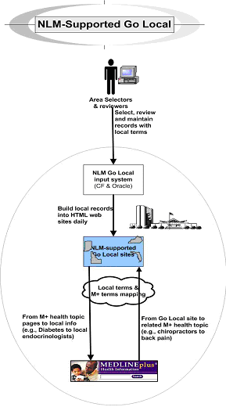

Figure 1‑1: NLM-Supported Go Local Flowchart

### Go Local area coverage

A Go Local project may cover an entire state (e.g., Michigan), a portion of a state (e.g., Texas Gulf Coast), or even a grouping of parts of several states (e.g., Four Corners area consisting of portions of Arizona, New Mexico, Colorado and Utah).

## Technical Background Information

The Go Local Input System, which resides on a server at NLM, is the database used to create and maintain all NLM-hosted Go Local Web sites. The Go Local Input System contains all of the records (including user accounts, the local area banner page, individual resource/services records, etc.) for an NLM-hosted Go Local Web site. The Go Local Input System is designed to work with Internet Explorer and Macromedia Flash on a PC. Other browsers are not supported.

### Go Local Input Syste****m****

#### **Accessing the Go Local Input System:**

The URL for the Go Local input system is:  
<http://wwwcf.nlm.nih.gov/mplocal/login.cfm>

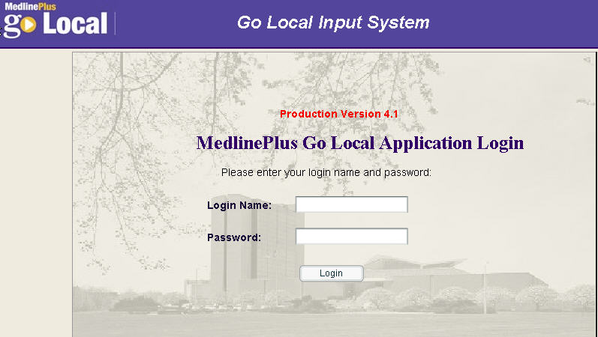

Figure 1‑2: Go Local Input System

### ****Technical requirements for the Go Local Input System****

Table 1: Technical Requirements

| **Technical Requirement** | **Required** |
| --- | --- |
| Windows operating system | ✓ |
| Internet Explorer 5.5 or above | ✓ |
| Set Internet options to Accept Cookies | ✓ |
| ActiveX enabled | ✓ |
| Set Internet options to check for new version of page every time | ✓ |
| Macromedia Flash version 8 (you will be prompted to install if you do not have Flash or if you have an older version) | ✓ |

### Set Internet Options

Set Internet options to check for new version of page every time.

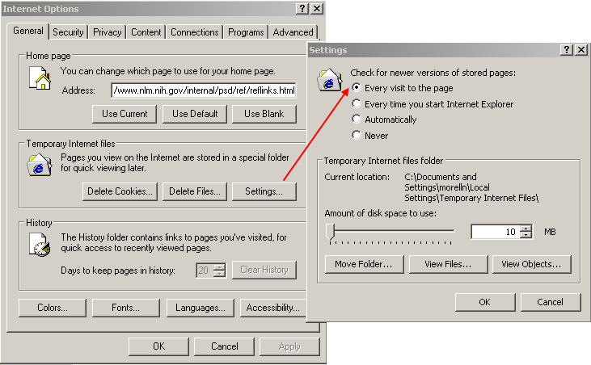

Figure 1‑3: Internet Options Screen

### ActiveX Settings:

ActiveX settings must be enabled in your browser. In Internet Explorer, enable the ActiveX settings by choosing Tools > Internet Options > Security (tab) from the menu. Select the Custom Level button and scroll down to the Run ActiveX controls and plugins and select the enabled radio button.

### Special Considerations for Macromedia Flash:

If you are not using the latest version of Adobe Flash, you may receive the following error message:

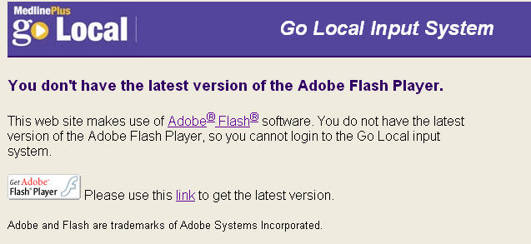

Figure ‑: Go Local Flash update message

You sometimes need to click on action buttons in Flash (instead of pressing the Enter key).

When you click on links in a browser, you usually see an indication that a page is loading (a status bar or the animated graphic in the top right corner.) With Flash you do not see this. The Go Local input system does display "loading" messages while a page is loading. It's a good idea to avoid using your browser's back button. Use the navigation on the pages instead. On some screens, you will need to hold down the Ctrl key and click on list items to select them.

Adjusting the Flash settings can help with some specific Flash issues. The local storage setting can be adjusted on a person’s individual computer. For some, the default setting works fine while others benefit from increasing it. Start by increasing the storage setting to 1 MB. Since the appropriate setting can depend on various factors, you may need to continue increasing this setting. To get to this setting, right click from within a module of the input system and select Settings.

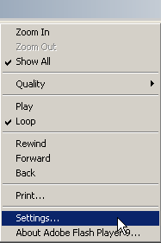

Figure 1‑5: Locate Flash Player Settings

Open the tab indicated by a picture of a file folder. You can then adjust the local storage setting.

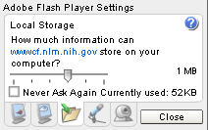

Figure ‑: Adjust Flash Player Settings

## Functions within the Go Local Input System

### ****What do I do in the system?****

Create records for local health care providers, health facilities, and health care programs and services. If you're a local area administrator, manage your maps, approve organization names, create your Go Local look and feel Suggest additional topic mappings, see references, etc. For a complete list of privileges see Appendix 1, User Privileges.

### ****What NLM does in the system****

* Creates the graphic map of your region
* Maps your site records to areas on the map--done by address information in site records
* Creates your Go Local site map
* Runs broken link report-- weekly report is available within the system to check
* Runs web statistic reports — monthly report is available to Local Administrators within the system
* Creates local service terms--you can suggest additions and changes through the Go Local listserv (see <https://list.nih.gov/archives/mplus-golocal.html>)
* Maps the pages of local services on your site to MedlinePlus pages -- based on your indexing of records
* Provides a zip code lookup

### ****What other information do I need to know?****

* If you cannot view options from a menu, we've provided a way to view or print a screen or list: click on the View/Print icon. You must manually close view windows.
* Depending on your privileges, you may see different options on menus. For example, a selector does not see approval functions.
* The system has some rules built in and will prompt you if you haven't filled out a form properly. For example, if you haven't included a required field such as a zip code, the system will not let you submit a record.
* It's a good idea to have only one browser running the input system. You can run it in multiple windows, but sometimes things won't work. For example, if you've been editing a record in one window and log out of the second one, when you submit the record from the first window, the system will log you out!
* Try not to use browser back button or refresh page button.
* The cancel button gets you out of your current module.
* If you want to uncheck a checked item, use the control-click feature.
* You can sometimes make multiple selections by using the control-click feature.
* In order for you to be able to change the size of text you see, be sure that under Internet Options, Temporary Internet files, the setting is to check for newer versions of stored pages for every visit to the page.
* If you encounter problems with multiple browser windows, you may need to close all browser windows and start fresh.

# Setting Up the Go Local Area *(Updated September 18, 2008*)

## Creating the Designated Local Area

Before you can log in, NLM must create a designated Go Local area associated with a local administrator. Though project proposals indicate the area to be covered, you may be asked to verify your designated local area. If your designated local area is an entire state you do not need to provide any information on counties. If your designated local area covers parts of a state or parts of more than one state, then you will need to verify what counties to include.

If the designated local area is for part of a state, for example Central Texas, NLM will give the local area a name, assign the state, and add the particular counties. Only those counties which you have specified will be included in this Designated Local Area.

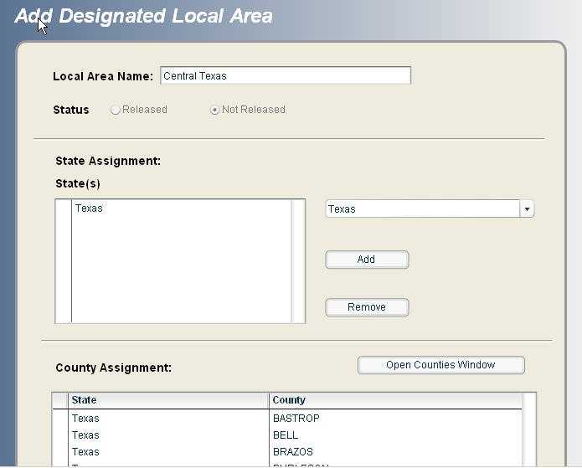

Figure ‑1: Designated Local Area for Central Texas

Your Designated Local Area as it appears in the Map Organization feature.

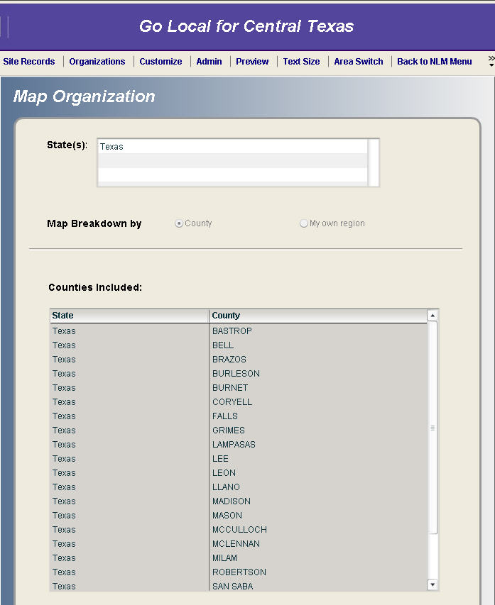

Figure 2‑2: Map Organization Screen for Central Texas

## Map Local Area

### Map Organization

Once NLM creates your designated local area, your local administrator can change the Map Organization for your site. This module allows you to build regions based upon county, city/town or zip code. NLM staff use the information from the Map Organization module to create your geographic map. Go Local project staff cannot edit the actual map. Using this module is only necessary if you want to define your own regions - the default mapping is by county, not region.

#### Default Map Organization Settings

The Map Organization for a local area automatically defaults to a Map Breakdown by County. The default Map Organization settings include: the State Name, the Map Breakdown by County radio button is selected, and the list of Counties Included

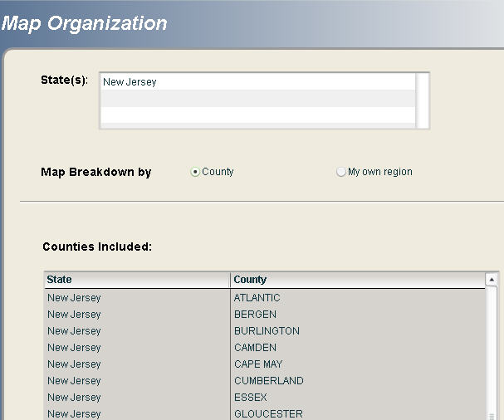

Figure ‑: Default Map Organization settings by County for New Jersey

In the public display the list of counties appears in the Counties section shown below the map.

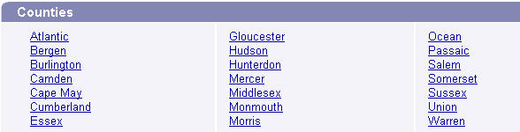

Figure ‑: Public Display of Default Map Organization by County for New Jersey

#### Creating Your Own Regions

Caution: Regions must be created for a Go Local site before entering any records. Once a record is entered into the system for a local area, the system will not allow regions to be defined or edited.

To create your Map Organization, choose Admin>Map>Map Organization from the menu bar.

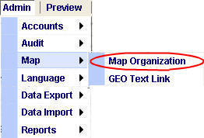

Figure ‑5: Map Organization Menu Option

Go Local sites can also choose to create their own regions. Select the “My own region” radio button to define your own region. Regions can be defined by County, City/Town or Zip Code. Select the appropriate radio button to define your region by one of these options.

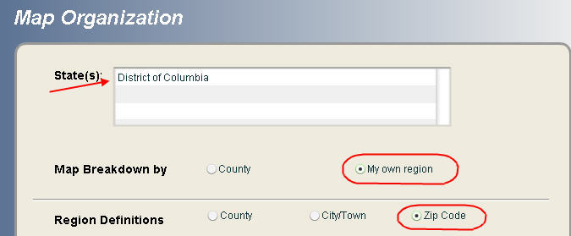

Figure ‑: Defining Your Own Region

Once the Region Definition is selected, type each new region name in the New Region box and click the Add button.

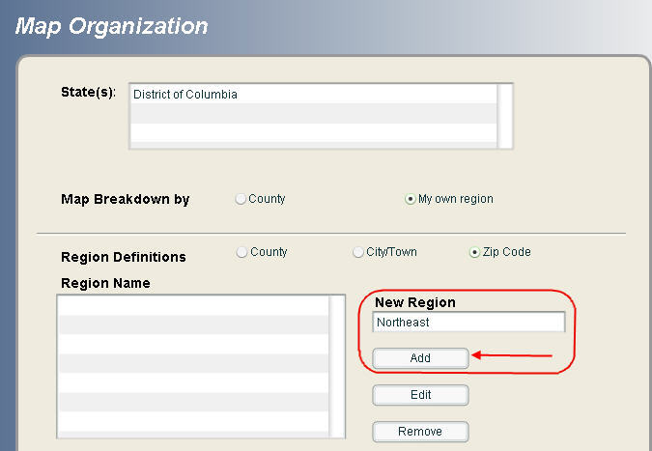

Figure ‑: Add New Region

The new region will appear in the Region Name list. Add additional regions by repeating these steps. All regions will be listed in the Region Name list.

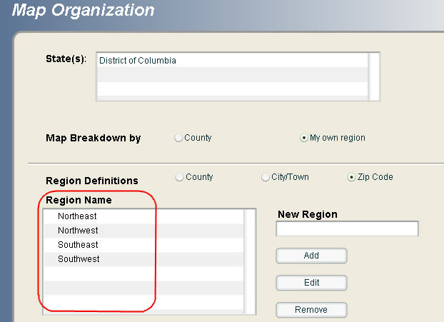

Figure ‑: Region Name List

A region can be removed from the list by selecting it (clicking on the region name) and then clicking the Remove button.

Caution: Removing a region will automatically remove all elements (counties, cities/towns, or zip codes) assigned to that region. Once records have been added to the database no changes (including adding elements to or removing elements from a region) can be made to a region.

#### Assigning Region Properties

After a region has been added to the Region Name list you can assign the appropriate counties, cities/towns, or zip codes to the region. Click on the Open Counties Window, Open City/Town Window, or Open ZIP Codes Window to display the list of places or zip codes to assign.

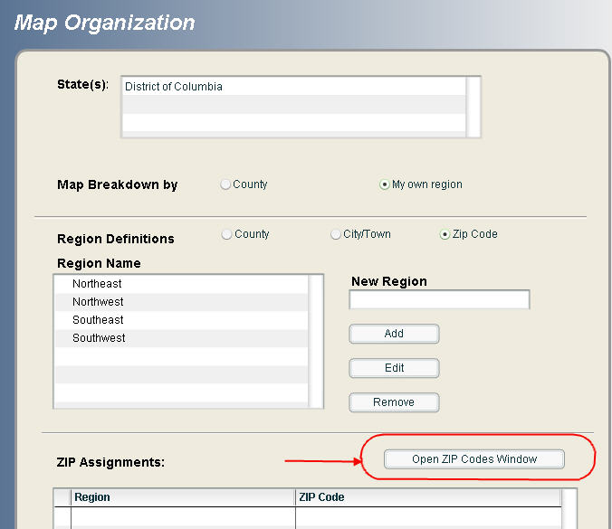

Figure ‑: Select Open Zip Codes Window

In the following example, the Northeast region of the District of Columbia is defined by zip code. By clicking on the Open ZIP Codes Window button, a complete list of zip codes for the District of Columbia is displayed.

Select the region you want to populate by selecting the region name from the Assign to Region box.

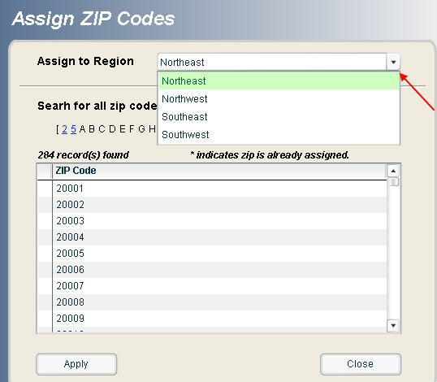

Figure ‑: Select Region to Assign

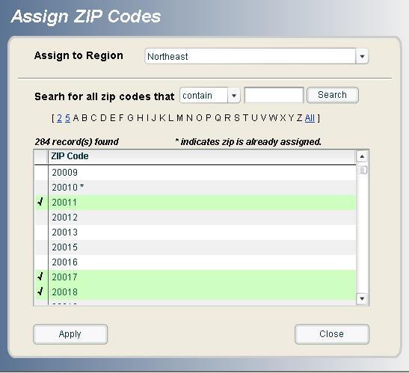

Figure ‑: Assigning Zip Codes to the Northeast Region in the District of Columbia

Select each zip code to be assigned to the region by clicking on the zip code. Selected zip codes will be highlighted in green and display a checkmark next to the zip code. Multiple zip codes can be selected by holding down the CTRL key and individually clicking on the zip code. Once the zip codes have been selected, click the Apply button to assign them to the region. Zip codes that have already been assigned to a region will display an asterisk (*) next to the zip code.

Click the Close button when finished assigning items to a region. You must click the Close button to close the counties, cities/towns, or zip codes window and return to the main Map Organization screen.

The complete list of assigned region elements will be displayed on the Map Organization screen. In this example, the complete list of zip codes assigned to each region in the District of Columbia can be viewed by scrolling down the ZIP Assignments list.

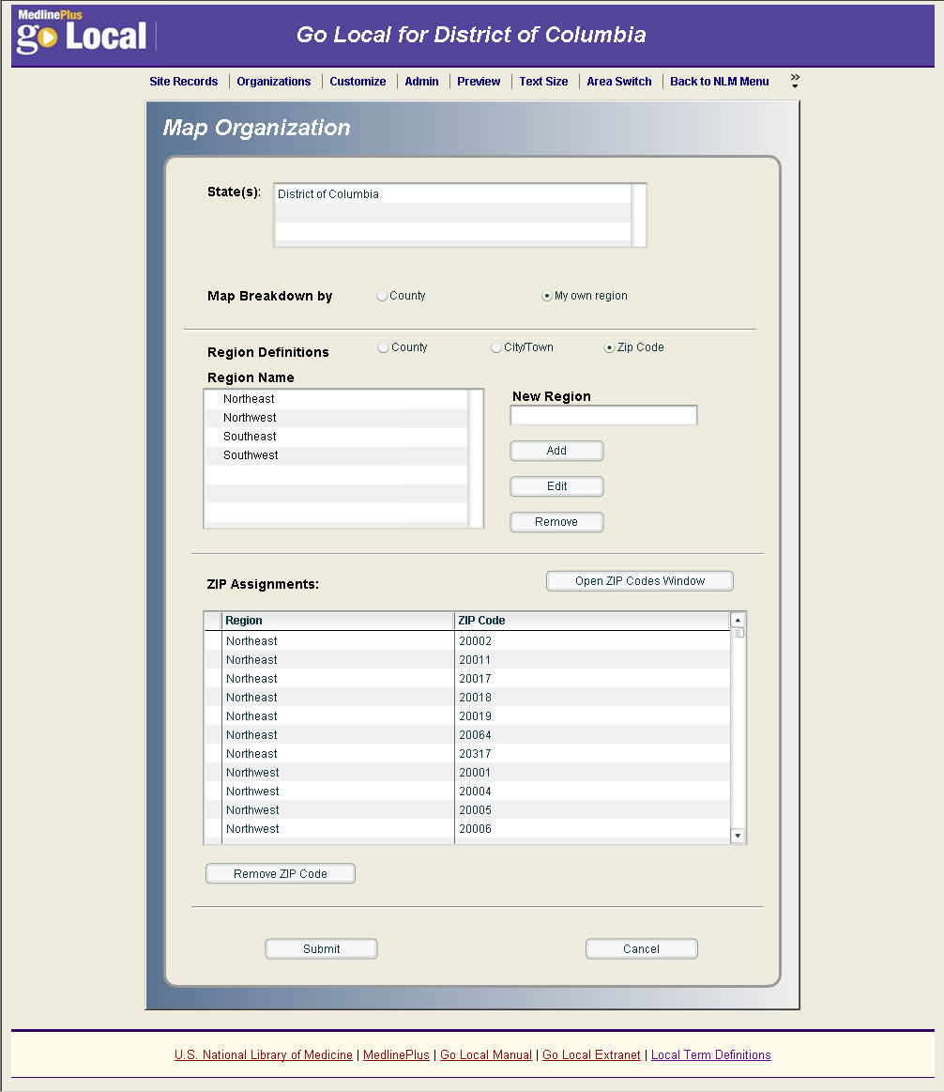

Figure ‑: Completed Assigned Regions by Zip Codes

Click the Submit button when **ALL** of the regional items (counties, cities or zip codes) have been assigned to regions. If you try to submit before assigning ALL of the regional items, you will receive an error message.

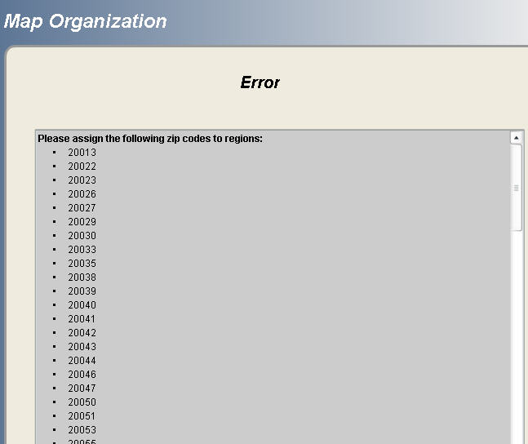

Figure ‑: Error Message for Incomplete Map Organization Record

Upon successful submission you will receive a confirmation message. Click Yes to confirm and complete the regional assignments, or click No to cancel and edit the regional assignments.

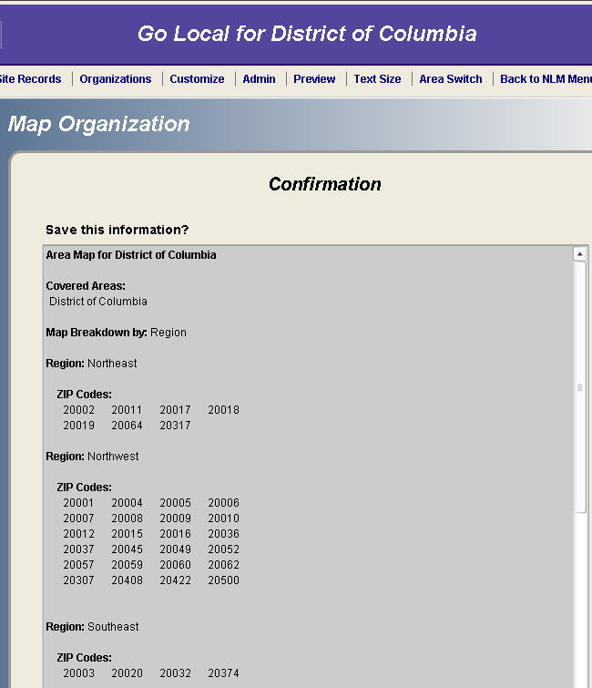

Figure ‑: Confirmation for Completed Map Organization Record

In the public display the Regions list (either by County, City/Town or Zip Code) will appear below the map and be titled “Regions” instead of Counties.

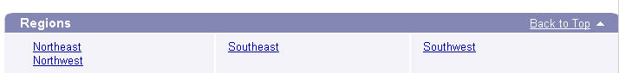

Figure ‑: Public Display of Self-Defined Regions (by Zip Code) for the District of Columbia

Once you have finalized your regions, NLM staff will work with you to create a geographic map with labels that match your regions.

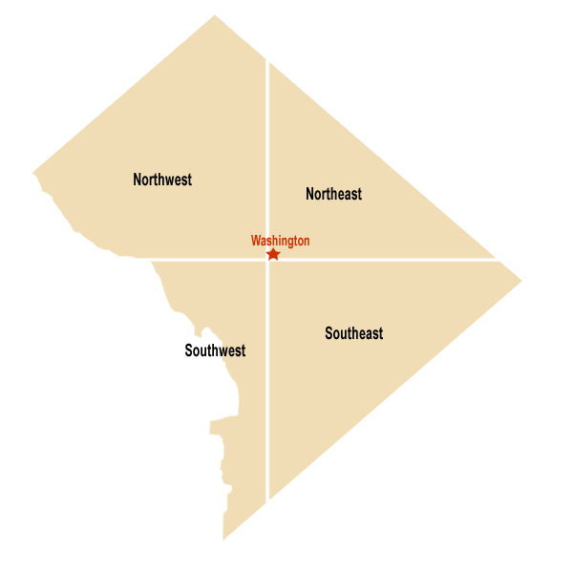

Figure ‑: Sample Region-Defined Image Map for the District of Columbia

### GEO Text Link

Once records have been added, the local administrator can use the GEO Text Link module to add cities and towns to the list of locations. This is best done shortly before a site is released, since the list of cities is automatically generated from the site records for the Go Local area.

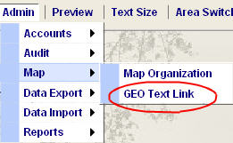

Figure ‑: GEO Text Link Menu Option

Local Administrators choose which cities appear as text links on the public site. To do this, on the GEO Text Link input screen, mark a check ✓ next to each city to be listed as a text link. We recommend you select just some of the cities for display, not all of them, if there is a lengthy list.

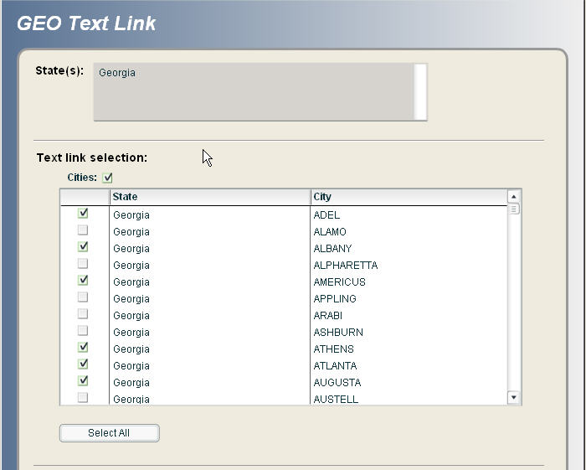

Figure ‑: GEO Text Link input screen with selected cities

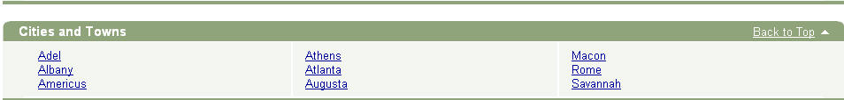

Figure ‑: Public site listing designated city text links

## User Accounts

Next, NLM must create user account(s) for the local administrator(s) – these accounts can only be created by NLM staff. If the proposal did not indicate who the local administrator will be, this information will be requested in the proposal acceptance. Local administrator(s) can then create accounts for reviewers and selectors. Once accounts are created, they can be made inactive but cannot be deleted. This permanence is necessary because user accounts are tied to the records a person works on.

### Types of User Accounts

There are three levels of user accounts in the Go Local system. Listed below are **example**s of tasks and system privileges attributed to each type of User Account. For a complete list of privileges see Appendix 1, User Privileges.  
  
Selector:

* Searches the Internet for health services information using search engines, web portals, announcement listservs, and drilling down through organizational home pages.
* Evaluates sites using Go Local selection guidelines developed by each Go Local area.
* Enters site record form for new materials into system.
* Reviews site records semi-annually.

###### Reviewer:

* Reviews work of selectors.
* Previews pages before Go Local site is released.
* Assigns sites for semi-annual review.
* May delete site records.
* May also perform all or some duties of Selector, above.

###### Local Administrator:

* Creates user accounts for all Selectors and Reviewers.
* Makes accounts inactive when people stop working on Go Local.
* Promotes color schemes for Go Local web site.
* Creates parameters for Go Local maps, including subdivisions of local area, links for cities, or user-defined regions on local map.
* Creates customized static pages for Go Local site.
* May import data.
* May delete organization records.
* Promotes all customization changes for Go Local areas that are released.
* May also perform all of duties of Selector and Reviewer, above.

### Creating User Accounts

Once the local administrator logs in, he/she may create accounts for local area users. Here are some important things to know about user accounts:

* You can only create accounts for people in your Go Local area.
* There is no limit on the number of accounts you can create.
* If someone stops working on your project, you should make the account inactive by changing the Account Status. Accounts cannot be deleted since the user names are usually tied to actions on records.
* Login Names have a 15-character limit and are case-sensitive.
* Login Names must be unique throughout the system; it is not possible to have people with the same Login Name in more than one area. So you will need to use some sort of "standard" for creating Login Names. You can:
* Always start with local area initials **OR**
* Always put a number after the Login Name

### Sample suggested schemes for creating Login Names:

Table 2: Sample Login Names

| **Person's Name** | **Local Area** | **Login Name** |  | **Login Name** |
| --- | --- | --- | --- | --- |
| Jane Smith | Connecticut | smithjct | OR | smithj1 |
| Jane Smith | Minnesota | smithjmn | OR | smithj2 (in this case, if the Minnesota administrator tried to create a login for Jane Smith called smithj1, the system would say that this Login Name already existed.) |
| Bill Jones | Minnesota | jonesbct | OR | jonesb1 |
| Bill Jones | Connecticut | jonesbmn | OR | jonesb2 (in this case, if the Connecticut administrator tried to create a login for Bill Jones called jonesb1, the system would say that this Login Name already existed.) |

Add a user by choosing Admin>Accounts>Add User from the menu.

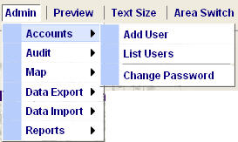

Figure 2‑20: Add a User Menu

Complete the required information fields represented by the asterisk (*). Click Submit when completed. Note that the Designated Local Area is automatically filled-in.

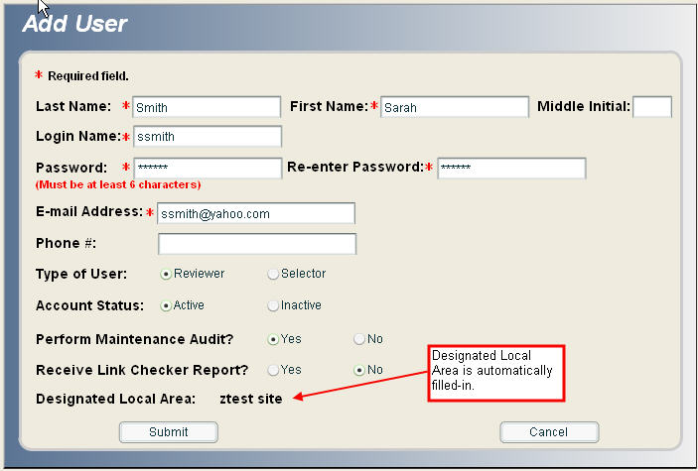

Figure 2‑21: New User Record

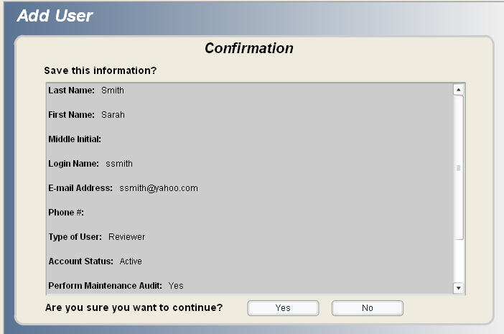

Figure ‑: Add User Confirmation

Click Yes to confirm and continue with the save.

View the complete list of users for a Designated Local Area by choosing Admin>Accounts>List Users from the menu.



Figure 2‑23: List Users Menu

# Creating, Editing, and Managing Health Services Records *(Updated October 23, 2008)*

## Logging In

When you log into the input system, you will see a menu with buttons. Each button has a pull-down list of additional items. The buttons you see depend on your user privileges.   
Here is the main login screen:



Figure 3‑1: Go Local Login Screen

In the next figure, user Nancy Morell has logged in and the system recognizes her as the Go Local administrator for a fictitious site called “ztest” site.

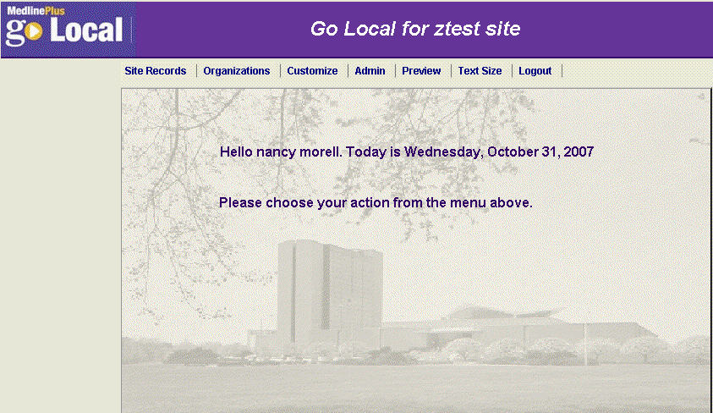

Figure 3‑2: Go Local Login Welcome Screen

### Troubleshooting Login Error Messages

See the Special Considerations for Macromedia Flash section for information on trouble-shooting the following login error messages:

****************

Adobe Flash Player Settings Local Storage

wwwcf.nlm.nih.gov is requesting permission to store information about your computer. Requested: up to 1 MB”

If you do not have ActiveX enabled, you will not be able to log into the Go Local system and may receive the following error messages:

Redo Active X screen captures

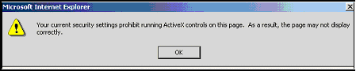

Figure ‑: ActiveX Error Message

When you click OK, you'll see this screen:

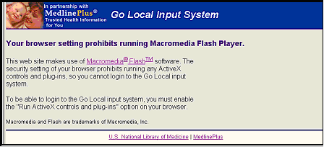

Figure ‑: Macromedia Flash Error Message

See the ActiveX Settings section for information on how to enable ActiveX controls and plug-ins.

### System Timeout

If you have logged in but have not performed any actions in the input system for 30 minutes, the system times you out. You'll see this message below. You may restart your session without losing your work by entering your password, or you may log out.

Note: If you are on a long screen, you may need to scroll to see the time-out message.

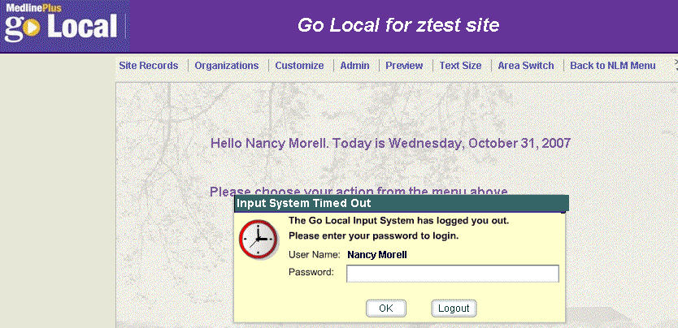

Figure 3‑5: Input System Timed Out Screen

## Menu Options

Menu options appear at the top of every screen, so they are always available.

The local administrator main menu looks like this:  


Figure 3‑6: Main menu for local administrator

The selector and reviewer main menu looks like this:



Figure 3‑7: Main menu for selector and reviewer

All menus can be expanded by clicking on an option to view the expanded selections.

### Expanded menu options:

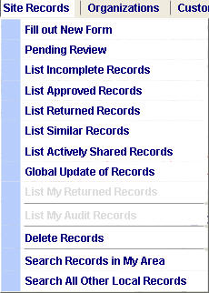

Figure 3‑8: Site Records Menu - expanded

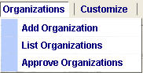

Figure 3‑9: Organizations Menu – Expanded

  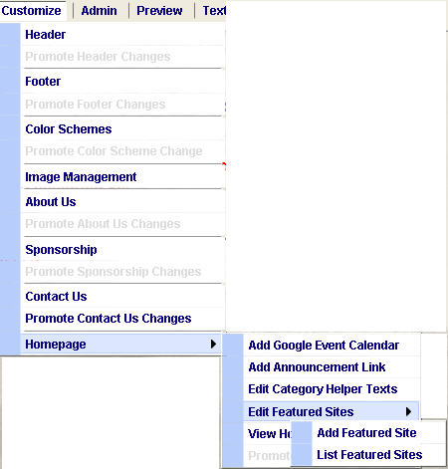

Figure 3‑10: Customize Menu - expanded

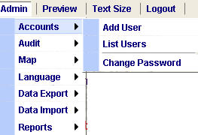

Figure 3‑11: Admin Account Menu - expanded

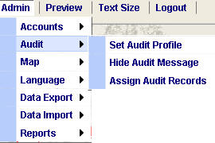

Figure 3‑12: Admin Audit Menu - expanded

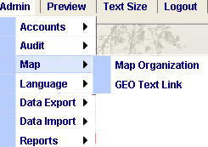

Figure 3‑13: Admin Map Menu - expanded

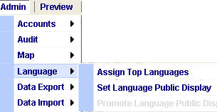

Figure 3‑14: Admin Language Menu - expanded

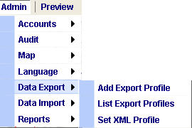

Figure 3‑15: Admin Data Export menu – expanded

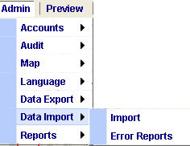

Figure 3‑16: Admin Data Import Menu - expanded

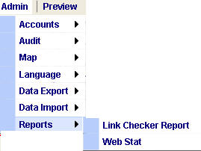

Figure 3‑17: Admin Reports Menu - expanded

 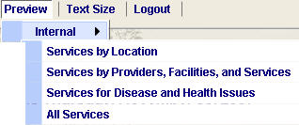

Figure 3‑18: Preview Menu - expanded

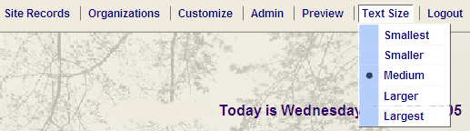

Figure 3‑19: Text size menu - expanded

## Creating Site Records

### Go Local Site Record Input Screen

A form for a site record has four main sections: Site identifier information, Display status and service area, Topics, and Local organization site belongs to.

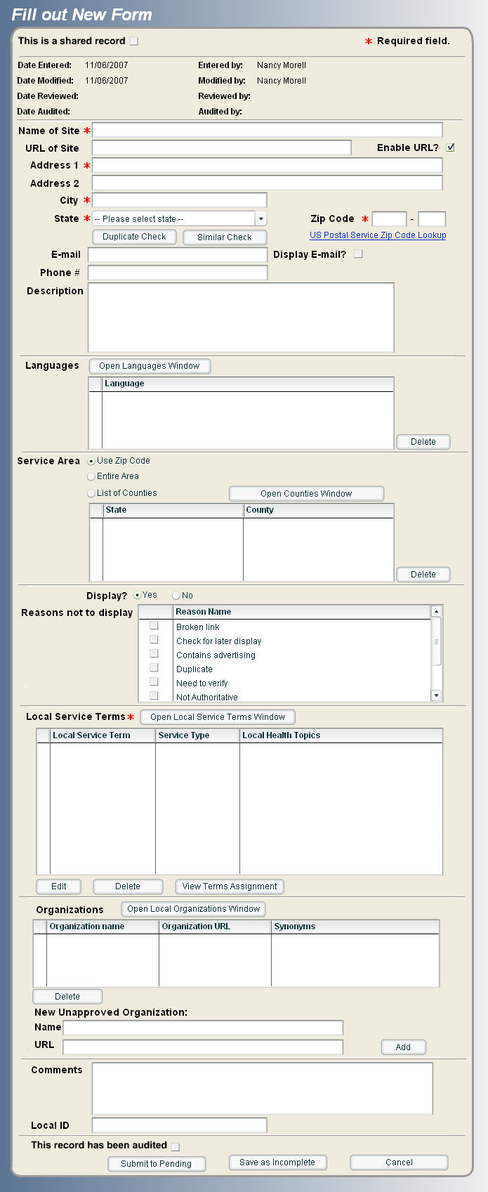

Figure ‑: Go Local Site Record Input Screen

### Fields and Descriptors:

Table 3: Go Local Input Record Field Descriptions

| **Field Name** | **Description** | **Required** |
| --- | --- | --- |
| This is a shared record | Checkbox. Default is unchecked. |  |
| Date Entered | When you begin filling out a new form, this is automatically entered by the system. |  |
| Entered by | Name of person creating the record. This is automatically completed based on your login information. |  |
| Date Modified | Whenever a record is edited, a modified date is automatically entered by the system. |  |
| Modified by | Name of person modifying site. This is automatically completed based on the person's login information. |  |
| Date reviewed | When a reviewer approves a record, this is automatically entered by the system. |  |
| Reviewed by | Name of person reviewing site. This is automatically completed based on the reviewer's login information. |  |
| Date Audited | Whenever a record is audited, an audit date is automatically entered by the system. |  |
| Audited by | Name of person who has audited the site. This is automatically completed based on the auditor’s login information. |  |
| Name of Site | This is the name of the service, e.g., St. Mary's Hospital, Valley Diabetes Clinic, Columbia Cardiology Associates. | Yes |
| URL of Site | URL: Must begin with http:// or https:// |  |
| Enable URL? | By default this field is automatically “checked”. |  |
| Address 1 | An address is required, but it can be only one line. Note: It is important for the local administrator to create standards for abbreviations such as Street, Drive, etc. because the system does not recognize these as being the same. This can cause problems with duplicate records. | Yes |
| Address 2 | Additional address information such as Suite, Bldg number, etc. |  |
| City | City | Yes |
| State | There is a pull-down menu for selecting a state. Typing in the first letter of the state takes you to states beginning with the letter. | Yes |
| Duplicate Check | Click this button to have the system check for duplicate records. If there is a match on the Site Name, Address 1, and URL fields, the system reports duplicate record(s) found. |  |
| Similar Check | Click this button to have the system check for similar records. If there is a match on the Site Name and City fields, the system will report similar record(s) found. |  |
| Zip Code | Five-digit zip code is required. A link to the USPS zip-code lookup web site is available. Zip code must be valid for the state. | Yes |
| Zip Code Extension | 4-digit zip code extension. This is not a required field. |  |
| Phone # | Phone number and its extension: The phone number can be in any format, e.g., (301)496-5000 or 301-496-5000 or 301 496 5000 ext. 23. |  |
| E-mail | E-mail addresses must contain the @ sign and domain suffix such as .com or .edu. |  |
| Display E-mail? | By default, the e-mail address will not display. Check the box to display the e-mail address |  |
| Description | This is where you can add text to display about a service, e.g., "Provides flu shots from October to December and tetanus shots all year. Also provides periodic screenings for cholesterol, high blood pressure, and skin cancer." This description will display on public pages. Limited to 2,000 characters, though NLM recommends most descriptions be much shorter, usually under 500 characters, for better readability of the pages displayed. To create a link within the description code (opens a new window): <a href="http://www.medicare.gov/NHCompare/Include/DataSection/Questions/SearchCriteria.asp?" newwin="Y">Nursing Home Compare</a>  The code to open the link in the same window is: <a href="http://www.medicare.gov/NHCompare/Include/DataSection/Questions/SearchCriteria.asp?" newwin="N">Nursing Home Compare</a>   If no newwin value is specified the default will be 'open in new window'. |  |
| Languages: Open Languages Window | Feature that allows a Go Local site to display the languages spoken by service providers. Click on ‘Open Languages Window’ and select from the list of available languages. Languages will not display to the public unless or until this feature is turned on by your local administrator. |  |
| Service Area: Open Counties Window | The default is "Use Zip Code," which the system will translate into the county by using the zip code in the address. The other options are "Entire Area", which is the entire Go Local area, or “List of Counties” which works in combination with the ‘Open Counties Window’ button. The ‘Open Counties Window’ button allows you to select the specific counties served from a dropdown state/county menu. |  |
| Display? | The default is set to "Yes." If you are not going to display a site, you must chose "No" and select a reason. |  |
| Reasons not to display | Required if "no" is selected. |  |
| Local Service Terms | At least one local service term is required. The local service terms are mapped to local health topics. Click on the Open Local Service Terms Window to choose from the list of available service terms. | Yes |
| Organizations: Open Local Organizations Window | If the site is part of a larger organization, you may create an organization name to associate with the site. For example, if the record is for the Washington County Mobile Health Screening Center, the organization might be the Washington County Health Department. Click on ‘Open Local Organizations Window’ to select from a list of organizations already listed in the system. Or, add a new organization name and URL to the list. |  |
| Comments | This is where selectors may add information about the record to aid reviewers (e.g., This clinic is a part of St. Mary's Hospital. Should St. Mary's Hospital also be listed as an organization?) Reviewers can also add information if they return the record to the selector (e.g., Please add Ambulatory Care Centers to this record.) When you add a comment, a date is entered automatically when you submit. Place the cursor at the top of the comments box so that the comments are displayed with the most recent first. MedlinePlus selectors and reviewers find it helpful to add their initials to comments to track changes to a record. |  |
| Local ID | Local ID is a 15 character alpha-numeric internal code that does not publicly display but can be searched internally using an exact match search for the data. |  |
| This record has been audited | The default is unchecked. The user may check the box after a record has been audited (i.e., after all the information in the entry has been confirmed. |  |
| Submit to Pending | To save the record to the Pending queue for review. |  |
| Save as Incomplete | To save a record that is missing one or more required fields, or a record that the selector is still working on and is not ready for review. |  |
| Cancel | Click the ‘Cancel’ button to clear the record and return to the main menu screen. |  |

### Site Identifying Information

A site record requires a name, address, city, state, and zip code. It may also include a telephone number, email address, or a web address. (Note: Fields with * are required)

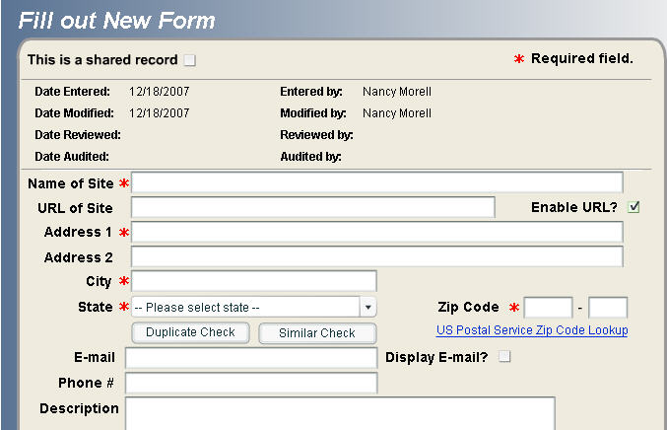

Figure 3‑21: Fill out New Form - Site Identifying Information

### Change Case Utilities

When filling out a new site record form, or when editing an existing site record, you can access the following three change case utilities through a right mouse click.

* Change to all lower case
* Change to all upper case
* Capitalize the first letter (e.g. change STREET to Street) of every word highlighted

To access these utilities, highlight the text that you want to change and then use a right mouse click:

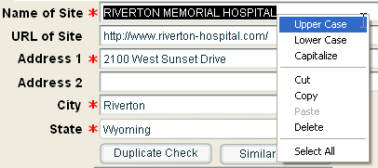

Figure 3‑22: Change Case Utility

It is important to highlight only the text for which want to change the case. When you highlight the text and right click, you should see the three options:

* Upper Case
* Lower Case
* Capitalize

If you don’t highlight the text to be edited and right click, the three options should be in the menu, but grayed out.

Select the option you would like and the system will execute the change you requested.

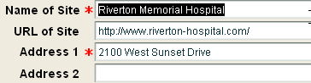

Figure 3‑23: Change Case Results

**Note:** Donot use the change case utility when making a Global Update unless the text in the field you are changing is identical in all records. The Global Update module does not recognize the formatting adjustment as the change. Instead the text from the field you are changing will appear in that field for all grouped records.

### Language Indicator

The Language Indicator is an optional feature that allows a Go Local site to display the languages spoken by service providers.

Local Administrators may:

* Customize the default “top languages” that will appear to reviewers and selectors when creating and editing site records.
* Turn on the public display of languages spoken. When turned on, the “languages spoken” line will appear under the description of a site record in the public display for those records that have languages associated with them.

Anyone can index the languages spoken in a particular site record, and this can be done even if this feature is not turned on.

### Assignment of Top Languages Display

Local Administrators may customize the initial list of languages that selectors and reviewers will see when trying to index languages to a site record. This feature can prevent unnecessary navigation by making the most frequently spoken languages for an area the first ones visible to selectors and reviewers. Selectors and Reviewers may always navigate to the full list of languages if they do not see a particular language on the initial “top languages” list.

* To manage the list of “Top Languages,” Local Administrators can go to Admin > Language > Assign Top Languages.



Figure 3‑24: Assign Top Languages Menu Item

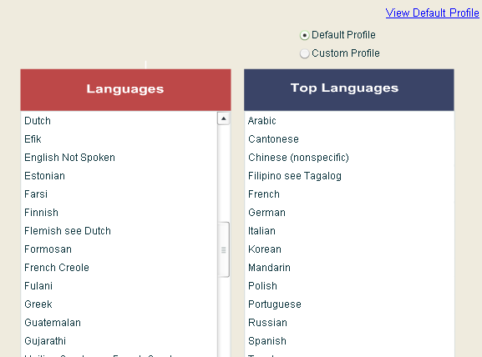

Figure 3‑25: Assign Top Languages Window

There are two types of Language Profiles.

1. Default Top Languages Profile – This is a profile created by NLM. It includes the languages that the Census indicates have over 500,000 people in the country who speak this language at home.
2. Custom Profile – This is a profile that the Local Administrator may customize for the specific Go Local area.

Your selection of the profile is indicated by the toggle buttons on the upper right of the screen.

The “View Default Profile” link at the top of the screen provides a dynamically-generated list of the NLM-selected top languages. This feature will be helpful if you want to see the default list of languages without needing to select the default profile.

The three buttons at the bottom of the page do the following:

1. Submit – Saves any changes you have made to the current profile.
2. Reset – Reverts back to the last saved profile.
3. Cancel – Takes you back to the main menu without saving any changes.

To make a change to the profile:

* Select the toggle button next to “Custom Profile” at the top right of the screen. You must select the “Custom Profile” option in order to make changes to the languages list.
* After selecting the “Custom Profile” option, you will be able to drag and drop languages from the main language list to the Top Languages list. You can also drag languages off the Top Languages list and back to the Languages list.
* To move a language from one column to the other, click on it, hold down the mouse, and drag the language to where you would like it to go.
* Some languages have see references associated with them. If you move a language with a see reference, all the associated see references will move with it.
* Once you have made your changes to the Top Languages list, click the Submit button at the bottom of the page.

**Note:** The English Not Spoken language choice has special features associated with it. If a site is indexed with the English Not Spoken language, a separate line that says **“Service provider does not speak English.” will appear under the description field of the public display. Refer to the display information below.**

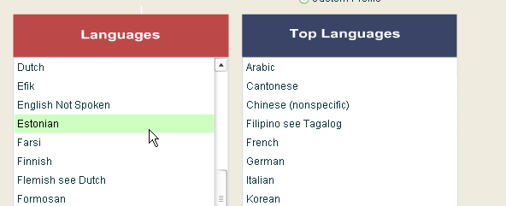

Figure 3‑26: Moving a Language from the Languages List

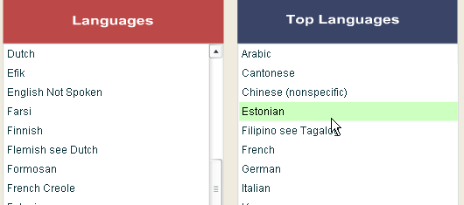

Figure 3‑27: Moving a Language to the Top Languages List

**Note:** The order of the languages in the list of Top Languages will be the same as the order that will appear to the selectors and reviewers. You can opt to have them in alphabetical order, the order of popularity, or other ways that you feel helpful.

If a language you need is not on the master list of languages, or you would like to suggest a change to the languages, please email the listserv at [MPLUS-GOLOCAL@LIST.NIH.GOV](mailto:MPLUS-GOLOCAL@LIST.NIH.GOV).

### Indicating the Languages Spoken on a Site Record

To indicate which language a service provider speaks, you can enter the information in the Languages area of the site record form.

The Languages box is part of the site record form that you will see when creating new records (Site Records > Fill Out New Forms) or when editing an existing record.

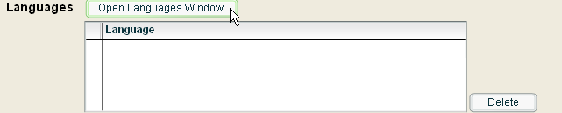

Figure 3‑28: Open Languages Window

* Select the Open Languages Window to see a list of default list of languages you can select from. If a custom profile has been created for the top languages, that short list will display here. Otherwise, you will see the default top languages profile.

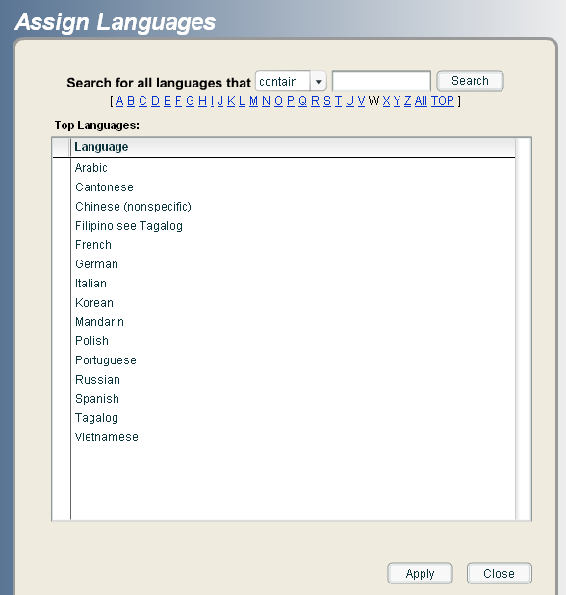

Figure 3‑29: Assign Languages

* If you do not see the language(s) you need on this initial list, select the ALL link at the top of the window, or use the A-Z look up list to go to the specific language that you are looking for. You may also search for the language using the search box.
* Select the language(s) that you want, holding down the control key to select more than one language.
* Select Apply
* Hit Close when you are done.

The Languages that you associated with that site will appear in the Languages area of the site record form.

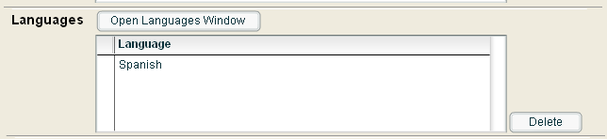

Figure 3‑30: Languages Associated with a Record

To remove a language that has been associated with a record, select that language in the language box and then hit the “Delete” button to the right of the Languages box.

### Languages Spoken Public Display

If the Local Administrator has turned on the Languages Public Display, when a language is associated with a site record it will display just under the description field of a site record.

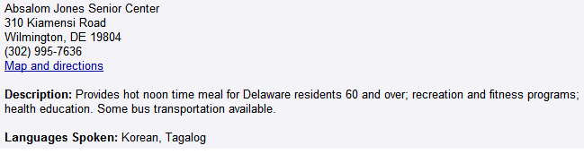

Figure 3‑31: Site Record Public Display of Languages Spoken

If the language “English Not Spoken” has been selected, a sentence saying “Service Provider does not speak English” will appear just under the Languages Spoken line.

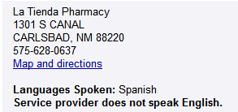

Figure 3‑32: English Not Spoken Public Display

If there is no description, the language information will appear under the “Map and directions” line.

### Turning on the Languages Feature in the Public Display

Local Administrators may decide when and if to turn on the language feature for display in the public view.

Some sites may want to index the languages first and then turn on the feature once the language information has been captured. Other sites may want to turn on the public display while language information incrementally appears as it is added in. Once it is turned on, the Local Administrator may also decide to turn off this feature at any time.

Go to Admin > Language > Set Language Public Display

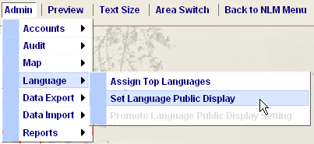

Figure 3‑33: Set Language Public Display Menu

* To turn on the feature, select “Yes”. If the Language Feature was already turned on, you may turn it off by selecting "No".

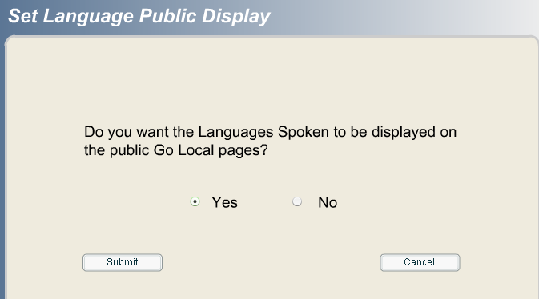

Figure 3‑34: Set Language Confirm

* Hit the “Submit” Button.
* After making a change to the Language Public Display, Local Administrators of live sites will need to promote the change.
* Go to Admin > Languages > Promote Languages Display.
* Select Promote Language Public Display. After confirming the change, the languages display will be visible on the public pages.

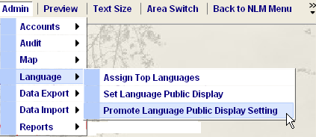

Figure 3‑35: Promote Language Public Display Menu

### Searching for Records that have Indexed Languages

In the Search area (accesses via Site Record > Search Records in My Area, or Site Records > Search Records in All Other Local Records), there are two options associated with languages.

1. The “Languages Assigned” box lets you search for those records that do or do not have languages associated with them.
2. The “Language” box allows you to search for records that have been indexed for a specific language.

These options appear towards the bottom of the search page.

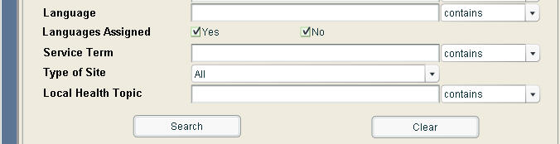

Figure 3‑36: Language Search Options

### Service Area

The Service Area has 3 options for data entry:

* **Use Zip Code**: this is the default input option. With this option, the NLM system uses the zip code entered in the record’s site address to determine the county served.
* **Entire Area:** select this option if a resource serves the entire Go Local area, even if the resource is located outside of your Go Local area. For example, aState Health Department or a National resource such as the American Academy of Pediatrics’ Pediatrician Referral Service located in Illinois.
* **List of Counties:** selectors choose all that apply from a list of possible counties in the Open Counties Window. The list of available counties is determined by your Designated Local Area. For more information see: Creating the Designated Local Area.

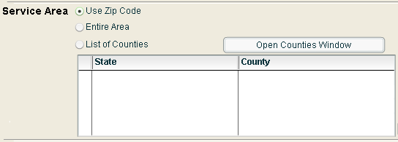

Figure 3‑37: Service Area Input Screen

Each option determines how and where the record will display in the list of resources in the public display. In essence, when you enter a record and input one of the 3 options for Service Area, you are indexing the record to a geographic location.

**The public display reflects three choices in the input system:**

* **Use Zip Code** - In the New Mexico example shown below, the records marked to use zip code with Zip Codes found in Santa Fe County appear in the listing “Resources in Santa Fe County” on the public display.
* **Entire Area** - In the New Mexico example shown below, this designation corresponds to the listing of “Resources serving all of New Mexico” on the public display, except for those resources located in Santa Fe County.
* **List of Counties** -. In the New Mexico example shown below, this designation corresponds to the “Regional resources also serving Santa Fe County” in the public display for those services providing services to residents of Santa Fe County, but the resource is not actually located in Santa Fe County.

Regardless of which Service Area option is chosen, the mapping program that NLM uses "decides" what county the service is located in by its zip code. Sometimes this won't be exactly right, since zip codes bleed across cities and even counties, but it is usually correct. If you find an error in the zip code mapping, notify NLM staff of the problem.

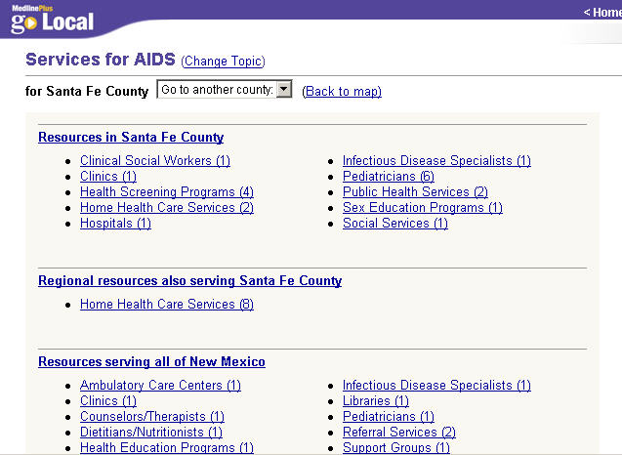

Figure 3‑38: Service Area Selection – Public Display

### Display Status

The default display status for a record is “Yes”. The selector must change the status to “No” for the site not to display. If you change it to “No”, you must also choose a reason not to display the record.

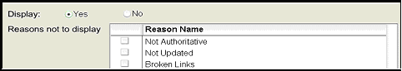

Figure 3‑39: Display Status

### Topics

Adding a topic is the most complex step in creating a record. You need to associate a record with both local service terms and local health topics. Here are some definitions:

#### Local service term:

These are the terms for healthcare providers, health facilities, and health programs and services. They are unique to the Go Local vocabulary. Once you use a local service term to index a site, you must also associate the service term with one or more Go Local health topics where the service will display. Local service terms may be used as a "see related" topic on the local services topic pages (e.g., on the Acupuncturists page may be a reference "You may also be interested in Pain Clinics.") Local service terms may be associated with local see references (e.g., AA see Alcohol Abuse Programs.)

#### **Local health topics**:

These are a subset of MedlinePlus health topics. The Local Health Topics map Go Local service records to corresponding MedlinePlus topic pages. They facilitate the connection from a MedlinePlus topic page into your Go Local service listings related to that topic. In some cases, the local health topics are identical to MedlinePlus health topics (e.g. Diabetes, Alternative Medicine.) In other cases, MedlinePlus health topics are used as see references to a broader topic (e.g., "AIDS and Infections" is mapped to the broader term AIDS). A see reference maps to a broader term.

### Topic Mappings

#### Local service term to local health topic

Some local service terms contain automatic mappings to health topics. They are provided for your convenience, so that you do not need to choose them each time you find a site that should be mapped to a health topic. Example: Acupuncturists is automatically mapped to the local health topic Alternative Medicine. You can remove the automatic mapping by deselecting the checkbox.

* Some local service terms contain suggested mappings to health topics. They are provided because you might want to associate sites to additional health topics. Example: Acupuncturists has a suggested mapping to the local health topic Cancer
* You may also choose to associate any local service term to any health topic. Example: You might choose to map Acupuncturists to the local health topic Foot Injuries and Disorders, if you are indexing a web site for an acupuncture practice that specifically says it treats foot pain.

#### Local service term to another local service term

* Some local service terms may have see references. Example: AA see Alcohol Abuse Treatment Programs.

#### Local health topic to another local health topic

* On some local health topic pages, other local health topics may appear on the page as "see related" references if there are additional services on one of these related topics. Example: On the Heart Diseases page you might see a link saying "Related Services in [name of Go Local site] area: Heart Failure."
* Some local health topics may have see references. These are MedlinePlus health topics that have been "mapped" to a broader local health topic. Example: Dermatitis see Skin Diseases.

#### Mapping to MedlinePlus health topics

* When you are on a local health topic page or a local services page, you will also see links to MedlinePlus health topic pages. Example: On the AIDS local health topic page, you will see a list saying "Health Information from MedlinePlus: AIDS, AIDS and Infections, AIDS and Pregnancy, AIDS-Living with AIDS," etc.

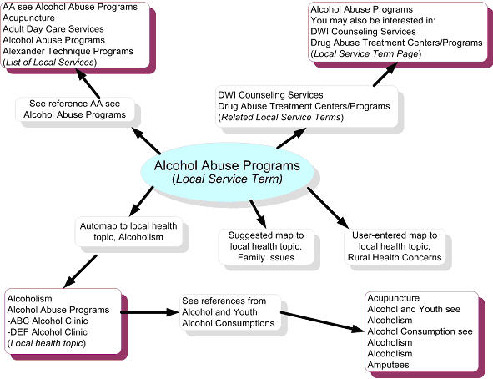

Figure 3‑40: Local Service Term Flowchart

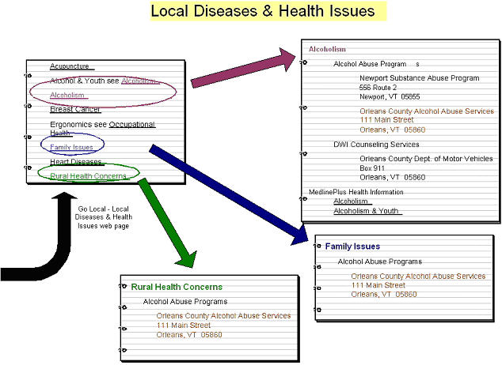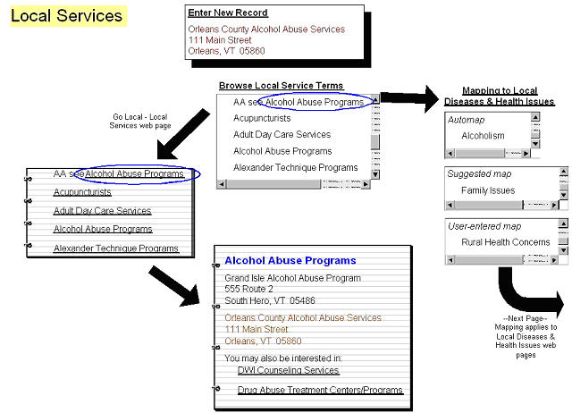

Figure 3‑41: Local Services and Diseases & Health Issues Flowcharts

### Selecting local service terms and local health topics

Step 1: Click on the Open Local Service Terms Window button

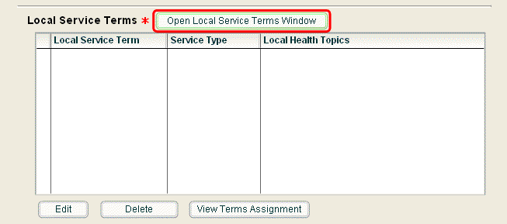

Figure 3‑42: Open Local Service Terms Window button

Step 2: The Local Service Term Window opens.

Step 3: Click on a local service term to select it, the scope note of the service term will appear.  Click OK. Note: You can only choose one local service term at a time. Clicking on a see reference to the local service term is the same as clicking on the local service term.  
  
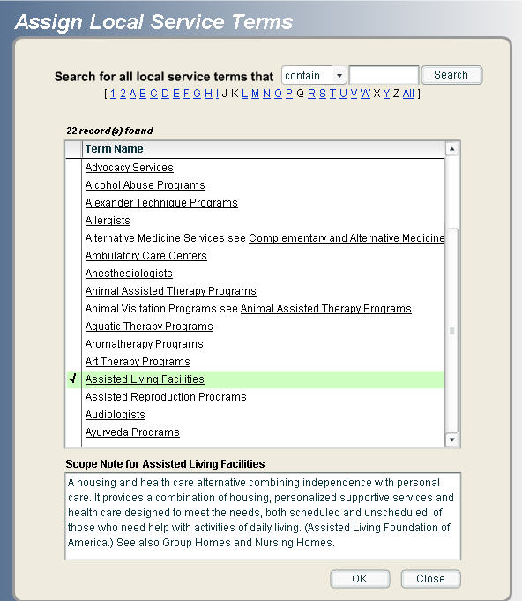

Figure 3‑43: Assign local service terms window

Note: When this screen opens, it shows you the first 20 local service terms. You can also select from the alphabetical list at the top of the screen. Another option is to type words into the search box. The options are "start with" and "contain."

Step 4: The window shows the automatic mappings to local health topic mappings, the suggested health topic mappings, and the "Browse Other Local Health Topics" button for you to associate additional terms if desired.

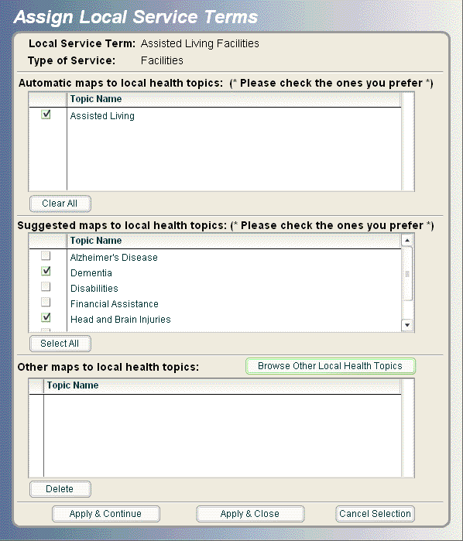

Figure **3‑44: Automatic local service term mapping**

Note: you may select as many suggested mappings as you want, or click select all to choose all suggested mappings.

Step 5: Below, you have clicked on Browse Other Local Health Topics and chosen to map Assisted Living to End of Life Issues:  
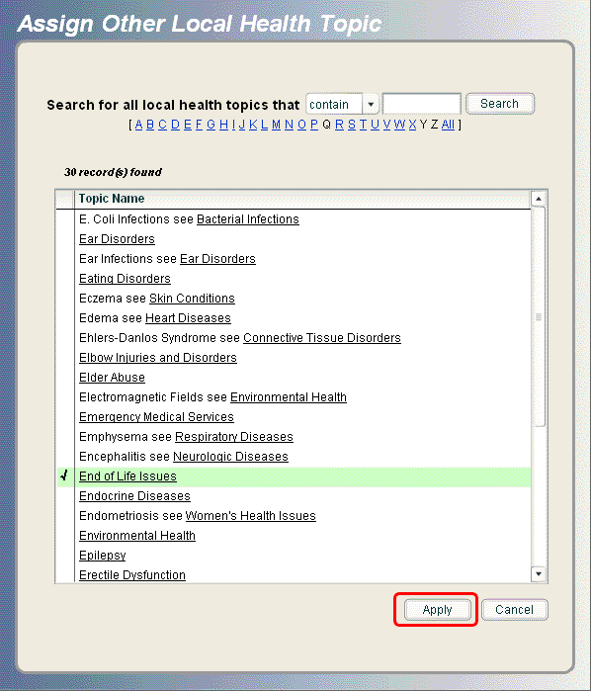

Figure 3‑45: Browse other local health topics screen

Note: You may select multiple topics by holding down the Control key (Ctrl) and clicking.

Step 6: When the user clicks Apply, the Other Local Health Topics window closes, and the user is returned to the mapping window for Assisted Living Facilities, which now looks like this:

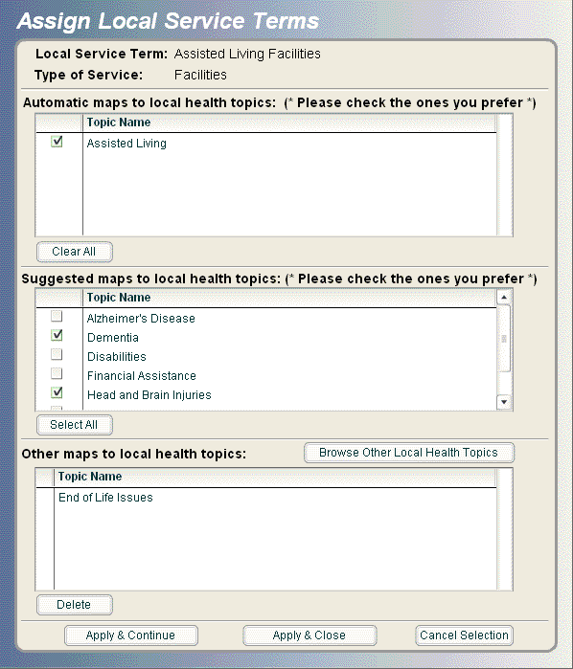

Figure 3‑46: Completed mapped window for Assisted Living

At this point you may:

* Click Apply & Continue to select another Local Service Term to map to this record.
* Click Apply & Close to finish the topic portion of the record.
* Click Cancel Selection to remove Group Homes (and its associated local health topics) and return to the Assign Local Service Terms window.

### Assign Local Organizations

The last step is to assign the local organization(s) to which the site belongs.

Note: Sites do not need to be associated with an organization name.

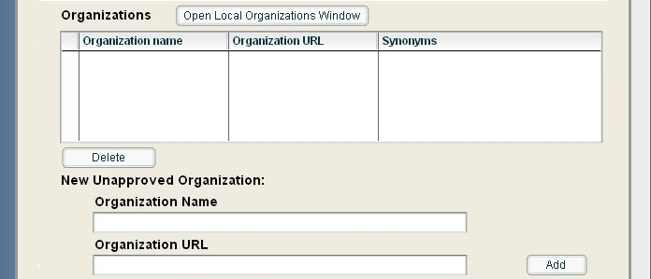

Figure 3‑47: Assign local organizations input fields

Click on "Open Local Organizations Window" to open the list of local organizations.

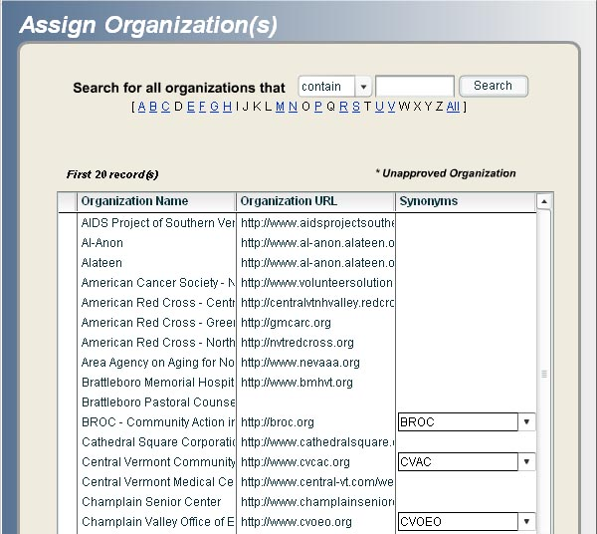

Figure 3‑48: List of local organizations

If the organization is not listed, you may enter a new unapproved organization name below the Organizations window.

Note: The system is programmed so that if the name of the site and the organization name in the record are *exact* matches, the organization name does not appear in the public display.

### Comments

Selectors may use the comments field to add information about the record to aid reviewers. Reviewers can also add information if they return the record to the selector. When you add a comment, a date is entered automatically when you submit. Place the cursor at the top of the comments box so that the comments are displayed with the most recent first. Note: Selectors and reviewers find it helpful to add their initials to comments to track changes to a record.

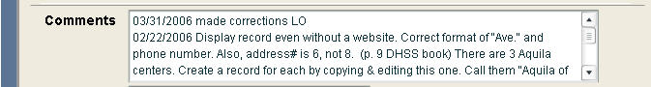

Figure 3‑49: Comments field with data

### Local ID

Local ID is a 15 character alpha-numeric internal code that does not publicly display but can be searched internally using an exact match search for the data.

### Submitting the Site Record

When you've filled out all the information on the form, you have 3 options for the completed record:

* Submit to Pending: Saves the record to the Pending queue for review
* Save as Incomplete: Saves a record that is missing one or more required fields
* Cancel: Clears the record fields and returns to the main menu screen



Figure 3‑50: Submit, Save or Cancel record

## Shared Records

The Shared Records feature allows sites to create and share records with other sites. This feature will allow for sharing of records serving an entire area, or records serving overlapping counties between areas (currently, this is possible in records from Tribal Connections Four Corners, Utah, Nevada, and New Mexico).

A shared record will be treated as one record, even though it is shared among many sites. One site can make a record available to share, while many may opt to share this record. Any site sharing the record can make changes to the record. If a change is made to a shared record, the changes will be reflected in the record within all sites sharing the record.

Only the area that originally created the record and made it shareable has the ability to delete the record and thereby delete it from the other areas using that shared record. Other areas using the shared record may delete the record from their individual areas, but cannot delete it from the other sites sharing the record

At anytime, an area that opted to use a shared record may choose to “split” the record and maintain it as an individual site record that is no longer connected to other areas. Each of these capabilities is outlined below.

### Creating a Shared Record

Only Local Administrators can create a new shared record or make an existing record “shareable.”

* Choose Site Records > Fill out New Form from the menu.
* Check the box for “This is a shared record”
* Fill out the record with the remaining required field data
* Submit to Pending and approve as you would normally.

**Note:** There are certain restrictions on the “Service Area” for shared records.

So that a record can be shared, the Service Area must meet ONE of the following conditions:

* Be set for the “Entire Area”
* Include Counties that overlap with other areas (currently this will only happen in counties shared by Tribal Connections Four Corners and overlapping areas in New Mexico, Arizona, and Utah).
* Include Zip Codes that overlap with other areas (currently this will only happen in counties shared by Tribal Connections Four Corners and overlapping areas in New Mexico, Arizona, and Utah).

**Note:** Shared records containing an organization name can only be shared with a site that maintains the same organization within their system. If you are creating a shared record that uses an organization name, it might limit other areas’ ability to easily use the shared record.

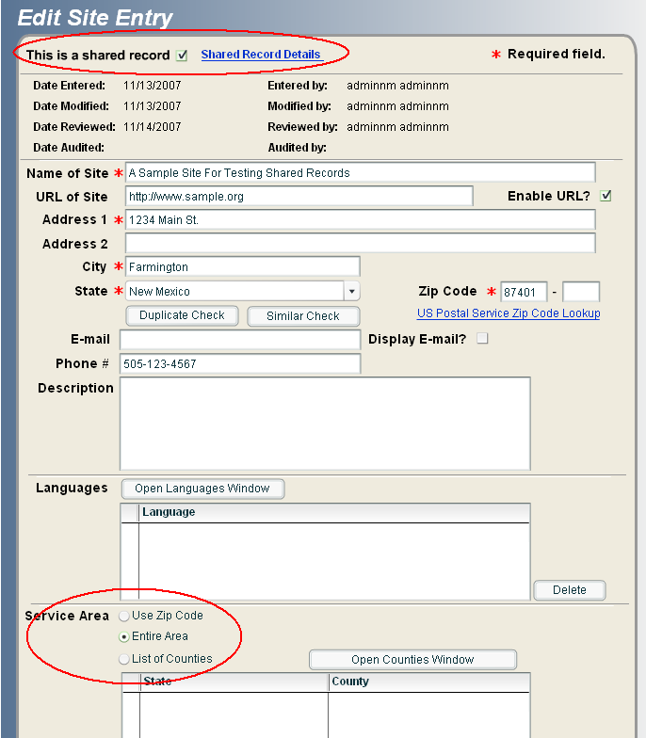

Figure 3‑51: Creating a Record that Can Be Shared

### Allowing an Existing Record in Your Area to be Shared

A Local Administrator can modify an existing record to make it available for sharing.

* Navigate to an existing record (the status of approved, pending, etc. does not matter).
* Edit the record

On the record edit screen:

* Check the “This is a Shared Record” box at the top of the screen
* You may need to change the service area to Entire Area unless you are working on a record shareable within the Tribal Four Corners area (see Creating a Shared Record section listed above)
* Submit to Pending
* Approve as you would normally

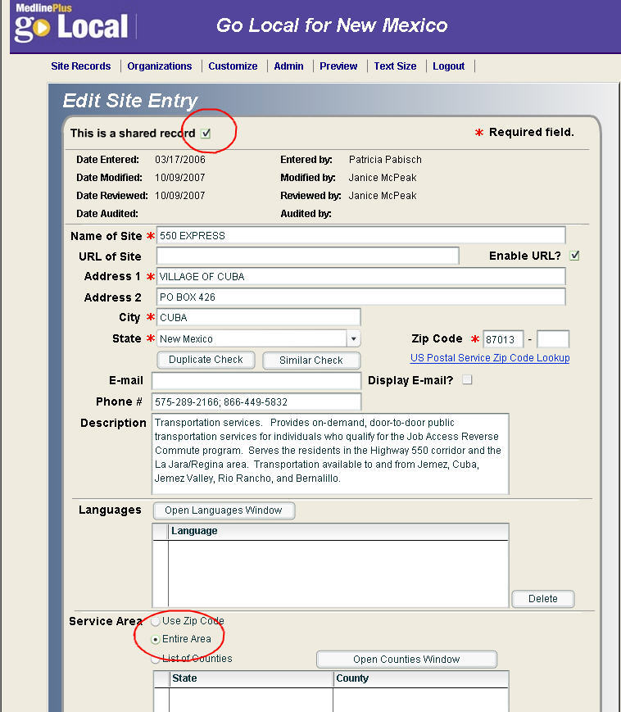

Figure 3‑52: Edit an Existing Record So that it Can Be Shared

### Changing the Status of a Record from Your Area to Unshared

A Local Administrator from the area that created a shared record can modify it so it may no longer be shared.

* Navigate to an existing record (the status of approved, pending, etc. does not matter).
* Edit the record

On the record edit screen:

* Deselect the “This is a Shared Record” box at the top of the screen
* Submit to Pending
* Approve as you would normally

**Note:** Deselecting the “This is a Shared Record” checkbox will **delete** the record from any areas that are already sharing it, so be very cautious about doing this. The record will remain active in your area.

### Selecting a Shared Record from Another Area

You can find records that other areas have made available for sharing. You can opt to share these records within your system.

From the menu choose Site Records > Search All Other Local Records

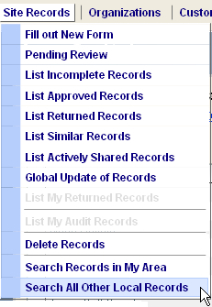

Figure 3‑53: Search All Other Local Records Menu Option

On the search screen, find the “Shared Record Created By” search criteria. It is located towards the bottom of the search screen.

Search for Shared Record created “By Other Area.” Deselect the “None” box and the “By My Area” box. You can enter other search criteria as well. (For example, you can limit to the Designated Area that created the original record, Site Record ID, Site Name, etc.)

Click Search to run your search.

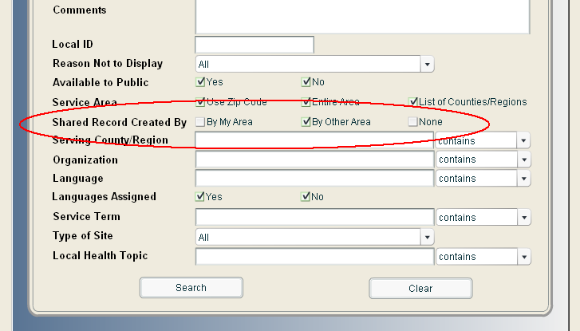

Figure 3‑54: Searching for Shared Records

In the list of results, the shareable records will appear highlighted in yellow

A record being shared by multiple areas is denoted in the results list by a downward arrow (🡫). A mouse-over on the downward arrow displays the designated areas which share this record.

“Note: the downward arrow ( ↓) will not appear when viewing a list of shared record results from Search Records in My Area.

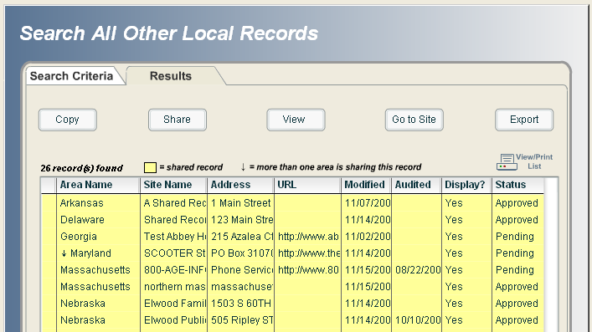

Figure 3‑55: Results of Search for Shared Records

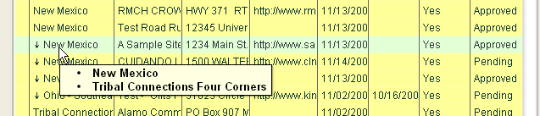

Figure 3‑56: Mouse-Over Displaying Designated Areas That Share a Record

Select the shareable record you are interested in (when you select a shareable record, the highlight color changes to green and a checkmark appears next to the selected record)

Click the “Share” button available at the top of the page.

At the Notification prompt Click OK

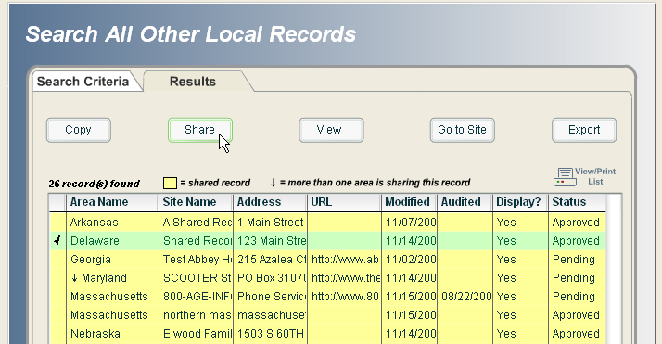

Figure 3‑57: Select a Record that is Available to be Shared

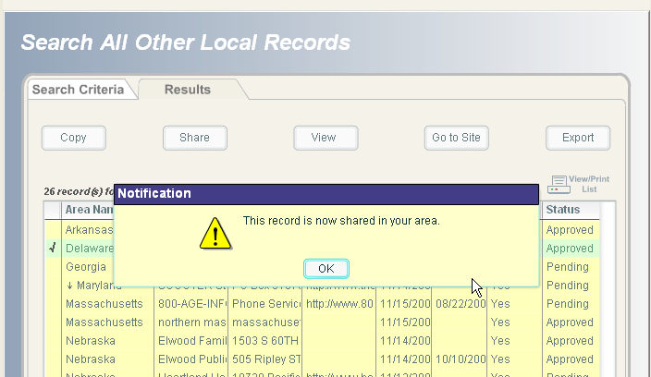

Figure 3‑58: Notification that you are Sharing the Record

**Note:** **The system will not allow you to use a shared record that is identical to a record already in your area.** It will check against the Site Name, URL, and Address. You cannot opt to share a record that has these three fields in common with a record already in your system. First, you must delete the existing record from your area. Then, you can opt to share the new record, thereby adding it to your area.

If you try to use a shared record that includes an organization in the organization field, you must also have that organization in your system. To create an organization in your system, go to Organizations > Add Organization.

Keep in mind the status of the record you are sharing. If you share a record that is currently in pending, it will appear in your pending queue. If it is approved, it will appear in the approved queue. The status of the record will be the same with all areas sharing the record.

Once you are “sharing” a record, you can make any changes to that record as you would normally. Changes you make will be reflected in all areas sharing that record. For instance, a record audited by one area will be shown as being audited in all areas sharing the record.

### Identifying Shared Records in Normal Displays

When shared records appear in lists of records, they are highlighted in yellow.

Each of the different lists of records (list of incomplete records, list of approved records, etc) contain the “Shared Record” and “Non-shared Record” filter boxes at the top of the screen.

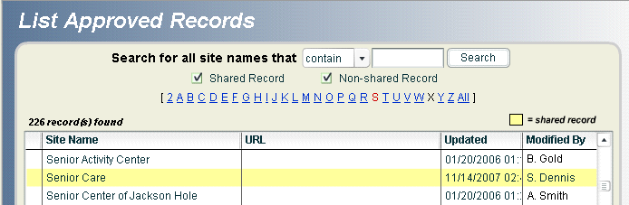

Figure 3‑59: Shared Record in Approved Records List

These checkboxes are available on the following lists available under the Site Records menu:

* Pending Review
* Incomplete Records
* Approved Records
* Returned Records
* Similar Records

By selecting the “Shared Record” checkbox and clicking on the search button, you can see only those records that are shared records. Selecting both “Shared Record” and “Non-Shared Record” means you will search both types of records. If you only select “Non-Shared Record,” your search will exclude all shared records.

Within a site record, you can identify information about the areas that share a record.

In the Edit view, shared records will have a link called “Shared Record Details”

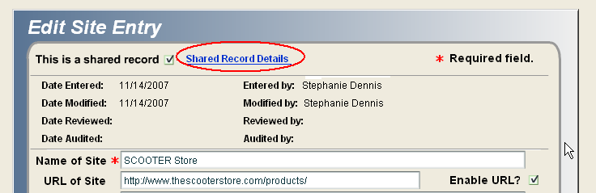

Figure 3‑60: Shared Record Details Link

After selecting the link, you will get a pop-up box with information about the areas sharing the record.

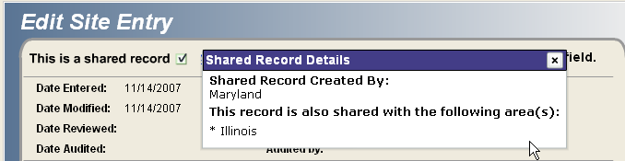

Figure 3‑61: Shared Record Details Box

When Viewing a site record, information about the areas sharing the record is available towards the bottom of the page.

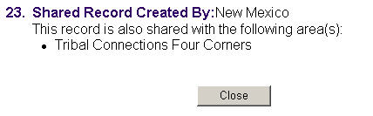

Figure 3‑62: View Site Record – Shared Record Field

### Managing Shared Records using List Actively Shared Records

The “List Actively Shared Records” window helps you manage your shared records. Access the window by going to Site Records > List Actively Shared Records.

The “List Actively Shared Records” window provides a list of:

* Records you are sharing that were created by other areas
* Shared records created by your area that are being used by other areas.

These lists are available through the two tabs at the top of the window.

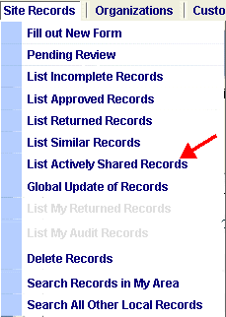

Figure 3‑63: List Actively Shared Records Menu Item

**To manage shared records that you are using but that were created by other areas:**

* Go to Site Records > List Actively Shared Records.
* Select the Created by My Area tab.

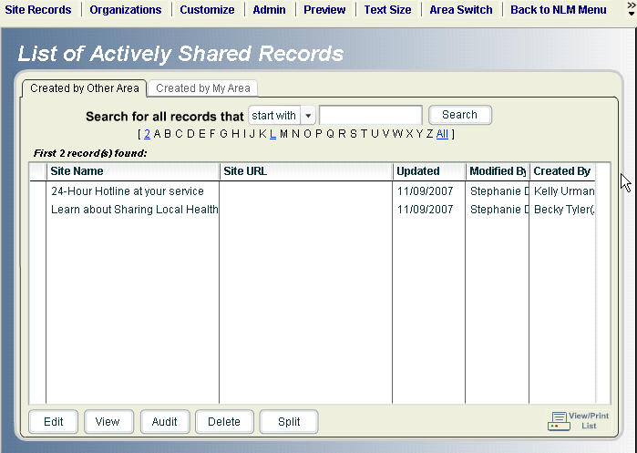

Figure 3‑64: List of Actively Shared Records

On the “Created by Other Area” tab, the following buttons are available:

* Edit
* View
* Audit
* Delete
* Split

The Edit, Views, and Audit buttons work as they do elsewhere in the system.

**Delete:** If you select a shared record created by another area and hit Delete, you will delete the record from your system. It will not be deleted from the other areas sharing it. The only entity that can delete the shared record and make it disappear from all areas sharing it is the area that created the record.

**Split:**  After opting to “share” a record that was made shareable by another site, you have the option of Splitting the record. If you highlight a record and hit the “Split” button, you are breaking your connection to that shared record. The record will disappear from this window (since it is no longer shared). If it was approved, it will appear in the approved queue, if it is pending, it will be in the pending queue, etc.

The record will continue to exist in your system, but it will be independent from the original record. Changes made to a split record will not be reflected among other sites that are sharing that record.

After you split from a record, the comments field will include text indicating that the record was split from AREA NAME by NAME OR PERSON on DATE.



Figure 3‑65: Split Record Comments Field

**To manage shared records that your area has created and that are being used by other areas:**

* Go to Site Records > List Actively Shared Records.
* Select the Created by My Area tab.

This tab will include all the records that you have made “shareable” that are being used by other areas.

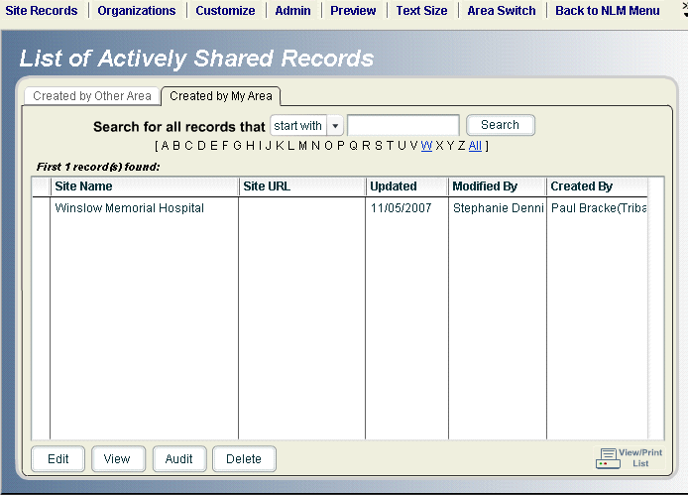

Figure 3‑66: Shared Records Created by My Area

This window has the following buttons available:

* Edit
* View
* Audit
* Delete

The Edit, Views, and Audit buttons work as they do elsewhere in the system.

**Delete:** If youdelete a record that you previously made shareable, you will be deleting that record from all the areas. This power is only available to the area that created the shared record.

## Identifying Similar and Duplicate Records

Similar records have the same site name and city name. Duplicate records must exactly match three fields: the site name, address1, and URL fields.

The List Similar Records module helps you identify, modify, or delete similar records.

### Find Similar Records when creating a New Record

To identify similar records when creating a new record:

* Enter the site name and physical address information
* Click on the Similar Check button found below the address fields
* If there is a match on the Site Name and City fields, the system will report similar record(s) found.

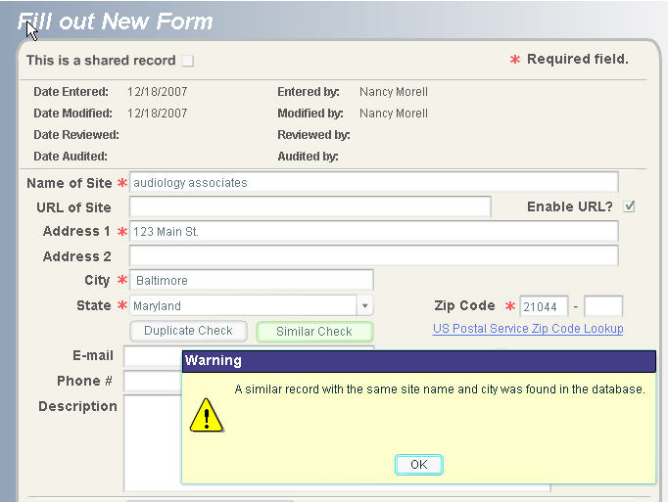

Figure 3‑67: Similar Records Check Warning Message

To view the list of similar records, from the menu choose Site Records > List Similar Records.

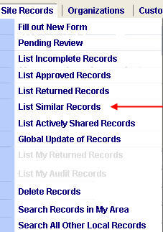

Figure 3‑68: Similar Records Menu Bar

* On the List Similar Records search screen, enter the search criteria for the site name or leave blank to see all similar records.
* Click the Search button to retrieve all records with similar site names.
* Select a similar record to Edit, View, or Delete. Note: only site administrators or reviewers can delete a similar record.

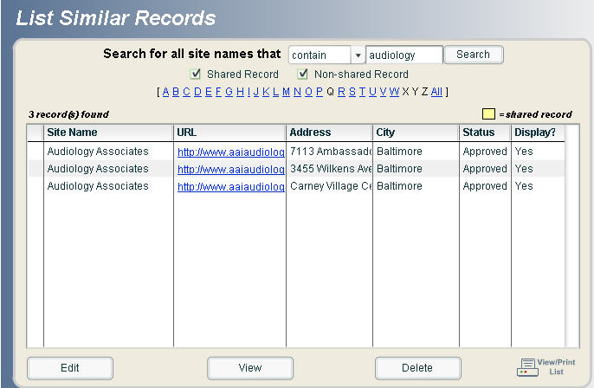

Figure 3‑69: Similar Records Found

### Find Duplicate Records when creating a New Record

 To identify duplicate records when creating a new record:

* Enter the site name, physical address information and URL (if available)
* Click on the Duplicate Check button found below the address fields
* If there is a match on the Site Name, Address 1, and URL field, (including fields that are blank) the system reports duplicate record(s) found.

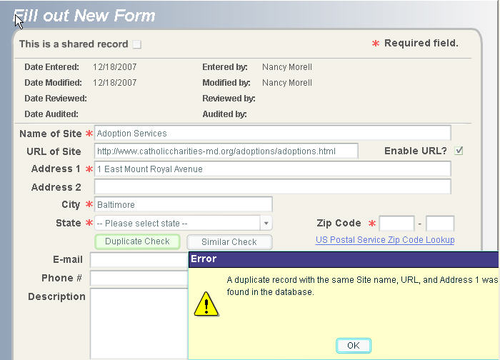

Figure 3‑70: Duplicate Record Error Message

You cannot save a duplicate record. The combination of site name, address 1, and URL must be unique in the system. Edit the information for the record to be unique, or cancel the record that is being created if it is a duplicate.

### Duplicate records not identified as duplicates

True duplicate records may exist in your database due to spelling or abbreviation differences in the name, address1 or URL field combination. The examples below would not be recognized as duplicate records, because of the difference in the street address (W. vs. West):

The Community Clinic

123 West Main St.

Anywhere, WV 25402

The Community Clinic

123 W. Main St.

Anywhere, WV 25402

## Incomplete Records

The incomplete record option allows you to save a record that is missing one or more required fields. This record cannot duplicate an existing record; the combination of Site Name, Address 1, and URL fields must be unique.

To save a record as incomplete, click on the “Save as Incomplete” button at the bottom of the Fill out New Form data entry screen.

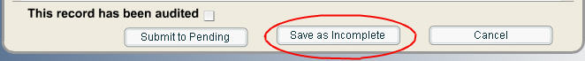

Figure 3‑71: Save as Incomplete button

To view a list of incomplete records, choose Site Records from the Main Menu, and then select List Incomplete Records.

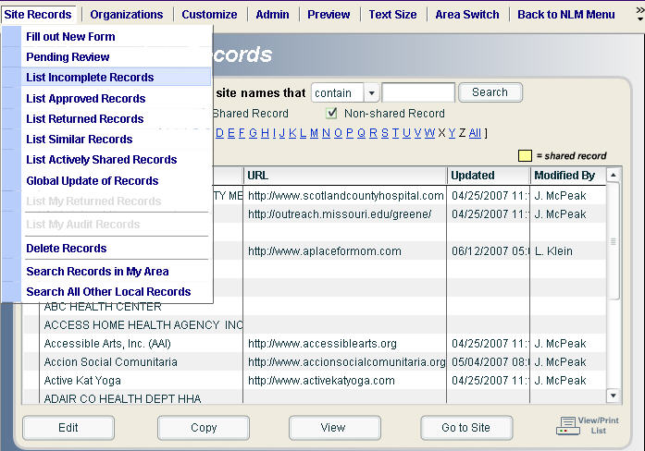

Figure 3‑72: List Incomplete Records

Note: Incomplete records will never appear in the pending queue.

## Pending Records

Local site administrators, reviewers, and selectors can all see the records in the pending queue.

Note: For optimum system performance, do not have more than 4,000 records in the pending queue.

From the menu choose Site Records > Pending Review.

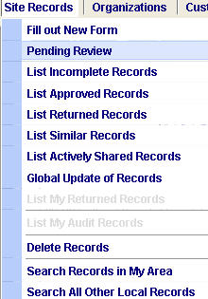

Figure 3‑73: Pending Review Menu Option

Only local site administrators and reviewers see the check boxes to approve or return records.

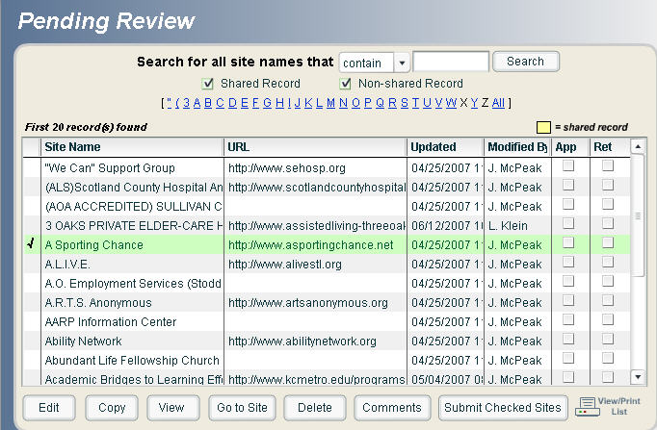

Figure 3‑74: Records Pending Review

A reviewer can add comments to the record indicating why the record is pending and the progress of the record status.

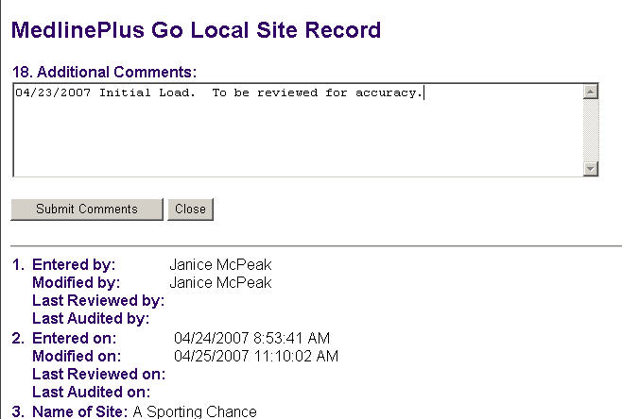

Figure 3‑75: Pending Record Comments Field

The reviewer must confirm whether the comments are correct to complete the process.

When the record comments are confirmed, the user is automatically returned to the pending records screen.

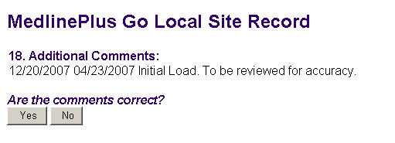

Figure 3‑76: Pending Record Comments Confirmation

The reviewer has the discretion of approving records for submission into the site or returning pending records for further review and edit. To approve or return records, mark a check in the appropriate column for each record. Then, click the “Submit Checked Sites” button.

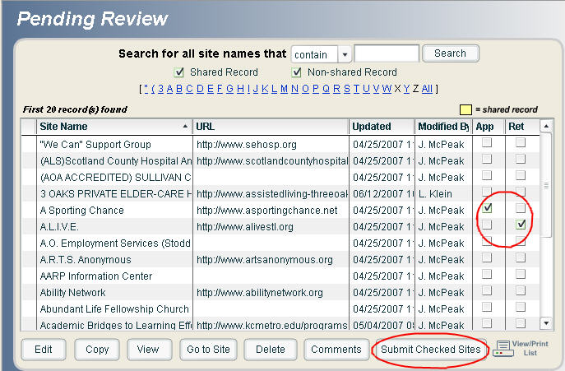

Figure 3‑77: Submit Checked Sites

After records are submitted, the confirmation message with options to continue will appear. Choose “yes” to continue; choose “no” to end the process and return to the Pending Review list of records.

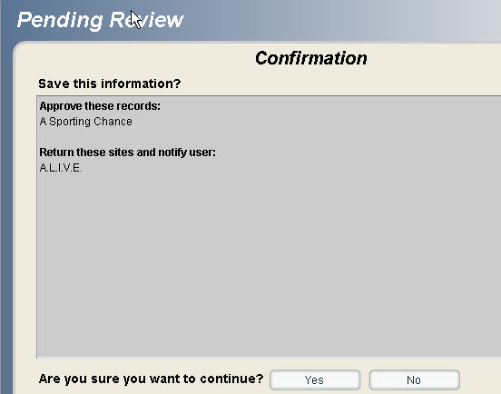

Figure 3‑78: Confirmation for Submitted Checked Sites

When a record is returned, the person who last modified the record will be notified upon login

### Pending Live

The pending queue is different for publicly-available Go Local sites and Go Local sites under development. If your site is under development, when you choose Site Records > Pending Review, you will see a list of your pending records.

Once your site is "live," when you choose Site Records > Pending Review you will see a screen with two tabs: Pending Live and Pending.

* If you edit a publicly displayed record it goes to a "Pending Live" queue.
* If you do not approve a record in the "Pending Live" queue by 2 AM Eastern Time the following day, the record will no longer display on your public pages.
* If there are records in the "Pending Live" queue, the Pending Live tab will display when you click Pending Review.
* If there are no records in "Pending Live," the Pending tab will display when you click Pending Review.

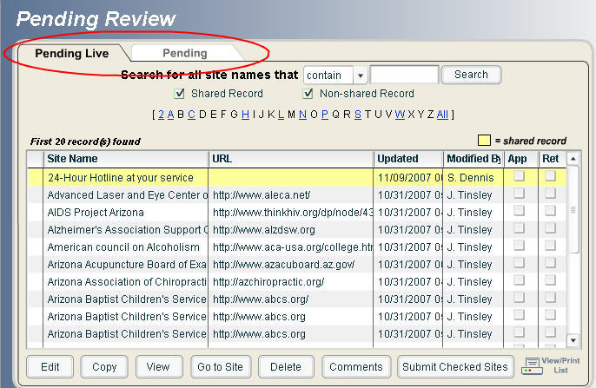

Figure 3‑79: Pending Live and Pending Tabs

## Search Records: in My Area or in All Other Local Records

The Go Local input system allows you to search for records in your local area and also search for records in all of the other NLM-hosted Go Local sites.

From the menu choose Site Records > Search Records in My Area or Search All Other Local Records.

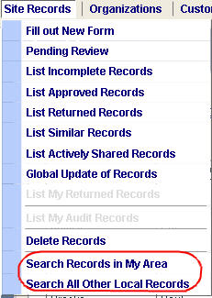

Figure 3‑80: Search Records Menu

Both the Search Records in My Area and Search Records in All Other Local Records screens are divided into 2 tabs:

* Search Criteria tab - which includes the fields available for searching
* Results tab - which displays the list of results based on your search criteria

The search screens for Search Records in My Area and Search Records in All Other Local Records are the same with the exception of an additional search field of “Designated Area” in the Search Records in All Other Local Records and the ability to search for records with an “incomplete” approval status in the Search Records in My Area. This “incomplete” status is not an available search factor for All Other Local Records.

### Search Records in My Area

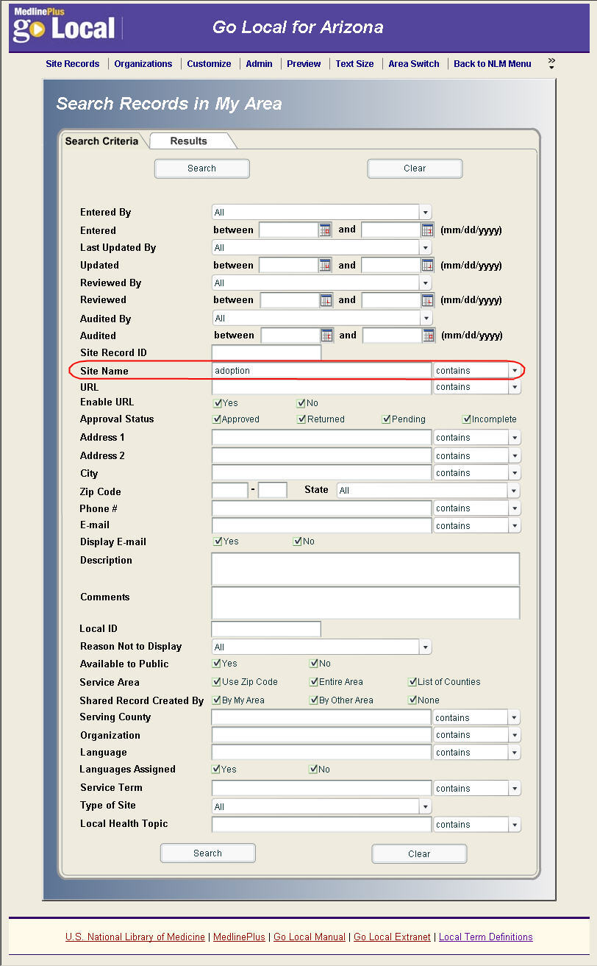

Figure 3‑81: Search Records in My Area Search Screen

* Enter your search criteria and click the Search button located at the bottom of the screen.

From the Results screen in the Search Records in My Area, you can:

* Edit a record
* Copy a record
* Audit a record
* View a record
* Go to the site and open the Web site in a new window
* Export the list of records to an Excel file. The exported file will include the local service terms and local health topics associated with each site record, so you will be able to sort records to get a preview of how your pages will look.
* Delete a record
* View or print the list. This is useful for long lists of results.

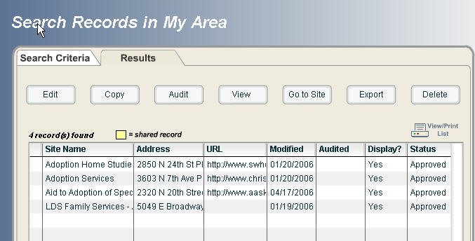

Figure 3‑82: Search Results for Search Records in My Area

### Editing a record from the search results:

The edit screen opens in a new window. This preserves the search results list so you will not have to reenter the search criteria and re-run the search after editing each record.  The downside to this is that the results are not refreshed. Therefore, if a record that was just edited no longer falls within the search criteria, it will still display in the results.

### Search All Other Local Records

From the Search All Other Local Records results screen, you can:

* Copy a record
* Share a record
* View a record
* Go to the Web site (opens in a new window)
* Export the list of records to an Excel file.
* View or print the list. This is useful for long lists of results.

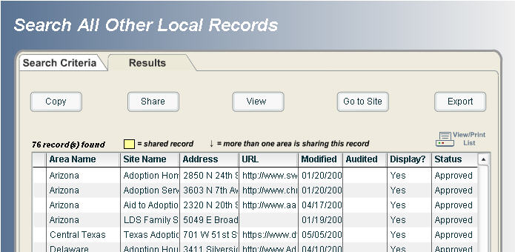

Figure 3‑83: Search Results for Search All Other Local Records

IMPORTANT: When you're on the results tab, don't use the browser back button or your search strategy will be lost.

You cannot search for records by county or region, because these are generated from the mapping program in the database.

## Auditing Module

The Audit Module allows Local Administrators to assign records to be audited. Specific functions include:

* the ability to set an audit profile for each local area
* the ability to assign specific records to be audited

### Set Audit Profile

From the menu choose Admin > Audit > Set Audit Profile



Figure 3‑84: Set Audit Profile Menu

All Local Administrators will have the ability to set the site record review interval. The default is set at 6 months, to change time interval enter a numeric value in the text box (limit 2 digits).

**Note:** We recommend you audit records at least every twelve months. If you would like to increase the timeframe, we recommend you change it to 12 months.

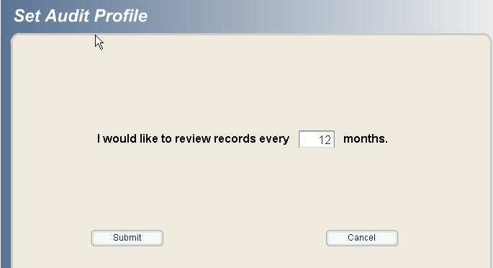

Figure 3‑85: Set Audit Profile Review Interval

The Local Administrators will be notified of the number of records due for review and the number of records assigned at login if the Display Audit Message option is selected (set to display as the default).

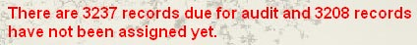

Figure 3‑86: Audit message at login

The Local Administrators can hide this message if the Hide Audit Message option is selected.

From the menu choose Admin > Audit > Hide Audit Message.



Figure 3‑87: Hide Audit Message Menu

### Assign Audit Records

The Assign Audit Records module allows the Local Administrator to assign audit records to system users with audit privileges (All Local Administrators and Reviewers by default, and Selectors with permission).

From the menu, choose Admin > Audit > Assign Audit Records.



Figure 3‑88: Assign Audit Records Menu

The Assign Audit Records module is very similar to the current Search Records module. It contains the same search criteria with the addition of the Audit Assigned criteria. The search form is flexible enough for Local Administrators from each area to decide their own audit criteria.

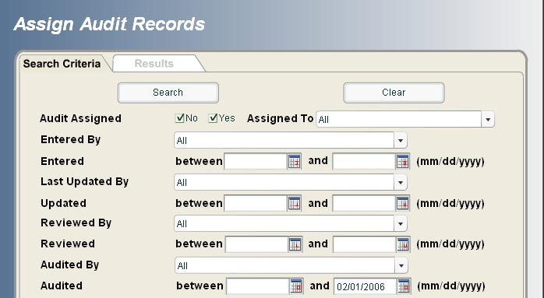

Figure 3‑89: Assign Audit Records Search Form

As the default, the Audited date will be set as the current date minus the audit interval.



Figure 3‑90: Assign Audit Records Search - Audited Date Fields

For example, if today's date is 6/09/06 and the audit interval is 6 months, the last Audited date will be set at 12/09/2005. The search results will contain all records that were last audited on or before 12/09/2005. System users will be able to change the default date.

From the search result tab Local Administrators will be able to assign record(s) to system users that have audit privileges. To select multiple records hold the Ctrl key down; to select a range of records hold the shift key down then select the first and last records in the range. **Note: You cannot assign more than 1000 records at once.**

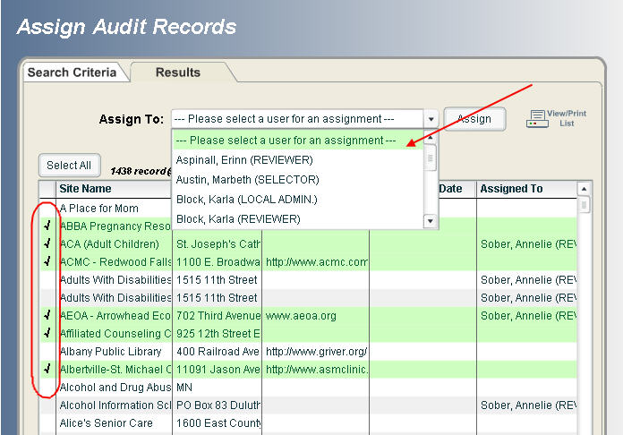

Figure 3‑91: Assign Audit Records – select and assign to auditor

Once the record(s) is assigned to the system user, the following message will be displayed on his/her login screen as a reminder.



Figure 3‑92: Records to be audited message

This message links to the List My Audit Records module.

### List My Audit Records

The module List My Audit Records allows users to perform their audit review. Choose Site Records>List My Audit Records from the menu.

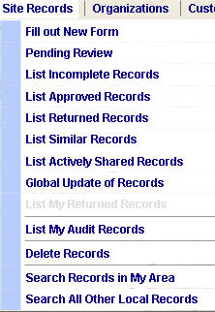

Figure 3‑93: List My Audit Records Menu

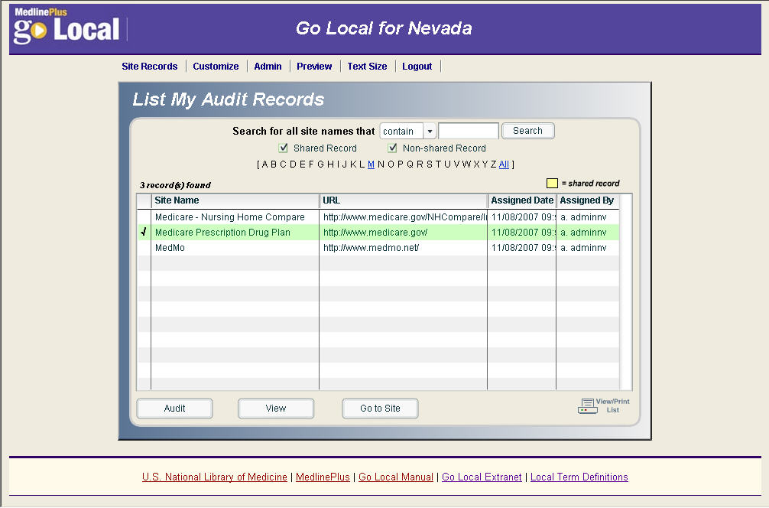

Figure 3‑94: List My Audit Records Option Screen

Select a record by single-clicking on the record. A check will appear next to the record you wish to modify or view.

* Audit – allows the auditor to view, submit and/or edit the audit record.
  + All data fields are "view only" except the Comments field.
  + If the user has the need to edit this record, they can click on the "Edit Audit Record" button. This will bring the user to the regular site record edit form. After the record editing and submission, the user will be brought back to this audit form.
  + When the record audit is done, the user can click on the "Submit Audit Record" button. This action will update the audit time stamp.
* View – allows the auditor to display and print the record.
* Go to Site - opens the Web site in a new window and allows the auditor to review the Web site and the record simultaneously.

### Updating the Audit Date from Edit

The “This record has been audited” checkbox will be added to the bottom of the edit screen (default=uncheck). When the box is checked and the edited record is submitted or saved as incomplete the audit date timestamp will update.

Note: Only system users with audit privileges will see the audit checkbox in edit.

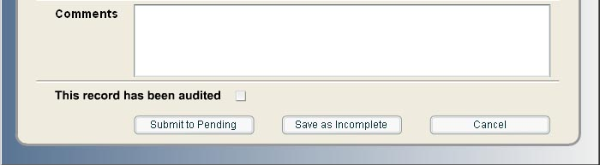

Figure 3‑95: Audit Checkbox

**Note:** For sites that have not yet released, you can audit records as you verify and complete them or as you approve them. You do not need to wait for the release to begin the auditing process.

# Customization Module *(Updated September 18, 2008)*

The Customization Module allows you to modify the site's header, footer links, colors, upload images, create the "About Us" page, provide contact information, and create a featured site for the homepage. These functions allow you to personalize your site. Any permission level may customize (Site Administrator, Reviewer, or Selector) before a site is released. However, after release, changes can be made at any level but can only be promoted to the public pages by the Site Administrator. All customization modules must be completed before release.

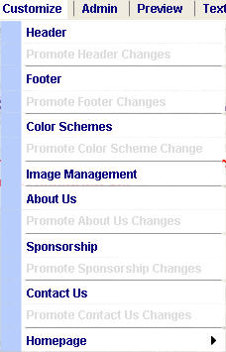

Figure 4‑1: Customize Menu

## Header

From the menu choose Customize > Header.

* **Title** - Header Title Line is a required field with a character limit of 50
* **Tagline** - Header Tag Line is a required field with a character limit of 70.
* **Logo**
  + **Default Logo** - is an outline image of your state provided by NLM.  Partial state coverage can by modified to reflect a specific area. Please contact NLM prior to releasing a partial coverage site.
  + **Customized Logo** - You may upload an image to use as a logo for your site.  The maximum size is 111 pixels width by 95 pixels height.  If the background of your image is transparent the header color will display as the background.
  + **Logo Alt Text** - **(required field)** The default alt text is [area name] logo. You can edit this.

To view changes, select the *Preview* button at the bottom of the page.  Select the *Submit* button to apply all changes.

### Complete Banner

The system allows you to upload a banner that will be displayed in the header of your Go Local site.  Please contact NLM prior to promoting your banner to the Web.

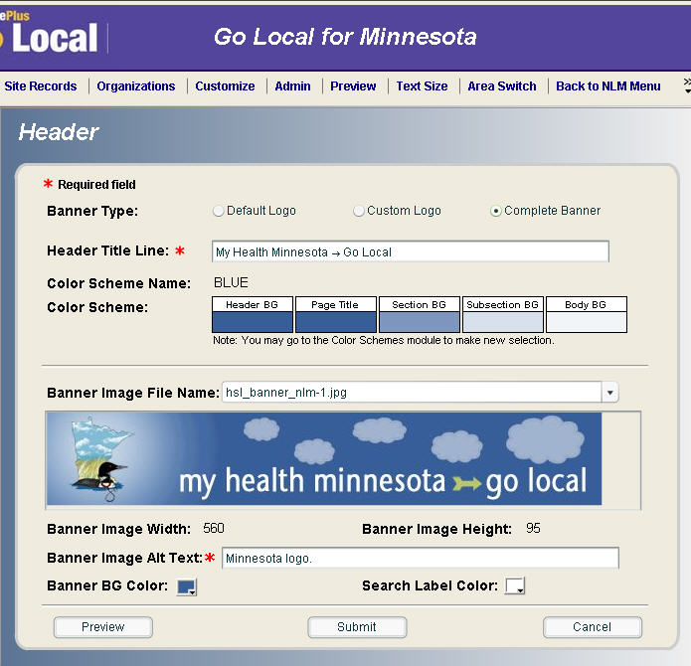

Figure 4‑2: Header Screen

 Banner specifications include:

* Banner size 560 x 95 pixels, background color must match a selection from the background color palette.
* Banner should contain logo located on left, site name, and site tagline.  Alt tag should contain site name: tagline
* Banner colors should compliment one of the 5 choices from the page color palette.

Please note that the banner will be a fixed length of 560 pixels. Depending on the size of the monitor, it will not extend the full length of the header. Therefore, you may want to pick a design that has a solid colored background. Avoid intricate designs with a multicolored background. You can match the header (using the Banner BG Color Box as detailed below) to the background color so it appears that the banner extends the full length of the header.

### Changing the Search Label Color or Banner Background Color

There are several ways to change the search label color or banner background color.

* Select the color box next to each option then:
* Choose a color from the color palette or
* Enter in the hex code in the upper left corner of the color selection box

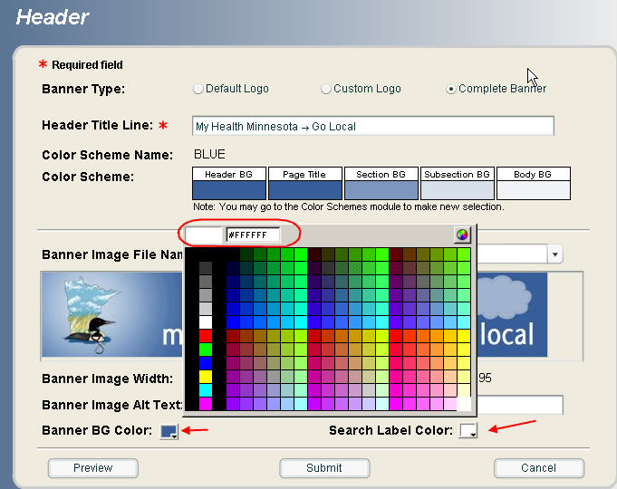

Figure 4‑3: Changing Search Label or Banner colors

Or, select the color wheel in the upper right corner of the color palette then choose a color by clicking on the palette or enter the RGB color into appropriate box. The system will convert the RGB code into the correct hex code.

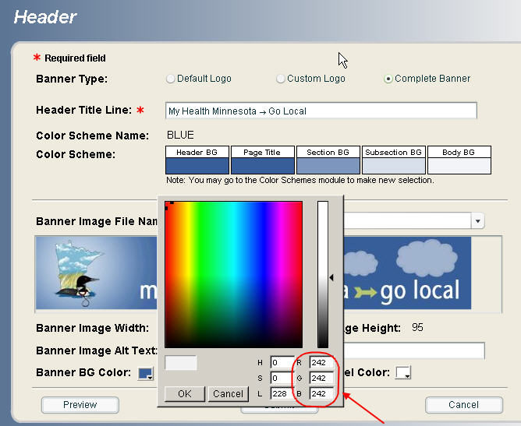

Figure 4‑4: Header Color options using RGB

Note: The Search color should contrast with the background color and be clearly visible to low vision users.  The Go button for Search is yellow; therefore, the background color should not be yellow or gold.

### Upload a banner

* Upload a 560 x 95 image into the Image Module. Access the image module under the main menu > Customize > Image Management
* From the main menu, select Customize > Header select Complete Banner. Then, select the image you want from the Banner Image File Name pull-down menu
* Change background color by selecting Banner BG Color box.

## Footer

From the menu choose Customize > Footer.

* The Footer links appear at the bottom of each page. The Footer module allows you to provide links to the institutions affiliated with your Go Local site.  The system will automatically generate the appropriate NLM footers, including copyright, privacy, and accessibility.
* Only one footer link is required.  Up to four personalized footer links can be displayed.  The 'Linked Text' is the text that is displayed in the footer, such as the name of your institution.  The Linked URL is the url of your institution. The url must contain http:// and a domain extension, for example ".edu"
* To view changes, select the *Preview* button at the bottom of the page.  Select the *Submit* button to apply all changes

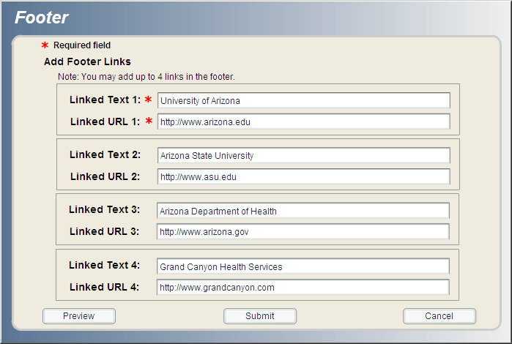

Figure 4‑5: Footer screen

## Color Scheme

Choose Customize > Color Schemes from the menu.

* The 'Color Scheme' module controls the color of the header background, the page title, the section background, and the subsection background. There are currently five color scheme choices.
  + The default color scheme for the Go Local pages is purple. You can change color schemes by clicking the narrow column to the left of the color scheme name. A checkmark appears next to your selection. When you choose *Select the Submit Color Scheme Selection*, you will see a confirmation screen displaying all the colors of the selected color scheme. Click *Yes* to continue and apply changes or *No* to revert back to the color scheme selection screen.

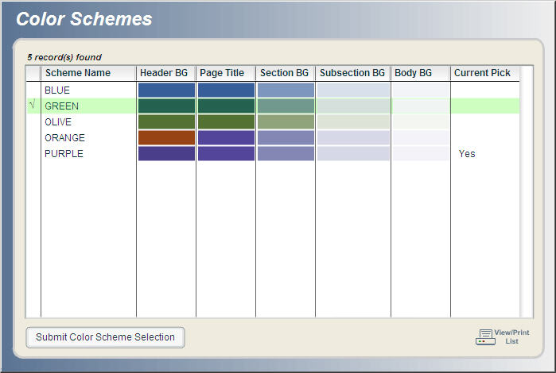

Figure 4‑6: Color Schemes Selection Window

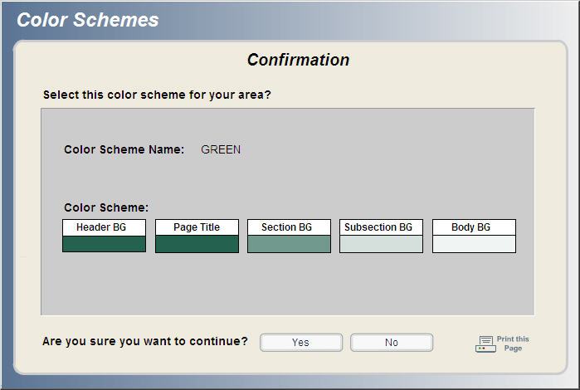

Figure 4‑7: Color Scheme Confirmation

### Hexadecimal Color Codes

Each of the colors listed in the five color schemes is represented by a hexadecimal code. The hexadecimal code may be useful when creating marketing materials in support of your Go Local site.

Table 4: Color Scheme Hexadecimal Codes

| **Color** | **Hexadecimal Color Codes** |
| --- | --- |
| Blue | Header #355f99  Page Title #355f99  Section #7c97bd  Subsection #d7e0eb  Body #f2f4f8 |
| Green | Header #22634f  Page Title #22634f  Section #709a8d  Subsection #d4e0dc  Body #f0f5f3 |
| Olive | Header #527233  Page Title #527233  Section #8fa47b  Subsection #dde4d7  Body #f3f6f1 |
| Orange | Header #9b4215  Page Title #53459a  Section #8387b4  Subsection #d7d8e7  Body #f3f3f8 |
| Purple | Header #4a3e8a  Page Title #53459a  Section #8387b4  Subsection #d7d8e7  Body #f3f3f8 |

## Image Management

Choose Customize > Image Management from the menu.

The 'Image Management' module allows you to upload and store images for the header logo, featured sites, and the "About Us" page. Image types are limited to .gif or .jpg

* Click the *Upload New Image File to Server* button and browse to where the image is stored on your PC. Then click the *Upload Image File* button. A confirmation page will display the image file name, size and the image. Select the *Yes* button for the image to upload or *No* to cancel.
* The uploaded images appear on your list of available images on the Image Management window.

Note: There is no size limitation when uploading images. However, there are size limits for the header logo and the featured site image. You can also display images on the "About Us" page; there is no size limitation for this page.

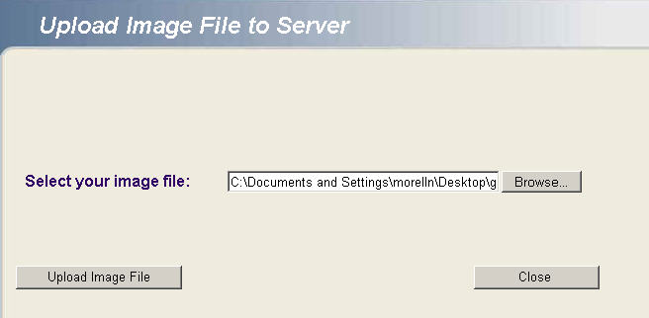

Figure 4‑8: Upload image file to server screen

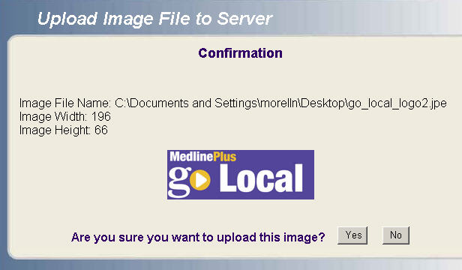

Figure 4‑9: Upload Image Confirmation

* The 'Image Management' module contains a search box to help locate images that you have uploaded.
* You can limit your search alphabetically or by the pull-down menu filter choices *start with* or *contain*.
* A selected image can be viewed (to see a larger scale picture) or deleted from the list.

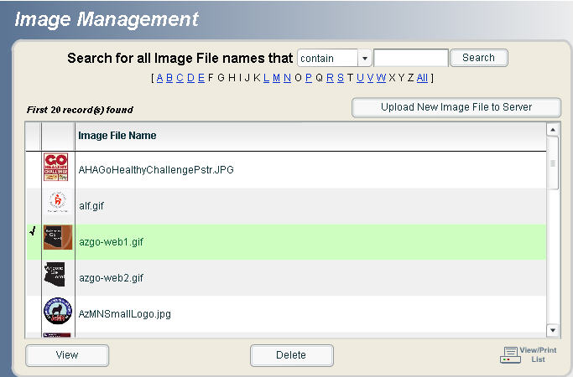

Figure 4‑10: Image Management Window

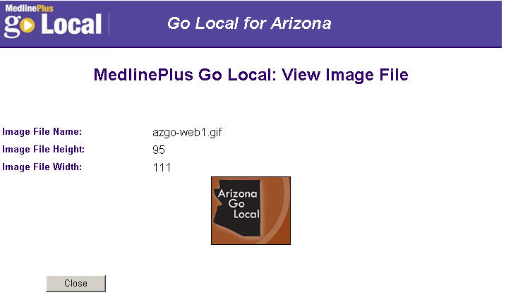

Figure 4‑11: View Image

## About Us

Choose Customize > About Us from the menu.

You have complete control of the content of this page. It can contain text, links, images (see Image Module), and bulleted items. The requirement for this is that you enter the correct HTML tags. For example:

Example of paragraph HTML tags:  
<p>Welcome to MedlinePlus, a goldmine of good health information from the world's largest medical library, the National Library of Medicine. Health professionals and consumers alike can depend on it for information that is authoritative and up to date. MedlinePlus has extensive information from the National Institutes of Health and other trusted sources on over 700 diseases and conditions.</p>

Example for bulleted list HTML tags:  
<ul>  
<li>Did you find what you were looking for?</li>  
<li>Do you have a suggestion for improving MedlinePlus?</li>  
<li>Did MedlinePlus help you find an answer to your health question?</li>  
</ul>

Example for HTML link tag:  
<a href="http://www.nlm.nih.gov/medlineplus/news/fullstory_22341.html">Full Story</a>

Example for HTML image not in the input system:  
<img src="http://www.nlm.nih.gov/medlineplus/images/news1.gif" title="Current Health News" alt="Current Health News" border="0" width="205" height="25">

Example of HTML image tag for images uploaded into the input system:  
<img src= "dablgson2.jpg" alt="Color photo of Dr. Donald A.B. Lindberg and grandson at computer" align="left" border= "0" width= "160" height= "146">

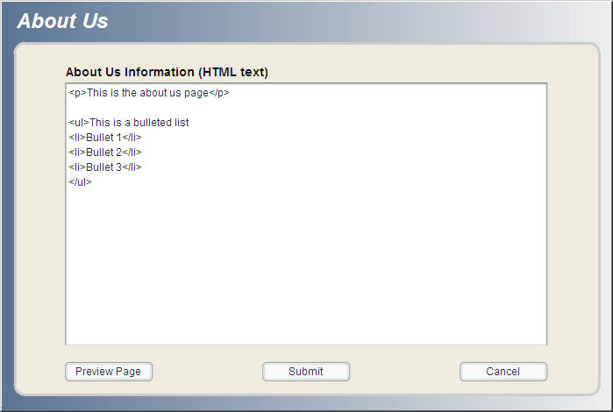

Figure 4‑12: About Us Window

## Sponsorship Page

Participants can create a separate page to acknowledge sponsoring agencies. This page display will be optional.

Manage the Sponsorship page by choosing Customize > Sponsorship from the menu.

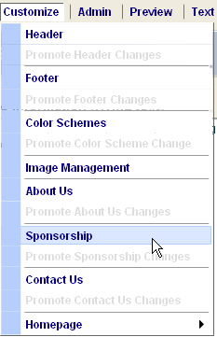

Figure 4‑13: Sponsorship Menu Option

This page can contain text, links, and images. Refer to the Image Module section of the Go Local manual for additional details about uploading images. You need to use correct HTML tags to control the behavior of the page.   
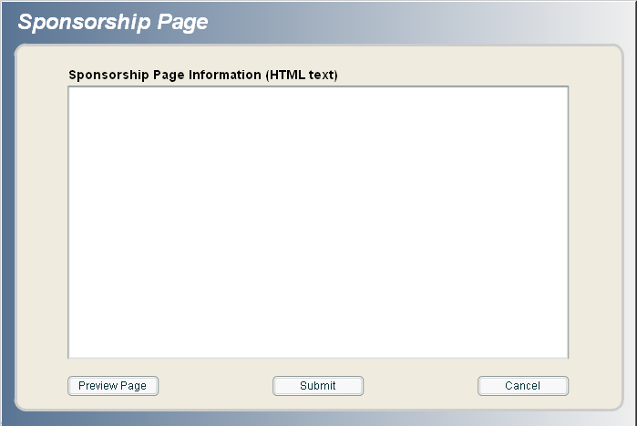

Figure 4‑14: Sponsorship Page Information

* Enter your text, including HTML tags, in the box.
* Check how it will look by selecting the “Preview Page” button.
* Use the “Submit” box to save the changes.

Examples of HTML tags include:

* HTML link tag:

<a href="http://www.medlineplus.gov">MedlinePlus</a>

* HTML tag for images uploaded into the input system:

<img src= "meals.gif" alt="Meals on Wheels Logo">

* HTML tag for an image not in the input system:

<img src="http://www.nlm.nih.gov/medlineplus/images/news1.gif" title="Current Health News" alt="Current Health News">The bottom of the page will automatically include the following text:

[Site name] may partner or receive sponsorship funding from the organizations listed on this page. [Site name] and the National Library of Medicine do not endorse these organizations and their products or services. Sponsors do not play a role in selecting or editing [Site name] information.

* After making and submitting the changes, Local Administrators of live sites will need to promote the page.
* Do this by going to Customize > Promote Sponsorship Changes.
* Once the page has been promoted, a sponsorship link will automatically display at the bottom of your Go Local public pages.

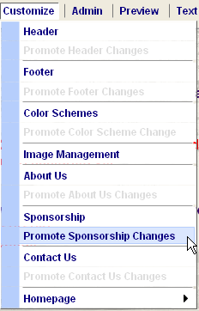

Figure 4‑15: Promote Sponsorship Changes Menu Item



Figure 4‑16: Sponsorship Link

To delete a sponsorship page that you have already created, simply delete the text from the sponsorship box. The Local Administrators of live sites will again have to promote the change. The system will recognize that there is no information to display. The link appearing at the bottom of the pages will disappear.

**Note:** Go Local’s link checker will not be checking links on this page. Sites with a sponsorship page should periodically check the links.

## Contact Us

The Contact Us page provides a mechanism for users to contact you regarding your site. The system will generate a standard form that will e-mail messages to the email address you specify. There are also options for displaying institutional addresses, virtual reference, and additional comments that will be displayed on the public Contact Us page. Selectors, reviewers, and local administrators can make changes to the Contact Us page. But, Local Administrators must promote the changes for them to display on the public page.

Select Customize > Contact Us from the menu bar to create or edit the Contact Us page information.

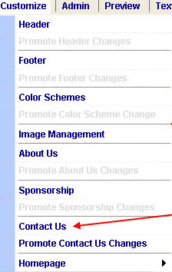

Figure 4‑17: Contact Us Menu Option

The Contact Us module includes the following fields:

* **Split e-mail address** – “No” by default.
* **E-mail address** - **(Required field)** This is the e-mail address to which the contact us form contents will be sent.
* **Display Message** - This area is for any text you want to display at the top of your form.
* **Disclaimer** - This area is for any text you want to display at the bottom of your form.
* **Additional Contact Us Information** - You can display addresses for up to three institutions. The institutions will appear on the right side of the screen in order of the numeric tab.
* **Comments for Display** - comments added into this field will be displayed on the Public Contact Us page. This is text only, no HTML tagging is acceptable. If you want to create a link, please use the Virtual Reference fields
* **Virtual Reference Link** - This field is provided for institutions that offer virtual reference, or would like to provide access to some other link. The Linked Text field will display under the Additional Contact Us addresses. The Virtual Reference URL url must contain http:// and domain extension, for example .edu

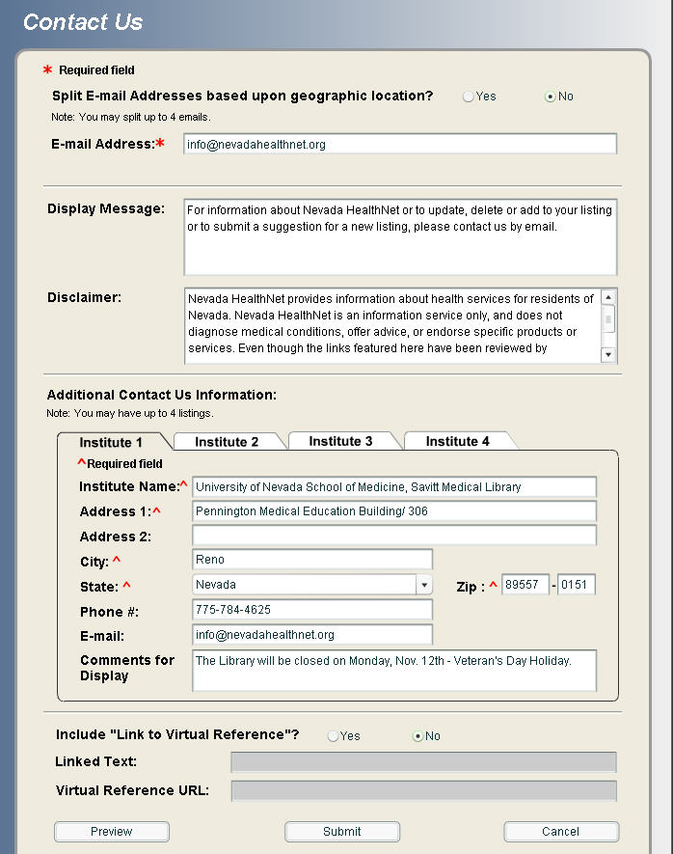

Figure 4‑18: Contact Us Data Entry Screen

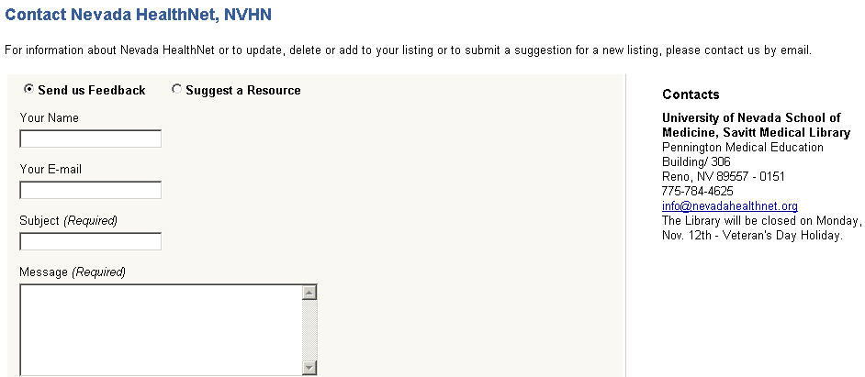

Figure 4‑19: Contact Us Public Display

#### Split e-mail address

This feature allows you to have more than one e-mail address receive user messages via the "Contact Us" form. The e-mail that receives the message is based on county or region chosen by the sender. If the sender does not select a county or region, the system uses the default e-mail address.

* You can assign e-mail address by county (or region depending how your local area is assigned). After selecting the '*Yes*' button, the system will prompt you to add up to three e-mail addresses. Only one of the entered e-mail addresses can be the default.

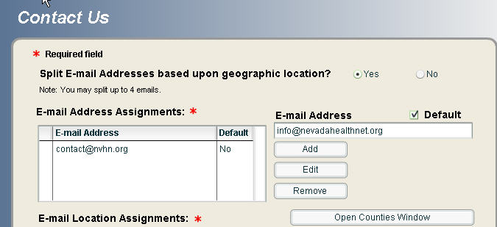

Figure 4‑20: Default Split e-mail Address

* To assign e-mail addresses by county or region, choose an e-mail address from your list.
* Then click on the *Open Counties* (or Regions) button. You will see your area and a list of counties.
* Click on the county, a checkmark will appear next to the county name.
* Click on *Apply* to add that county to the e-mail address you are editing. To choose more than one area hold the control (Ctrl) key down as you make your selections.
* Select the *Apply* button, an * will appear next to the counties/regions that are assigned e-mail addresses.
* Select another e-mail address from the pulldown and repeat assignment process. The system will not allow you to proceed from this module until all of the counties/regions are assigned.

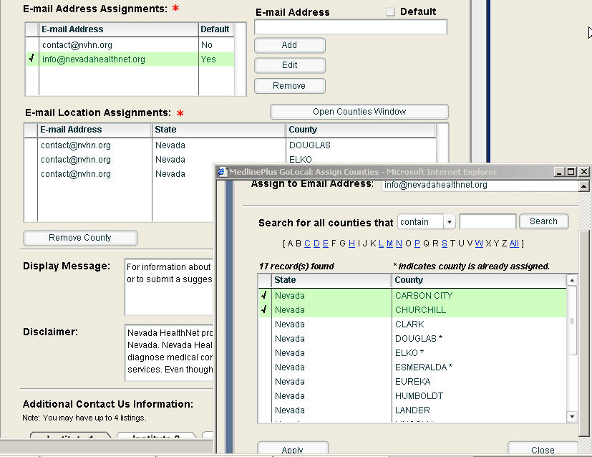

Figure 4‑21: Assigned Counties for Contact Us Split e-mail

### Feedback and Suggest a Resource public pages

There are two forms that the public can use to contact individual Go Local sites: Send us Feedback and Suggest a Resource.

Send us Feedback – used to receive general comments. The subject and message are required fields.

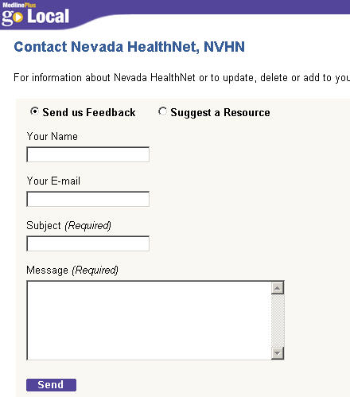

Figure 4‑22: Send us Feedback online form

Suggest a Resource - data fields prompt users for specific contact information about potential resources to be listed in Go Local. The Resource name is required.

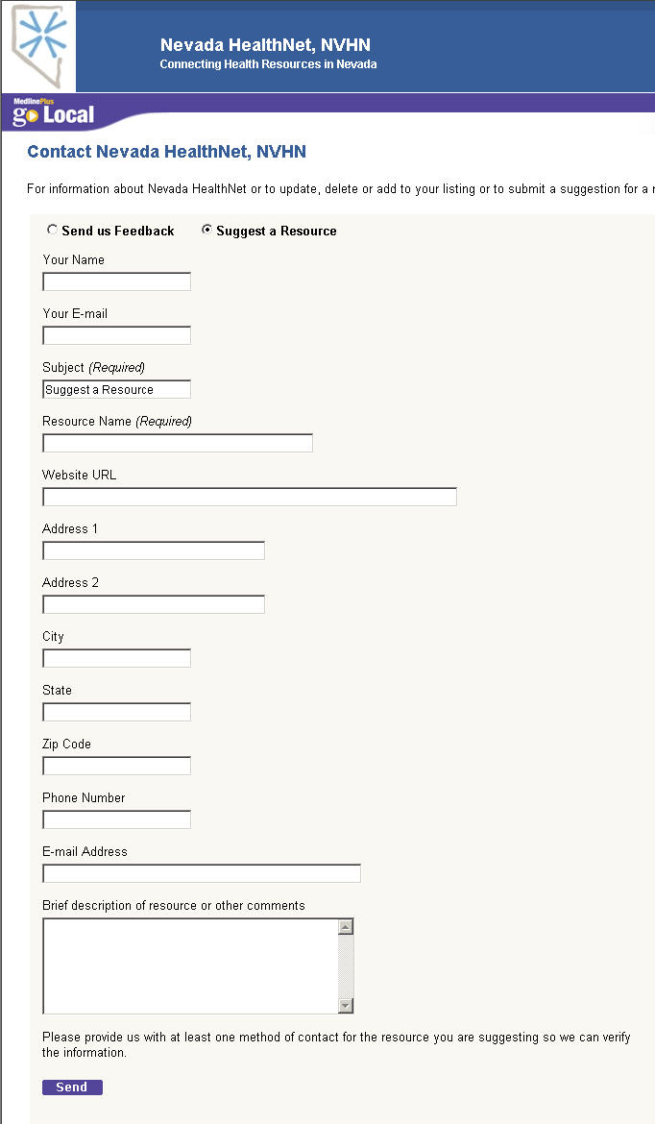

Figure 4‑23: Suggest a Resource online form

Note: If the sender opts to not include his or her email address, the default email address in the note you receive is [nlmmedpladm@mail.nih.gov](mailto:nlmmedpladm@mail.nih.gov). It may look like NLM has sent in this suggestion, but it is actually from an anonymous user.

## Home Page

### Add Announcement Link

This module allows local administrators to select the announcement links to be displayed on the homepage. The announcement links include a link to a Google Events Calendar and a Miscellaneous Link of each site’s choosing. The Miscellaneous announcement link will appear below the current Featured Site section. The Google Events Calendar will appear on the left side of the page listed below the Services and Health Information links.

Choose Customize > Homepage > Add Announcement Link from the menu.

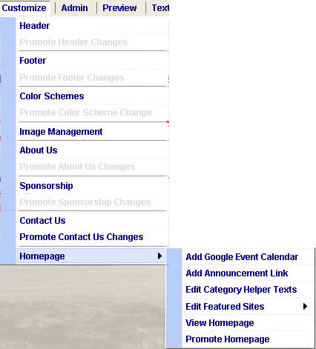

Figure 4‑24: Add Announcement Link menu

The Add Announcement Link input screen allows the local administrator to select one or both links for submission to the homepage. By default, both items are unchecked.

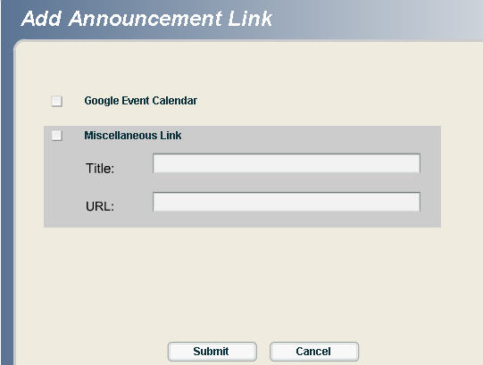

Figure 4‑25: Default Add Announcement Link input screen

When the “Google Event Calendar” link is checked and submitted, the system checks the Google API to make sure that the calendar exists. If no calendar exists, an error message will display. In order for the Google Event Calendar to be functional, the calendar must first be created in Google and then added to the Go Local system via the Add Google Event Calendar menu option.

### Google Events Calendar

The Google Calendar feature can be used as an events calendar for each individual Go Local project. The Go Local system will link to your Calendar via the Google Calendar ID. There are three steps to creating a Calendar of Events for your Go Local Area.

1. Create a Calendar in Google
2. Link the Calendar ID number under Customize > Homepage > Add Google Event Calendar
3. Turn on the Calendar link on your home page by going to Customize > Homepage > Add Announcement Link

When activated, the Google Events Calendar will appear on the left side of the page listed below the Services and Health Information links.

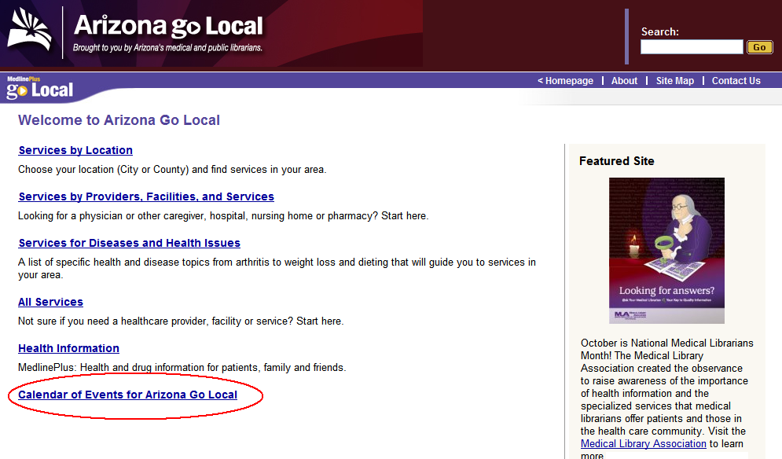

Figure 4‑26: Calendar of Events Link on Homepage

#### Creating the Calendar

Each Go Local area that would like to use this feature must first create a Google Calendar (at http://www.google.com/calendar). Help on preparing a calendar is available from the Google Web site. You can access this via the “Google Event Calendar Help” link available within the input system at Homepage > Add Google Event Calendar.

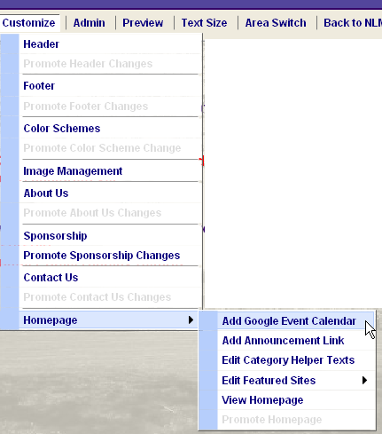

Figure 4‑27: Add Google Event Calendar Menu Item

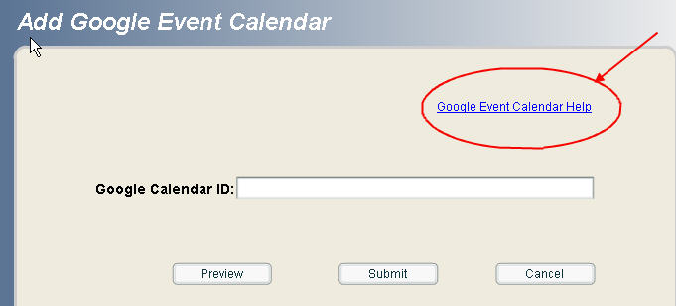

Figure 4‑28: Google Event Calendar Help

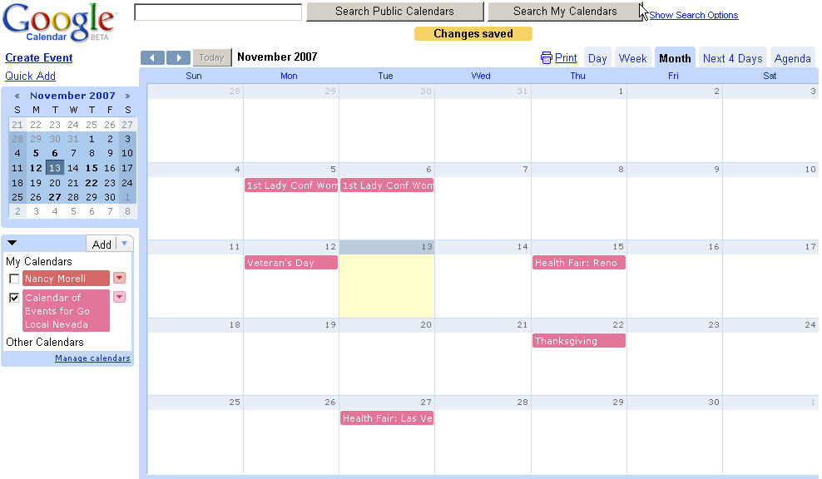

Figure 4‑29: Sample Google Event Calendar

**Note:** Google will automatically name your calendar using your account name. You can change the name of your calendar or create multiple calendars with different names and events.

Within Google Calendars, you must set certain sharing options so that your event calendar can appear on the Go Local homepage:

* Check to select your calendar
* Click “Manage Calendars” to edit the calendar settings

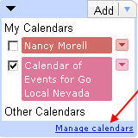

Figure 4‑30: Manage calendars

* Under the Calendars tab, click “Share this calendar” link to modify the share settings for your calendar.

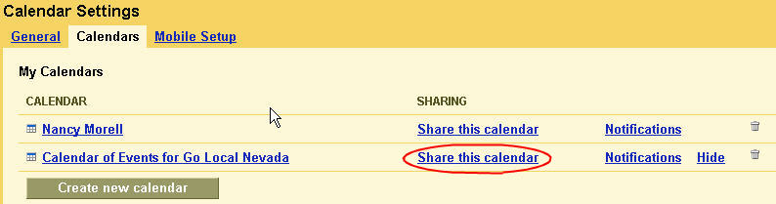

Figure 4‑31: Calendar settings

* Select “Share all information on this calendar with everyone”
* Save the settings

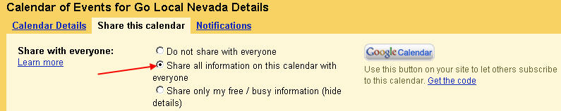

Figure 4‑32: Google Event Calendar share

#### Google Calendar ID

In order for the Go Local system to link to your Google Event Calendar, you will need to copy and paste the Google Calendar ID into the system.

To locate the Google Calendar ID:

* Select Manage calendars



Figure 4‑33: Manage calendars

* Click on the title hypertext link for your calendar

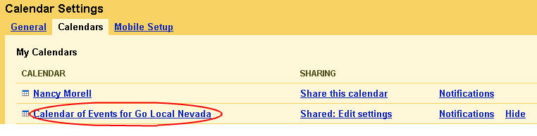

Figure 4‑34: Calendar of Events view settings

* Scroll down to the section containing Calendar Address. If you have multiple calendars, the Calendar ID for the first calendar will likely be your email login and the Calendar ID for additional calendars will be a longer identification code.
* Highlight and copy the Calendar ID. Later you will paste this into the appropriate place in the Go Local Input system (see below).

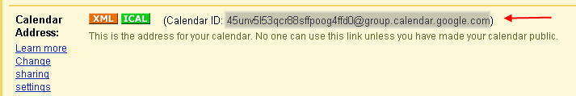

Figure 4‑35: Google Calendar ID

#### Adding the Calendar Link to the Input System

Choose Customize > Homepage > Add Google Events Calendar from the menu.

* Type or paste the Google Calendar ID into the field:

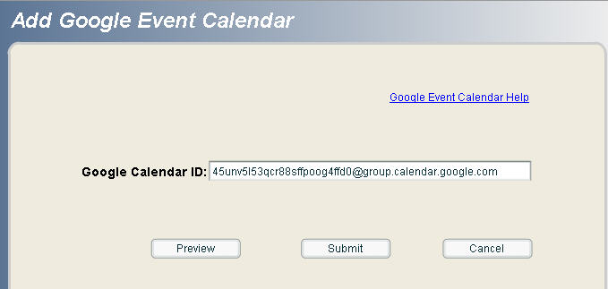

Figure 4‑36: Google Calendar input screen

* Click Preview to preview the site on the public homepage:

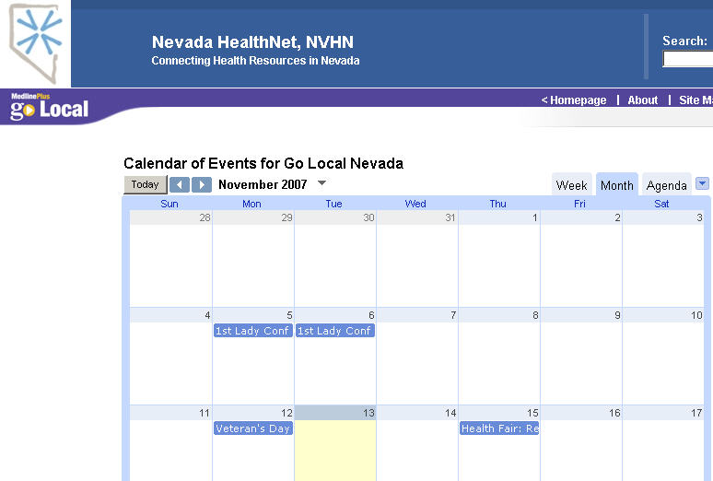

Figure 4‑37: Go Local Event Calendar preview

On the homepage, the calendar will be wrapped with the local area Go Local header and footer. Other default controls include:

* + **Mode** = Month
  + **Month Height** = 5 events per day (set per height of calendar but does not prevent users from entering more than 5 events.)
  + **Title of Event Calendar Link =** “Calendar of Events for <*Area Name>* Go Local”
* Click Submit to submit the Calendar ID into the system
* Click OK for notification message

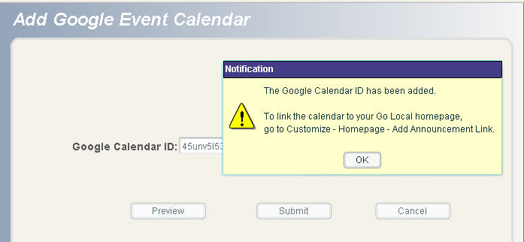

Figure 4‑38: Google Calendar notification

#### Activate the Calendar Link on Your Go Local Homepage

After submitting the Calendar ID into the input system, you also need to activate the link to the Calendar on your area’s Homepage. Choose Customize > Homepage > Add Announcement Link from the menu.

* Check the box to add the Google Event Calendar
* Click Submit (Note: if you choose to submit the calendar but no calendar has been created, you will receive an error message).

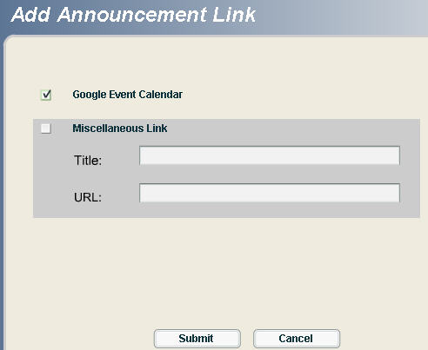

Figure 4‑39: Submit Google Event Calendar

* Click Yes to continue submission
* Click OK for status confirmation

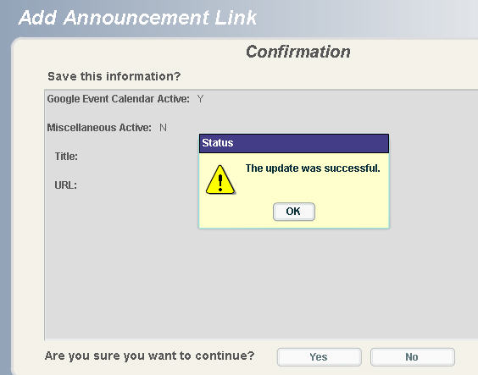

Figure 4‑40: Add Calendar Status Confirmation

The Local Administrators of live sites will need to promote the Homepage in order for the Google Event Calendar link to appear on the public page.

**Note:** You can update or modify your calendar in Google (add new events, etc.) and the calendar visible from your homepage will automatically be updated.

### Miscellaneous Announcement Link

Local Administrators may add an optional link that will appear below the current Featured Site section. Choose Customize > Homepage > Add Announcement from the menu

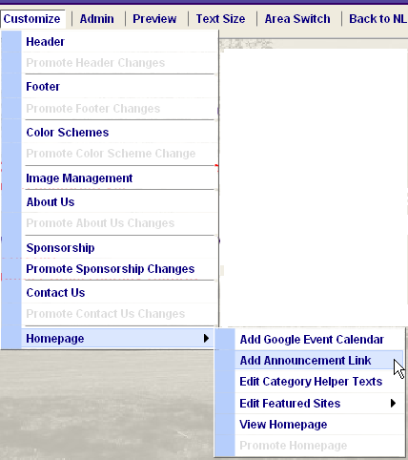

Figure 4‑41: Add Announcement Link Menu

You will see an option for:

* a Miscellaneous Link of the area’s choosing
* a Link to a Google Events Calendar (see above for information on Events Calendar)



Figure 4‑42: Default Add Announcement Link input screen

To add the additional “Miscellaneous Link”:

* Check the Miscellaneous Link box
* Enter the name of the link in the Title box. This is the text that will be visible on the homepage.
* Enter the URL.
* Hit the Submit button.

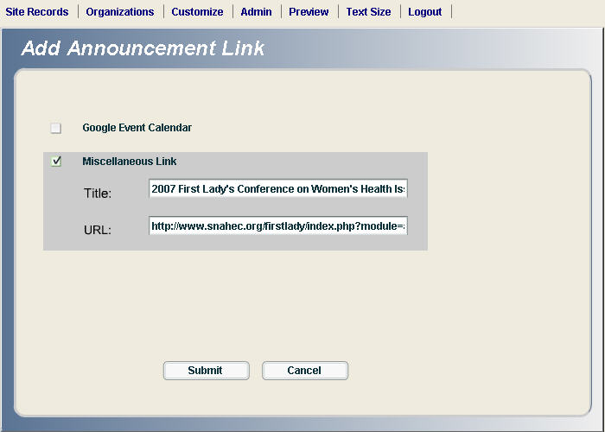

Figure 4‑43: Add Announcement Link completed input screen

* View confirmation page and click “Yes” to continue
* On status screen click “OK” to confirm

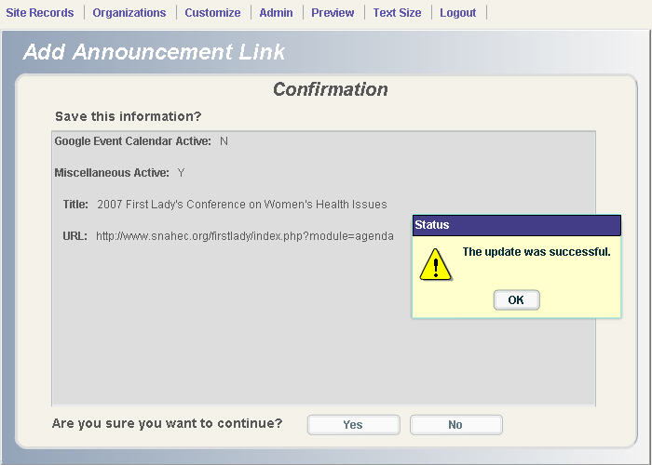

Figure 4‑44: Add Announcement Link Status Confirmation

The Local Administrators of live sites will need to promote the Homepage in order for the Miscellaneous Announcement link to appear on the public page.

Go to Customize > Homepage > Promote homepage.

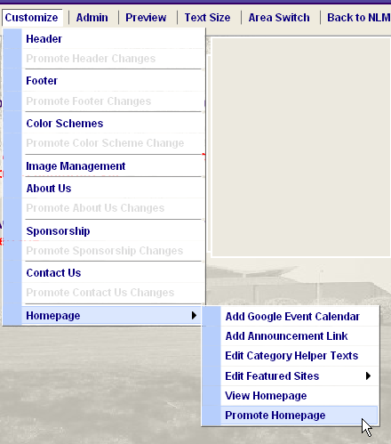

Figure 4‑45: Promote Homepage Menu Item

To preview before promoting, go to Customize > Homepage > View Homepage.

The new link will appear under the Featured Site on the right side of the homepage.

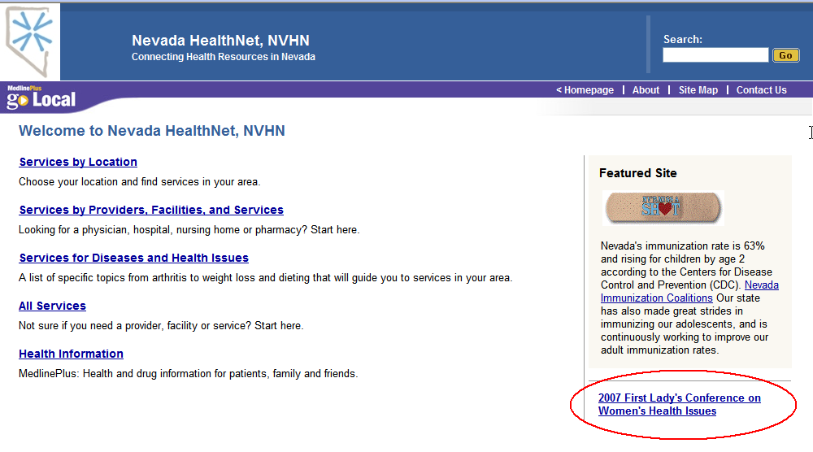

Figure 4‑46: Public Display Homepage with Miscellaneous Announcement Link

### Edit Category Helper Text

The Category Helper Text is the text below each of the four choices on the left side of the Go Local home page. To edit this text choose Customize > Homepage > Edit Category Helper Texts from the menu.

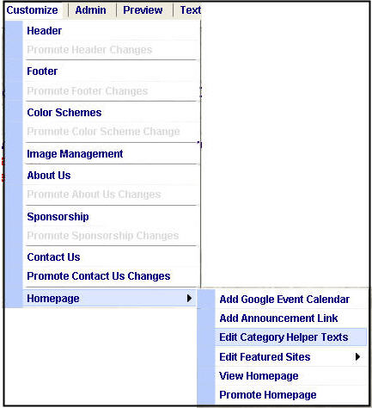

Figure 4‑47: Edit Category Helper Texts Menu

You can edit the text by selecting one of the Categories: All Services; Services by Location; Services by Providers, Facilities, and Services; Services for Diseases and Health Issues. Click in the narrow column to the left of category name and then select the '*Edit*' button.

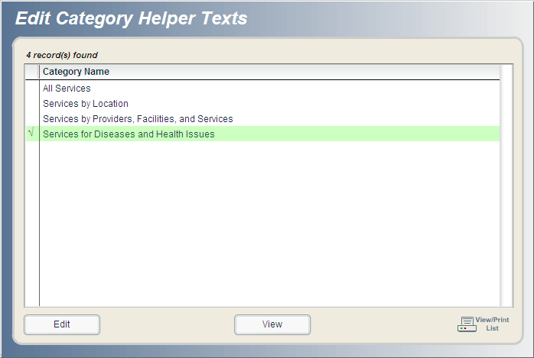

Figure 4‑48: Edit Category Helper Texts Selection Screen

Delete the default text and type in your own text to be displayed on the homepage. Select the '*Submit*' button to save your changes.

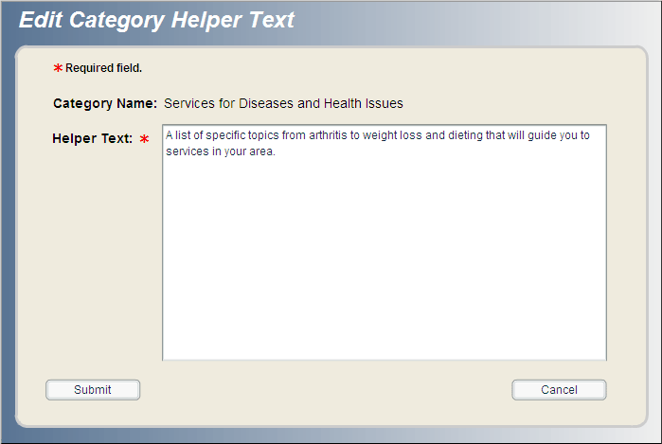

Figure 4‑49: Edit Category Helper Text Input Screen

### Featured Site - (Required)

The featured site will appear on the right side of the homepage. You can change the featured site as often as you like. Display options include text only, text and image, and image only. Images must first be uploaded via the Image Module. From the menu choose Customize > Homepage > Edit Featured Sites.



Figure 4‑50: Edit Featured Sites Menu

#### Add Feature Site

From the menu choose Customize > Homepage > Edit Featured Sites > Add Featured Site. To add a featured site, first choose format. Select 'Same Window' if you want the featured site to open in the same window, or select 'New Window' if you want the feature site to open in a new window (recommended). Note that the featured site form can support HTML in the “Text before the Title” and “Text after the Title” fields. If you would like to expand a featured site to include multiple links, you can include the coding for the additional linked text within the “text before the title” or the “text after the title” fields, as appropriate.

###### Text Only

1. Add text in the appropriate boxes depending on where you want it to display (before, after, or both). The Text to be Linked and Title and Featured Site URL are required fields. The URL most include http:// and .domain.
2. Click the 'Preview' button to view how the featured site will display on the home page.
3. Select submit, then 'Save' to add to the Featured Site List. You must submit for featured site from list for it to appear on the homepage.

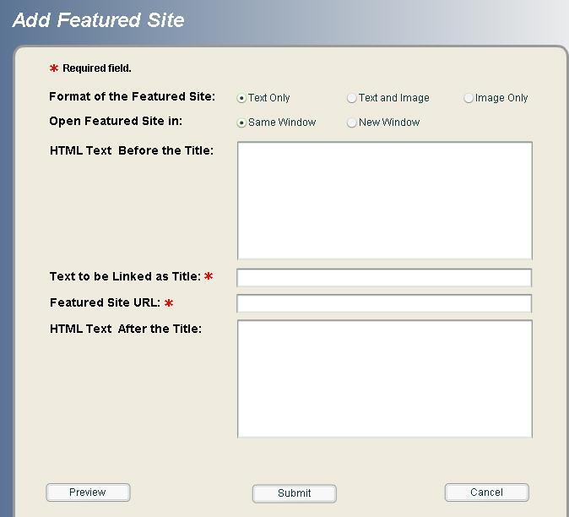

Figure 4‑51: Default Add Featured Site Screen

###### Text and Image

1. Repeat **step 1** for the **Text Only** option.
2. Choose to display graphic (image) either above or below the text.
3. If you would like the image to link to the featured site select the '*Yes*' button.
4. Select image to display from the *Image File Name* pulldown menu. Maximum image size for featured site display is 150 pixels x 150 pixels. Note: Images must be uploaded to system via the Image Management module.
5. Add descriptive text for image alt tag (required).
6. Click the '*Preview*' button to view how the featured site will display on the home page.
7. Select *Submit*, then '*Save*' to add to the Featured Site List. You must submit for featured site from list for it to appear on the homepage.

###### Image Only

The image is a hyperlink to the featured site. Repeat steps 4-7 for the Text and Image option to create an Image Only featured site display on the homepage.

### List Featured Sites

From the menu choose Customize > Homepage > Edit Featured Sites > List Featured Sites.

List Featured Site displays the features that you have created. You can retain featured sites for future use. For example: you may want to spotlight a flu shot clinic that is run annually, or awareness week for a specific disease or condition.

* You can edit, view, and delete feature sites by selecting the site from the list then selecting the appropriate button below the list.
* In the Current Pick column a '*Yes*' is displayed next to the featured site that is currently on the homepage.
* To change the homepage display:
  + Click in the narrow column to the left of the feature site name. The column displays a check mark.
  + Select the '*Submit for Featured Site*' button
  + Click '*Yes*' after reviewing the confirmation screen
  + The system will take you back to the List Featured Site screen with your new selection listed as the current pick.

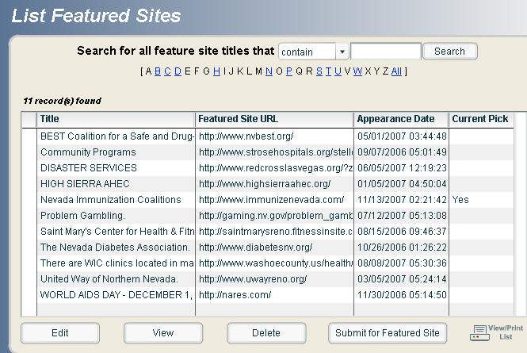

Figure 4‑52: List Featured Sites

### Promoting changes

Customization changes can be made at any account level (selector, reviewer, site administrator); however, once a site has been released by NLM all changes must be promoted by the site administrator. Prior to release all changes made by any account level will take effect immediately. From the menu choose Customize > Homepage > Promote Homepage.

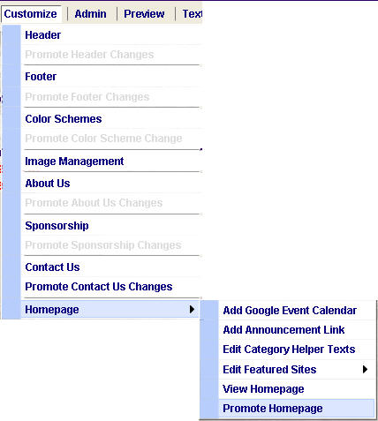

Figure 4‑53: Promote Homepage Menu

**Note:** There is no 'View' function from the promotion screen. Therefore, you will first need to view changes in the Preview module or through the menu by choosing Customize > Homepage > View Homepage.

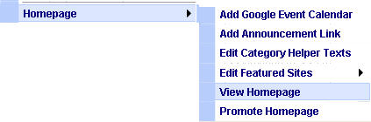

Figure 4‑54: View Homepage Menu

### Promotion Notification

#### Changes made by selectors and reviewers

The system notifies site administrators of submitted changes via a homepage message after logging into the input system.

* Message reads: The following changes have not been promoted
* The customization module that was changed will be displayed as a red hyperlink.
* Click on the red link to promote changes to production.

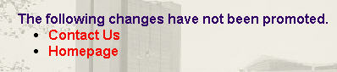

Figure 4‑55: Sample Promote Message

#### Changes made by the site administrator

Site administrators may promote changes immediately after submitting to production.

* After you submit changes in the customization module, the 'Promote' link becomes live in the customization module pull-down menu.
* Click the promote link from the customization module to promote changes.

# Reports *(Updated October 21, 2008)*

## Link Checker Report

The broken link report is accessible from the main menu Admin > Reports > Link Checker. The report is run weekly on Sunday and is available to all account privilege levels.  The link checker only checks the site URLs for approved, displaying records. It does not check approved records marked with a Display Status of “No,” and it does not look at the site URLs associated with pending or incomplete records.

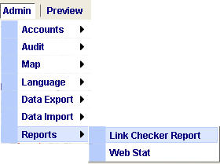

Figure 5‑1: Link Checker Report Menu

The report consists of the site name, URL, and server error code of the reported broken link. The URL is 'clickable' so you can verify that the link is actually broken. (Sometimes errors are reported in functioning links.)

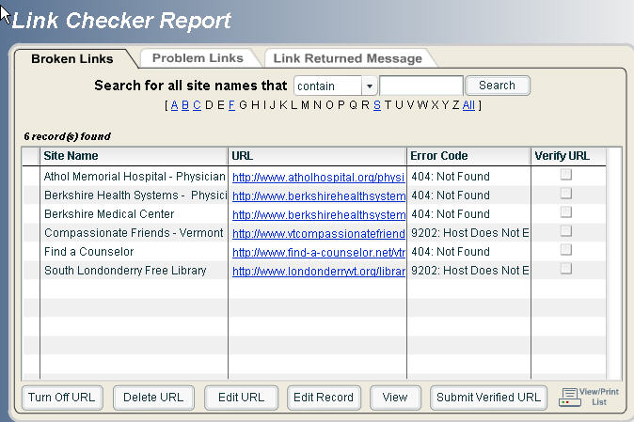

Figure 5‑2: Link Checker Report Screen

The Link Checker Report is divided into three categories; these categories are based on the error code returned by the Link Checker:

* **Broken Links**: URLs listed under this tab are most likely broken and need immediate attention.
* **Problem Links**:  URLs listed under this tab could be broken or the session timed out due to slow page loading or other reasons.  This queue should be monitored periodically.
* **Link Returned Message**: The Link Checker is reporting an abnormality with the URL, most likely not broken.  This queue should be checked occasionally.

### Corrective Actions

There are many corrective actions that can be taken to resolve a link problem. First select the link by clicking to the left the site name. A checkmark should appear in the left column.

* **Turn Off URL**: This will remove the URL from the public display, though it still remains in the database record. This is useful when it may be a temporary problem or a Web site is reorganizing.
* **Delete URL**: This will delete the URL from the record and public site.
* **Edit URL**: Type the correct URL into the New URL text box.  You can verify the URL by selecting the Verify New URL link.  Click the Submit button to update the record and public site.
* **Edit Record**: This links to the edit screen, allowing you to edit any data in that record.
* **View**: View all data in the record.
* **Submit Verified URL**: You can remove functioning links that are reported as broken. Select the checkbox in the Verified URL column. Click on the Submit Verified URL button to remove the entry from the report display.

Note: The Link Checker reports the error messages from the sites being crawled. It is possible that some sites will return error messages even though the URLs are correct. If you see a pattern with a URL or a series of URLs appearing in the report but you are confident they are correct, you may opt to skip over these during your weekly checks. If you do this, you would still want to check on them monthly to make sure they continue to work.

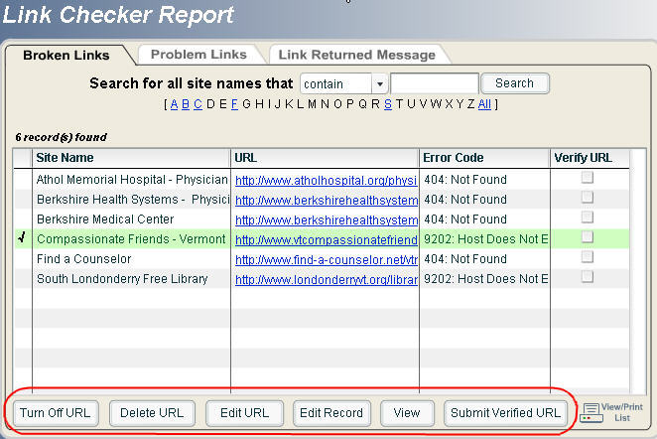

Figure 5‑3: Link Checker Report Corrective Action Options

###### E-mail notification

Automatic e-mail notification is available when a new Broken Link report is generated weekly. Select Yes for Link Checker Report? in the individual user account profile accessed from the main menu Admin > Accounts > List Users or Add User

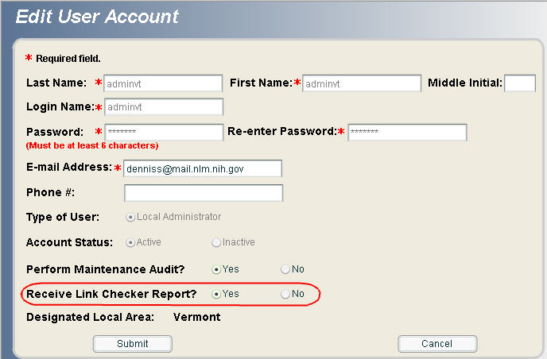

Figure 5‑4: Link Checker Report E-mail Notification Set-up

## Web Stat Report

Monthly web stats are available from the main menu: Admin > Report > Web Stat. All permission levels can access this report.  Web stats are run at the end of each month and are available in the input system at the start of the following month, usually after three working days. Reports are available for one year. Report formats include PDF (Adobe Portable Document Format) and CSV (Comma Separated Values) both types can be downloaded to a local personal computer. Go Local statistics include: unique visitors, average visits per day, page views, average page views per day, referring sites, tops pages, and more.

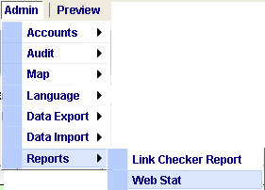

Figure 5‑5: Web Stat Menu

The Report Viewer opens in a new window.

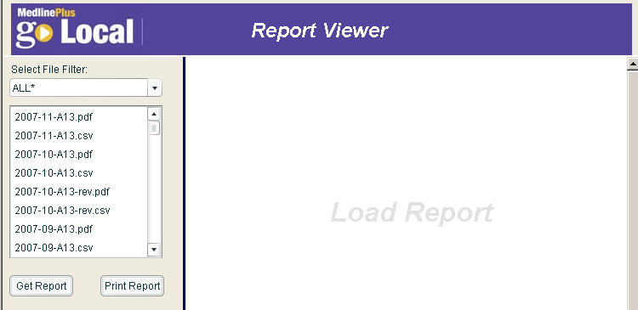

Figure 5‑6: Web Stat Report Viewer

Use the Select File Filter to narrow your selection by file format (PDF or CSV). The *ALL display will show both the PDF and CSV files.

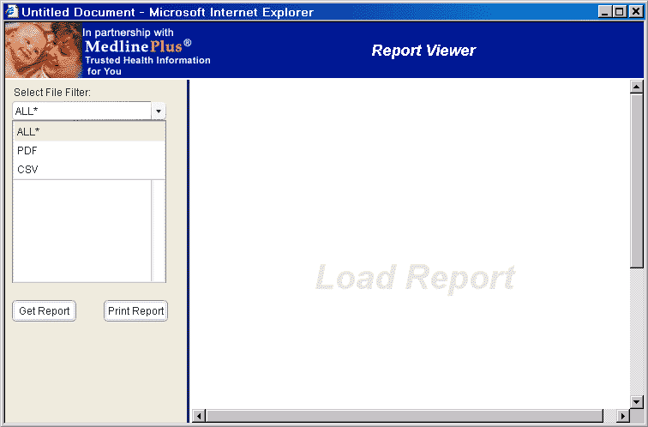

Figure 5‑7: Select File Filter

Display a PDF or CSV report by clicking on a report in the list. The report you selected will be highlighted in green. Click the Get Report button to load and display the report:

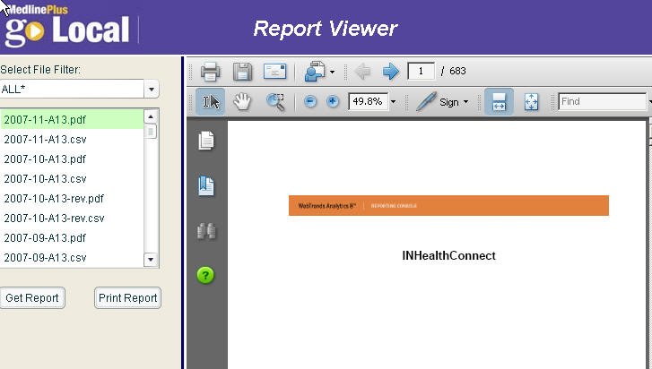

Figure 5‑8: Get Report View

**Note:** You must click Get Report before selecting Print Report.

Todownload a CSV file click the Save button when the File Download prompt box appears, otherwise select the Open button to view the report:

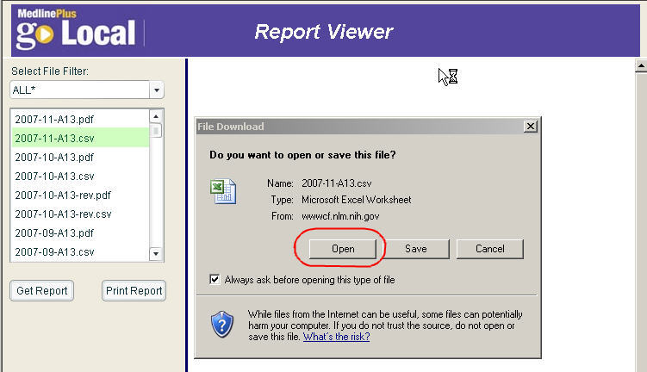

Figure 5‑9: Web Stat Report in CSV Selection

The CSV file format opens inside of the Go Local viewing window and displays as a spreadsheet.

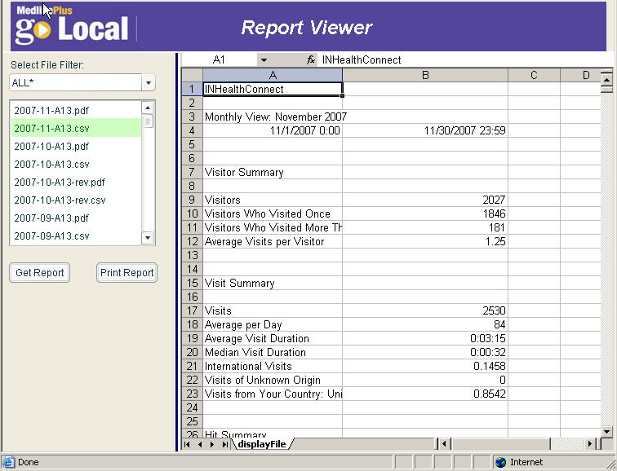

Figure 5‑10: Web Stat Report in CSV File Format

# Data Import/Batch Update/Export Profile *(Updated October 22, 2008)*

## Data Import

The site administrator for each Go Local area can upload local records to the Go Local Input system. The records will be imported with the "Incomplete Record" status. Once the records are in the Go Local input system, selectors and reviewers can complete the records.

### Technical:

You must have Macromedia Flash 8 for the data import module.  You can download Flash 8 from:

<http://www.macromedia.com/shockwave/download/download.cgi?P1_Prod_Version=ShockwaveFlash>

### Format:

Use CSV (Comma Separated Value) format to import your data.

The CSV file does not require that all 15 data fields be present or that they be listed in a specific order for data upload. The file can contain any number of standard fields in any order:

Table 5: Site Record Data Fields

| **Field Name** | **Field Size** | **Description** | **Data required in field?** |
| --- | --- | --- | --- |
| Site Name | 255 | The name of the resource, e.g., Maryland Department of Health, Shriner's Hospital of Boston | Y |
| Site URL | 1100 | The web address of the resource. The URL must begin with http:// or https:// | N |
| Address 1 | 200 | First line of street address. Elements might include number and street, building, box number, suite, etc. | N |
| Address 2 | 200 | Second line of street address, if required. | N |
| City | 100 | City | N |
| State | 2 | State. Must be the two letters state abbreviation code (e.g. MD). | N |
| Zip Code | 5 | Zip code. Must be a five digits code. | N |
| Zip Code Extension | 4 | Must be a four digits code, if extension exists. | N |
| Phone Numbers | 200 | Telephone number(s) of resource. This is a free format field. Multiple phone numbers are acceptable (e.g. (703) 222-2222 (301) 456-7893 ext 1234). | N |
| E-mail | 50 | E-mail address | N |
| Site Description | 2000 | Description of site. May include lists of services, special features, etc. | N |
| Languages | 4000 (100 for an individual language) | Use the "forced line feed" delimiter ( [alt]-[Enter] ) to separate multiple languages. | N |
| Organization Names | 4000 (200 for an individual organization) | Use the "forced line feed" delimiter ( [alt]-[Enter] ) to separate the multiple organization names. | N |
| Comments | 4000 | Any comments about this record. | N |
| Local ID | 15 | Free text field for internal use. | N |

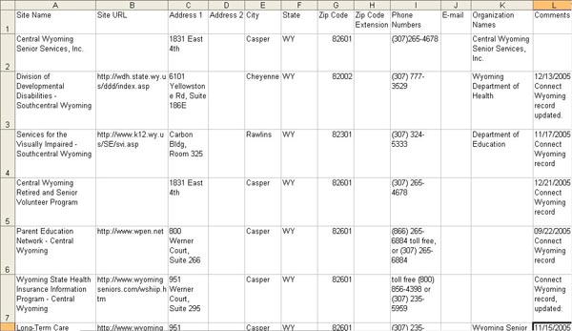

Figure 6‑1: Sample CSV data displayed in spreadsheet

#### Duplicate Records

The minimum required field is site name; however, there must be data in each record that makes it unique. The system automatically checks for duplicate records upon data import. The Site Name, Address1, and URL fields of each imported record are automatically checked against existing records in the database. If there is an exact match on these three fields (including if the same fields is blank in both the existing and imported record), then the imported record will be deemed a duplicate and will be rejected.

### System Provided Data:

In addition to the data you provide, the system will automatically provide:

* **area_id** : Your area_id will be assigned automatically.
* **created_date** : The current system date will be used as the created_date.
* **created_by** : The Login Name of the person performing the data import will be used.
* **record_status** : Records will be assigned "Incomplete" status.
* **audit_date** : An audit date reflecting the date of import will be assigned when you select import type "Upload existing records with Audit Timestamp" on the data import page.

### Accessing the Data Import Feature

You can access the data import module by choosing Admin > Data Import from the menu. Only the local administrators have access to this module.



Figure 6‑2: Data Import Menu

The Data Import menu feature is divided into two additional features:

* **Import**: This will bring up the data import module.
* **Error Reports**: This will bring up the error reports.

### Data Import Module:

From the menu choose Admin > Data Import > Import. Use this form to browse to and upload your CSV file.

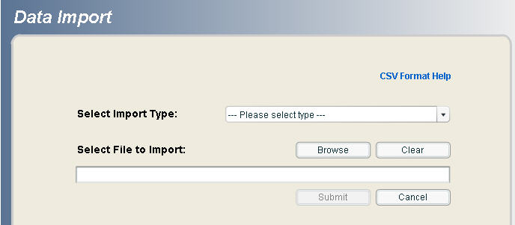

Figure 6‑3: Data Import Screen

1. Click on Format Help to get assistance on the CSV file format.
2. To select a data file to upload, click on the "Browse" button
3. Select a file from the browse window.
   1. Note: if the browse window doesn't open, please refer to the Troubleshooting section in this manual.
4. Click on the file name to enter it in the "Select File to Import" box .
   1. The system will only accept .csv files.
   2. If you need to deselect the file name, click on the "Clear" button.
5. Select Import Type from the pulldown menu
   1. New Records: These records will be assigned a Site Record ID
   2. Update Existing Records with Audit Timestamp: A modification to existing records will also get an Audit Date Timestamp (reflecting the date of import)
   3. Update Existing Records without Audit Timestamp: A modification to existing records will not get an Audit Date Timestamp

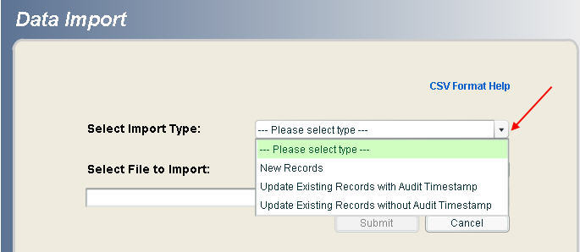

Figure 6‑4: Data Import Select Import Type

For more information on updating records, see the Batch Update of Modified Data section at the end of this document.

1. When you click "Submit" the selected file will start to upload. The status of the upload displays on the bottom of this page.
   1. The following are the possible messages you may see during uploading:
      1. Uploading data file to server
      2. Validating data file format
      3. Loading records

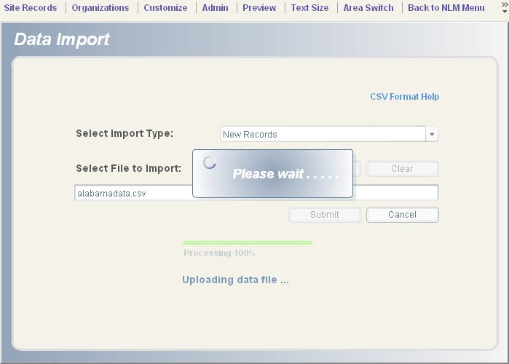

Figure 6‑5: Data Import CSV Load Message

###### Error Handling

Before your file can be loaded into the Go Local database, the system will validate its entire file format. If there is a problem with the file format, the entire file will be rejected. The possible error statuses are:

* If the system cannot upload the selected file due to a server problem you will see an error status message.

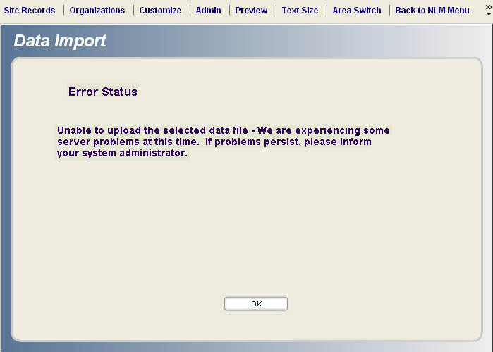

Figure 6‑6: Error Status Message

* + Click on the "OK" button to return to the Data Import module. Please contact NLM to report this problem.
* Once the selected file is uploaded, the data import process will validate the format of the selected file. If the format is invalid, you will see a status report message.
* Click on the "OK" button to return to the Data Import module.

###### Completion of the Data Import process

There are two possible outcomes when the data import process is complete:

* **Successful import of complete data** - the Status Report indicates successful importation of records. Select "Yes" to return to the select file to import screen or "No" to return to the homepage.

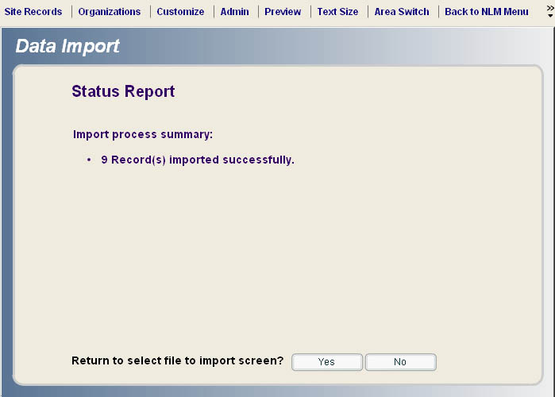

Figure 6‑7: Successful Import of Complete Data

* + **Partial import of data** - types of data errors include: missing required field (Site Name), duplicate records, and exceed size limit.

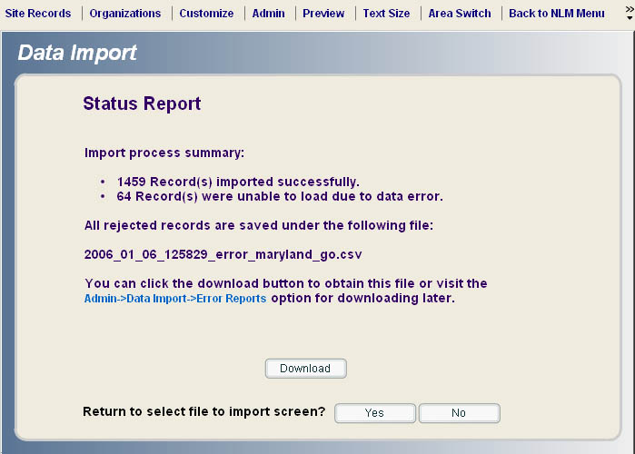

Figure 6‑8: Status Report for Partial Import of Data

The system automatically creates an error file containing rejected records. The format for this error file is almost identical to the original imported data file, except that it contains an extra field called "error status." The file name for an error file is "yyyymmddhhmm_error_filename.csv"

The file name derives from:

* yyyy is the year,
* mm is the month,
* dd is the day,
* hhmm is hour and minute in 24-hour time, and
* filename.csv is the original imported file name.

Download the error file from this page, or from the input system using Admin > Data Import > Error Reports.

* Click on the "Download" button to save the file.

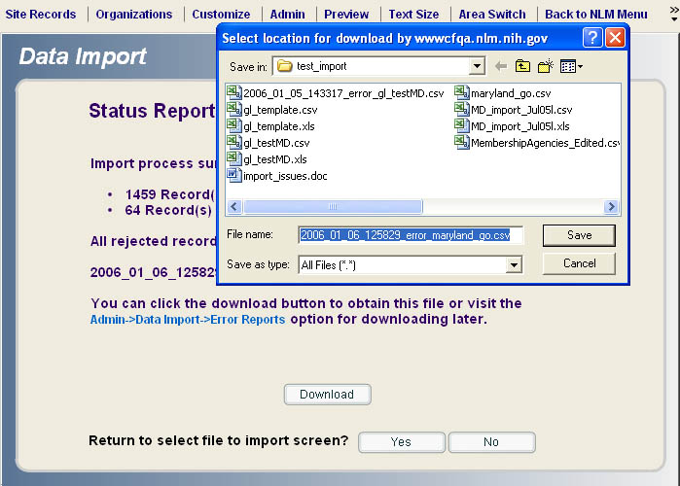

Figure 6‑9: Download Error Report

The report will be saved in Error Reports. You can access the report directly from the link displayed on this screen or via the input system menu Admin > Data Import > Error Reports.

## Error Reports Module

This module provides access to data rejected in the import process. The error reports are in CSV format and can be downloaded directly from the error report list and resubmitted after the data has been corrected. From the menu choose Admin > Data Import > Error Reports

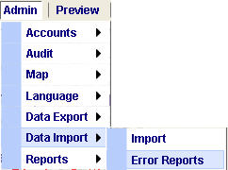

Figure 6‑10: Error Reports Menu

Data Import Error Reports are automatically created by the system when an error occurs during data import. In this example, there are 3 reports listed. Each report includes an Import Timestamp, a File Name, and the name of the user who imported the data when the report was created. From the list of available Data Import Error Reports, click on a report to select it. Then choose to View, Delete or Download the file.

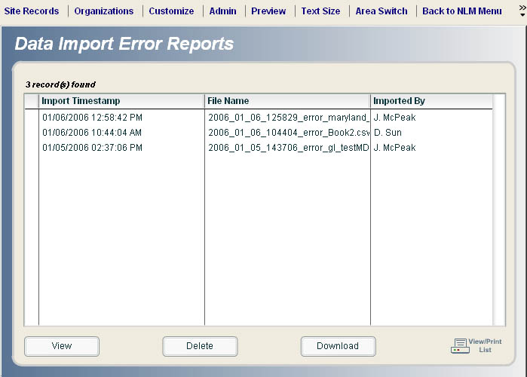

Figure 6‑11: List of Data Import Error Reports

## Batch Update of Modified Data

Local administrators will be able to update their existing records with or without the audit timestamp through the data import module. To do this, you must prepare a CSV file for importing. We recommend this be done in Excel. For details on using other editors such as WordPad or Notepad, see below.

### Creating the CSV File

The CSV file for data import must include the Site ID as well as the field(s) containing data that you want to modify.

In addition to the 15 standard data fields (as stated on the first page of this document), the CSV file for the update data import may also include the following 3 data fields (with Site ID being required):

Table 6: Update Data Import Site Record Fields

| **Field Name** | **Field Size** | **Description** | **Data required in field?** |
| --- | --- | --- | --- |
| Site ID | 38 | The record ID generated by the go local system. | Y |
| Display | 1 | The display status. The values will be Y or N. | N |
| Reasons Not To Display | 4000 (100 for an individual reason not to display) | One or more reasons not to display. These reasons have to come from the go local system. | N |

To tell the system to make a change, the CSV file must contain the Site ID field plus any one of these 16 data fields that have a change to the data. For example:

Table 7: Update Action Site Record Fields

| **Update Action** | **Entry on CSV File** | **Note** |
| --- | --- | --- |
| Modify a site name | Site ID, Site Name 000001, National Library of Medicine | The site name will be updated to "National Library of Medicine". |
| To remove an e-mail address | Site ID, E-mail  000001, | By using a blank space in the field, the e-mail address will be removed. |
| To add the organization name FDA to a current list of organizations | Site ID, Organization Names,  000001, "NLM NIH FDA" | The complete list of organization names need to be provided. |

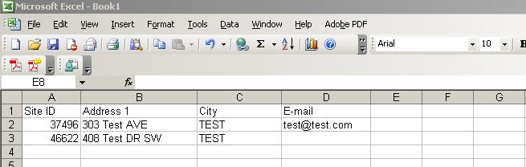

Figure 6‑12: Sample CSV File Created in EXCEL

In this example, the record with Site ID 37496 will have its Address 1 changed to "303 Test AVE," the city changed to "TEST" and the email address changed to "test@test.com". The record with Site ID 46622 is having its Address 1 changed to "408 Test DR SW," the city changed to TEST and the email address is going to be changed to an empty field.

Whatever is on the spreadsheet will overwrite the corresponding fields in the database. If you prefer to use a CSV file that contains all of the fields for a record, but only reflects changes in a select number of fields, it will still work to run the update.

**Note**: If you create your CSV file from a file that you exported out of Go Local, you will need to delete the search strategy criteria information provided at the top of the file.

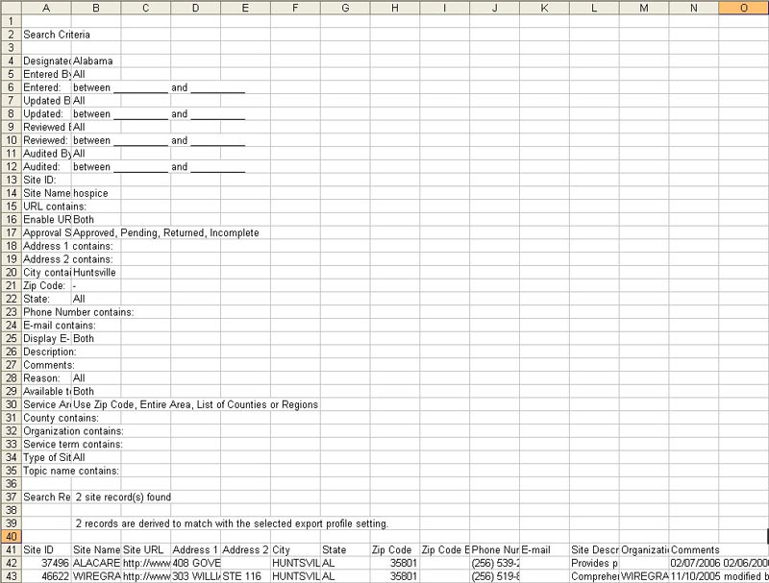

Figure 6‑13: CSV File Exported from Go Local

The above example shows the data that was exported from Go Local. The search criteria information is included at the top of the file. If you are using this type of file, you need to delete the rows containing the search criteria before making your modifications and before importing the modified data back into Go Local. In this example, you would want to delete rows 2 through 40 before making changes to the data.

After you delete the rows, the spreadsheet will look like this:



Figure 6‑14: Modified Spreadsheet Data

You can change those fields that need to be modified and import it back into the system.

### Importing Modified Data

To import the modified data, choose Admin > Data Import > Import from the menu.

You will be asked to select if you want to update the audit timestamp for the records being modified.



Figure 6‑15: Data Import Select Import Type

By selecting "Update Existing Records with Audit Timestamp," you are telling the system to make the modifications you specify and to also change the audit timestamp for those records to reflect the date of the update.

By selecting "Update Existing Records without Audit Timestamp," the system will not alter the existing audit timestamp for the batch of records that are updated. The only changes made will be the ones that you specify.

## Troubleshooting

If after selecting a data file to upload you are not prompted to open or save a document, and instead you remain at the data import screen, try the following: from the menu at the top of your browser window select Tools > Internet Options.

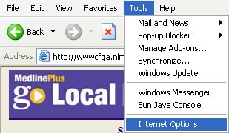

Figure 6‑16: Browser Menu for Internet Options

Select the Security Tab. Click on the Trusted Sites icon and then click on the "Sites" button

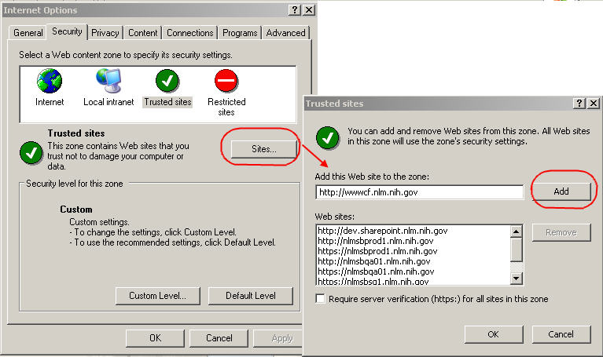

Figure 6‑17: Resetting Internet Options

* A new window titled "Trusted sites" will open.
* Deselect the check box near the bottom of the window that states "Require server verification (https:) for all sites in this zone."
* Copy and paste the input system URL http://wwwcf.nlm.nih.gov into the 'Add this Web site to the zone' text box. Click the "Add" button.
* Click "OK" Rerun the search and attempt to import the files again.

## Loading Data created with an editor

If you created the data with an editor (WordPad, Notepad) the following rules apply. If you generated the CSV file with Excel or Access, the software will automatically convert the data appropriately.

1. Fields must be separated with commas.
2. The program ignores leading and trailing space-characters adjacent to comma field separators.

Table 8: Sample CSV data with single comma delimeters

| **Original data** | **Data entered in the CSV** | **Data display** |
| --- | --- | --- |
| **National Library of Medicine** | **,    National Library of Medicine    ,** | **National Library of Medicine** |

1. Fields with embedded commas must be delimited with double-quote characters.

Table 9: Sample CSV data with embedded commas and double quotation marks

| **Original data** | **Data entered in the CSV** | **Data display** |
| --- | --- | --- |
| **12 Rockville Pike, Rockville Maryland** | **, "12 Rockville Pike, Rockville Maryland",** | **12 Rockville Pike, Rockville Maryland** |

1. Fields that contain double quote characters must be surrounded by double-quotes, and the embedded double quotes must each be represented by a pair of consecutive double quotes.

Table 10: Sample CSV data with embedded double quotation marks

| **Original data** | **Data entered in the CSV** | **Data display** |
| --- | --- | --- |
| **Services "free" to residents** | **,"Services 'free' to residents",** | **Services "free" to residents** |

1. Site Description(s), Comments and Organization Name(s) fields that contain embedded line-breaks must be surrounded by double-quotes.  All other embedded line-breaks will be automatically replaced by the input system.

Table 11: Sample CSV data with embedded line breaks

| **Original data** | **Data entered in the CSV** | **Data display** |
| --- | --- | --- |
| **Services include:** **Testing** **Counseling** | **,"Services include:** **Testing** **Counseling",** | **Services include:** **Testing** **Counseling** |

## Export Profile

The Export Profile allows you to choose data fields that you want to export and save as a profile. You can create several profiles using different data fields depending on the needs of your export.

**Note: All profiles are user account specific.**

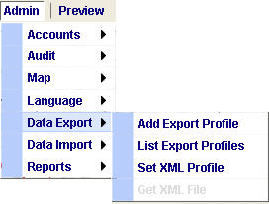

Figure 6‑18: Data Export Menu

### Add Export File

Add Export Profile is accessible from the main menu Admin> Data Export > Add Export Profile

Choose from Data Field Selection column by dragging and dropping into Data Fields Shown on Spreadsheet column.  The drag and drop will only work when dragging an item to the top of the list in the Data Fields Shown on the Spreadsheet column.  You can also drag a field off the Data Fields Shown on the Spreadsheet column and back to the Data Field Selection list.

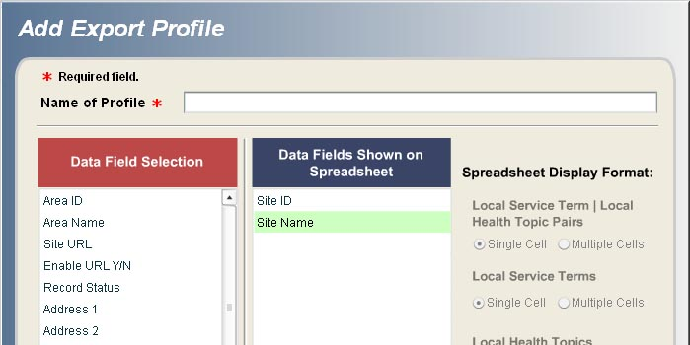

Figure 6‑19: Add Export Profile - Data Field Selections

If a data field that contains multiple entries such as Local Service Term/Local Health Topic Pairs, Local Service Terms, Local Health Topics, Service Areas, Organization Names and Reason Not to Display are selected, the option of Single Cell (default) or Multiple Cells will be clickable.

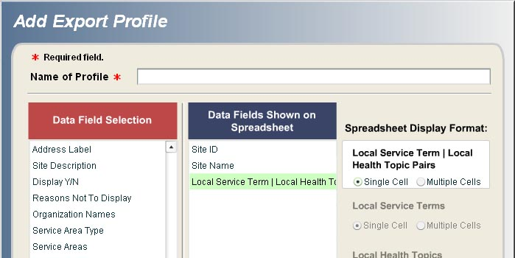

Figure 6‑20: Spreadsheet Display Format – Single or Multiple Cell Selection

Single Cell will display all of the data in one cell.

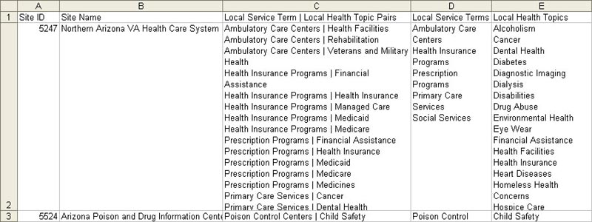

Figure 6‑21: Exported Data Single Cell Display

Multiple Cells will display the data in multiple cells, repeating the associated data.

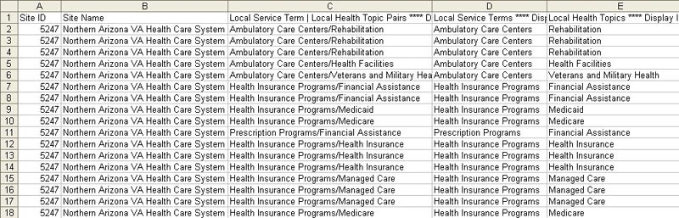

Figure 6‑22: Exported Data Multiple Cell Display

The Export Profile must be named before it can be submitted.

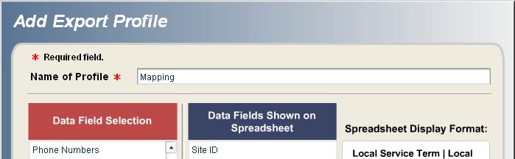

Figure 6‑23: Export Profile Naming

An optional description can also be added to each Export Profile.

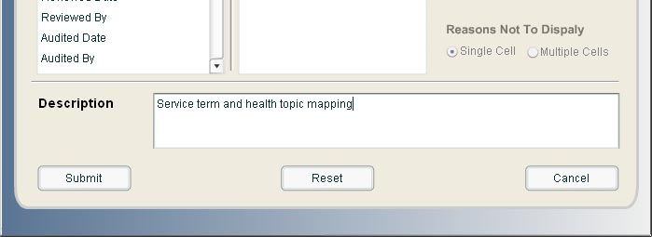

Figure 6‑24: Export Profile Description

### List Export Profiles

Once a profile is submitted and confirmed it will be available in the List Export Profile queue for the user's account.

List Export Profiles is accessible from the main menu by choosing Admin> Data Export > List Export Profiles.

* To run the export profile, you first need to run a search.
* Once a search criteria is entered and the search is done, select the Export button.
* You will be prompted to choose a profile from the List Profile queue.
* Select a Profile and click 'OK' and confirm the system will pull the data fields specified in the profile.

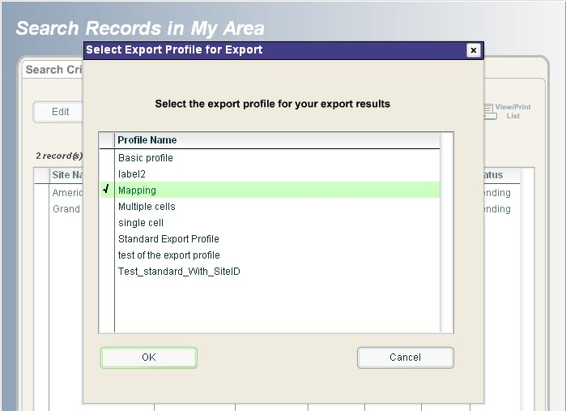

Figure 6‑25: Select Export Profile for Export

### Troubleshooting Export Errors

Make sure your IE settings are appropriate to allow for data export. From the menu choose Tools > Internet Options > Security > Custom Level for Internet > Downloads.

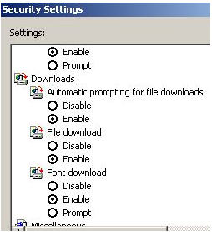

Figure 6‑26: Check IE Settings for Data Export

Note: If after selecting an export profile you are not prompted to open or save a document, and instead you are returned to the search results page, try the following:

From the menu at the top of your browser window select Tools > Internet Options.



Figure 6‑27: Browser Menu for Internet Options

Select the Security Tab. Click on the Trusted Sites icon and then click on the "Sites" button



Figure 6‑28: Resetting Internet Options

* A new window titled "Trusted sites" will open.
* Deselect the check box near the bottom of the window that states "Require server verification (https:) for all sites in this zone."
* Copy and paste the input system URL http://wwwcf.nlm.nih.gov into the 'Add this Web site to the zone' text box. Click the "Add" button.
* Click "OK" Rerun the search and attempt to import the files again.

If after adding the URL to your list of Trusted Sites, you are still not prompted to open or save your exported results, try holding down the Ctrl key while selecting the Export button. This should override the security pop-up blocker in Internet Explorer.

### Deleting an Export Profile

From the main menu Admin > Data Export > List Export Profile select a profile and click the "Delete" button and confirm.

## Data in XML Format

XML data is generated for all the records in a local area once a week on Saturday morning. The previous week's XML is overwritten with new data.

To generate weekly XML from the main menu select Admin > Data  Export > Set XML Profile select radio button "Yes" and click the Submit button. You will be able to get the XML file once a report has been generated. For example, if you set the XML profile to yes on Monday, you will not see the XML file until after Saturday when it is generated.

**Note**: Depending on the number of records that you have the XML could potential be very large. It is recommended that you save the file then open it rather than opening it in your browser.

# Other System Functions

## Global Update of Records

The purpose of global update is to allow local administrators to make data changes simultaneously to up to 2500 records at a time.  Global Update is only available at the Local Administrator permission level.  When records are updated via Global Update, the system will generate an email confirmation and a Global ID number.  The Global ID number is associated with the records that were updated and is referred to by NLM if the data needs to be reverted back to its original form.  Local Administrators have 14 days to notify NLM that the data needs to be reverted.

Global Update can be accessed from the main menu by choosing Site Records > Global Update of Records.

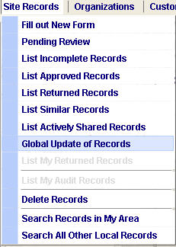

Figure 7‑1: Global Update of Records Menu

The Global Update form has three tabs: Search Criteria, Results, and Current Group Selection.

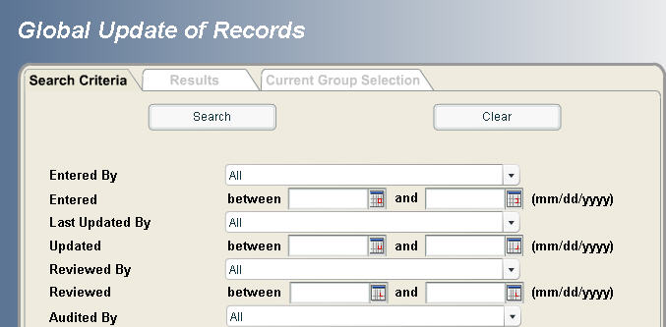

Figure 7‑2: Global Update of Records Screen

### Search

1. Enter your search strategy into the Global Update search form
2. Select the Search button

### Results

1. From the Results screen, select the records that you would like to update as a group by checking the checkboxes in the Group Selection column
2. Select the Confirm Group Selection button at the top of the results list

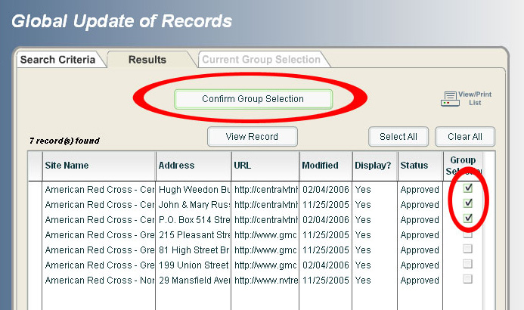

Figure 7‑3: Global Update of Records - Confirm Group Selection of Results

### Current Group Selection

1. The Current Group Selection tab displays the records that have been selected for a global update.
2. Select one baseline record by clicking on the left column (checkmark will appear).
3. Select the Global Edit button
4. Any field can be edited. **All edits made to the baseline record will be applied to each records in the group.**

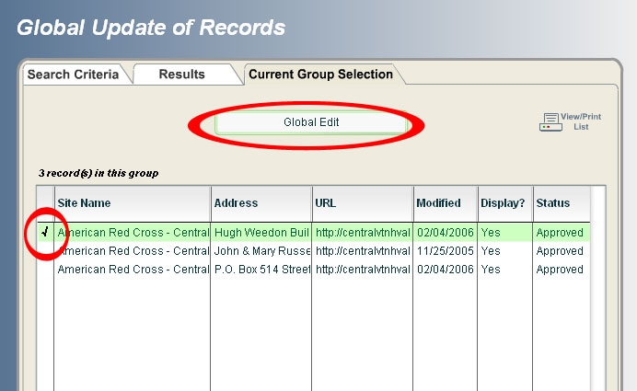

Figure 7‑4: Global Update of Records - Current Group Selection Screen

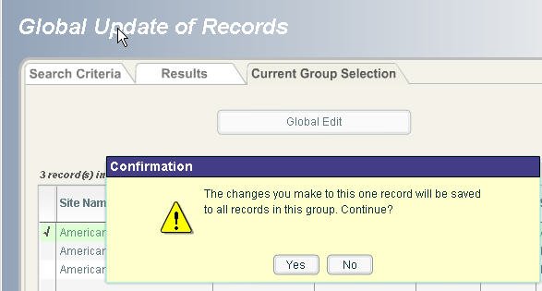

Figure 7‑5: Global Update Current Group Selection Confirmation

### Editing:

The baseline record will open in an Edit Site Entry for Group form. All changes made to this baseline record will be applied to each of the records in the group.  Since there are a variety of data fields in the Go Local records, there is some variation to how the data is updated depending on the field type.

#### Different behavior for changes to different field types:

* **Multiple selections**: Changes to selections in multiple data fields will be added/subtracted to the existing data. They will not overwrite all of the data appearing in the data fields. They will only overwrite in those instances of a 1-to-1 match.  For example, if you add a local service term to a baseline record, that service term will appear in addition to already existing local service terms appearing within the group. If you remove a local service term from the baseline record, it will be removed as a service term from the records within that group that already contained that service term; but, the remaining service terms will not be changed.

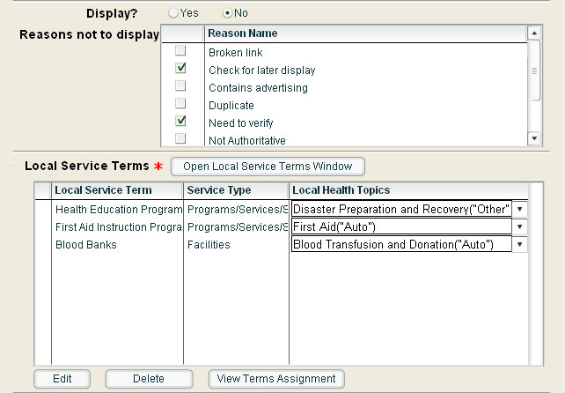

Figure 7‑6: Edit Site Entry for Group Form

* **Text Fields**: If you make a change in a text field, such as the description or comments field, the text in the baseline record will overwrite the text for all the records in the group.

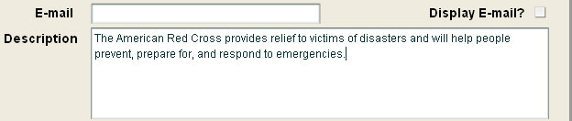

Figure 7‑7: Description Field Changes in Edit Site Entry for Group Form

### Confirmation:

Once the global update is submitted, the system will display a confirmation screen listing the data and fields that were updated.  At the bottom of the screen, you will see the message, “The changes you made will be saved to all records in this group.” Select either “Yes” or “No” for “Is this information correct?”.  A “Yes” selection will complete the update and a “No” selection will take you back to the “Edit site Entry for Group” screen.

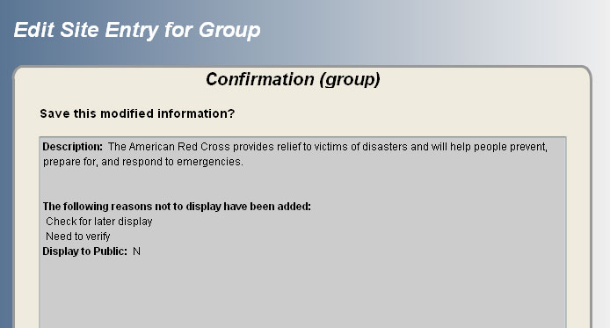

Figure 7‑8: Edit Site Entry Group Confirmation

* The system will generate an e-mail after each Global Update to the person who performed the update.

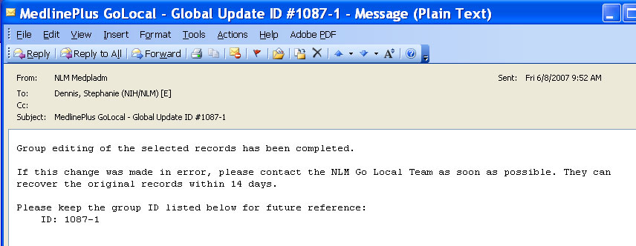

Figure 7‑9: Global Update E-mail Confirmation Message

### Data Revert:

If you want to undo the Global Update and revert back to the original data please notify the Go Local Team at NLM (GOLOCAL-ADMIN@LIST.NIH.GOV) within 14 days.  Please provide the group ID listed in the e-mail as a reference.

* Note: If you request that the data be reverted, changes made to any of the records in the group after the global update will be lost.

### System Generated Messages:

The system will validate and generate error messages for:

* Incomplete records sent to the pending queue
* Duplicate records
* Attempting to update more than 2500 records at once
* If you try to add another record after initiating the editing of the group records

The system will generate an alert message for:

* Service area mapping that does not include were the resource is physically located

## Organization Name Module

The organization module allows you to create names of organizations to associate with your site record listings. Organizations are not mandatory on your listings but can provide clarification for units with ambiguous names. Using an organization name helps users place a link in context without having to read the information in the site description.

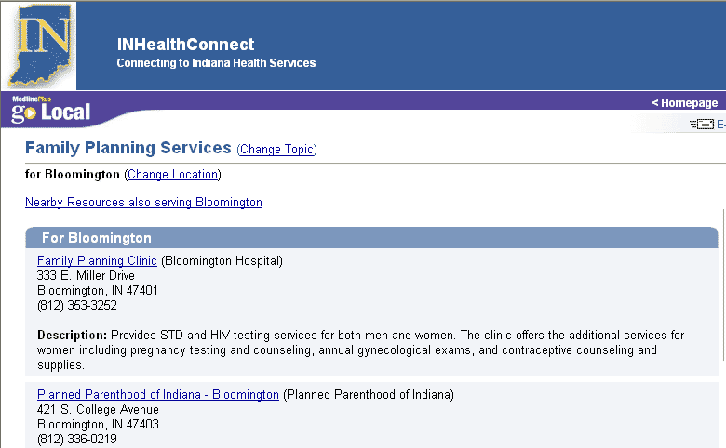

Figure 7‑10: Public Display Showing Organization Name

For example, Bloomington Hospital has a family planning clinic. The name of the site record and the link on the page will be Family Planning Clinic. Without the associated organization, the viewer might not know if this is a free-standing clinic or if it is a part of a larger organization. With the associated organization, the site record will say Family Planning Clinic (Bloomington Hospital)

Options available for Organizations can be selected from the Organizations menu. The options include: Add Organization, List Organizations, and Approve Organizations.

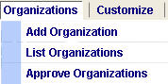

Figure 7‑11: Organizations Menu

### Add Organization

When selectors create site records, they assign the organization or organizations responsible for the site from a pick list. If they don't find the organization listed, they may create a new, unapproved organization name. You can also Add an Organization to the list by choosing Organizations > Add Organization from the menu.

Standardization of abbreviations, such as “Dept.” for Department or two-letter abbreviation for state name, is strongly encouraged. When adding an organization name, you may associate it with a URL. The URL is an active link; clicking on it will open a new browser window.

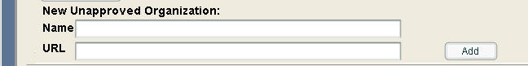

Figure 7‑12: Add Organization Option in Fill Out New Form

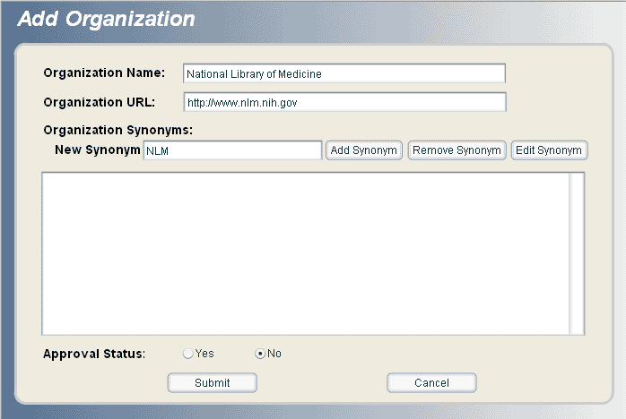

Figure 7‑13: Add Organization Screen Available from Menu Option

### List Organizations

Choose Organizations > List Organizations from the menu.

A listing of all organizations, URL, approved status and synonyms is provided in List Organization selection.  The local administrator approves or edits the name, URL or synonym from this module, or the organization can be deleted. The local administrator may also add synonyms as see references to organization names to assist selectors and reviewers.

Click on an individual organization to select it then choose Edit, View or Delete the organization record.

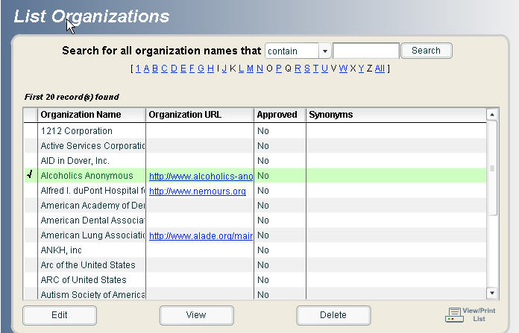

Figure 7‑14: List Organizations Screen

### Approve Organizations

Choose Organizations > Approve Organizations from the menu.

All organizations that have not been approved will remain in the Approve Organization queue. To approve select individual checkbox in the Approved column and select the Approve Checked Organizations button.

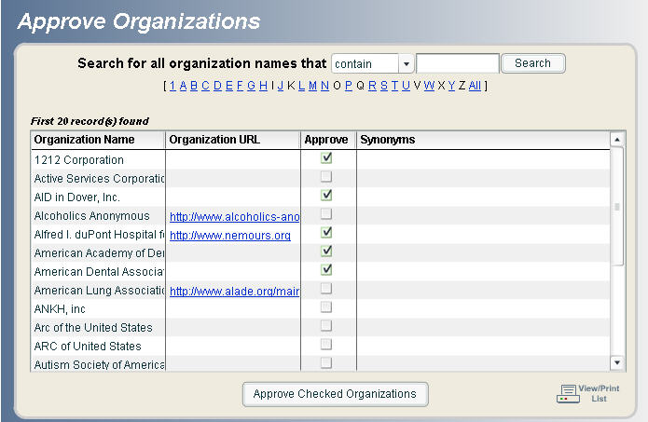

Figure 7‑15: Approve Organizations

## Preview Module

The preview module allows Go Local input system users to preview their pages before the area is available to the public. Once your Go Local site is released, you may also preview changes you are making using the Preview module.

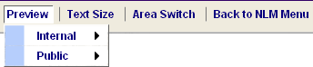

Figure 7‑16: Preview Menu

### Internal Preview

The Internal Preview is always available and allows you to view all records that are:

* Approved
* Pending records that are indexed to a health topic or service (these are labeled as pending in the preview display)

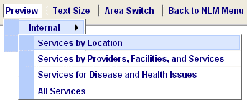

Figure 7‑17: Internal Preview Menu

### Public Preview

The Public Preview is only available until a site is released. This preview shows you what the site would look like to the public if it were live.  This function is useful to review the depth and breadth of coverage prior to release, as well as for demonstrations. Unlike the Internal Preview, only approved records are displayed and if no records are approved for a particular service there will be no link from the term or topic.  The number of service records available for display appears in parentheses. A link to MedlinePlus health topics enables you to choose your site via the Go Local pull down menu and go directly to services linked from a particular health topic.

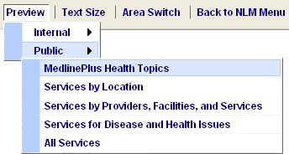

Figure 7‑18: Public Preview Menu

Here is a list of services by providers, facilities, and services:

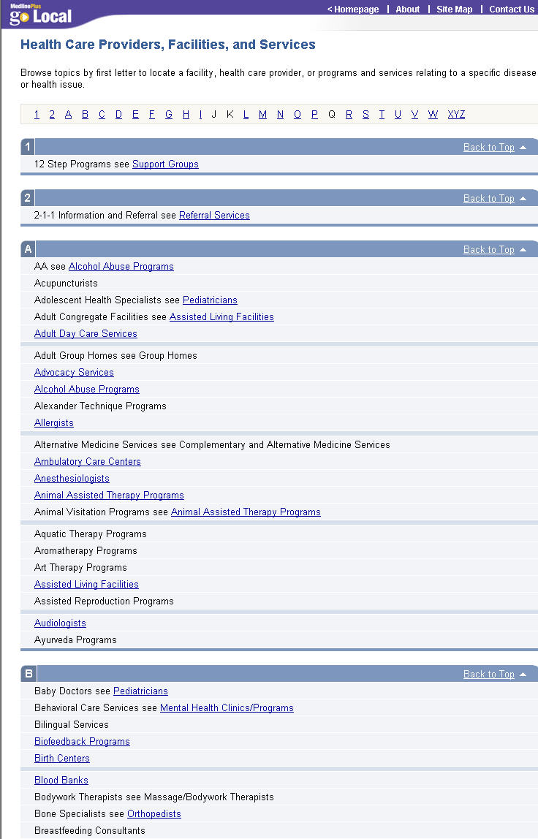

Figure 7‑19: Sample Public Preview of List of Services

## Changing Text Size

Because the Go Local input system is written using Flash, you cannot change the display of the size of the text you see on the screen using the "View, Text Size" feature of your browser. To change the size of the text you see, you will need to use the Text Size button. From the menu choose Text Size then select the size.

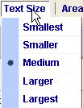

Figure 7‑20: Text Size Menu

There are five sizes:

* Largest
* Larger
* Medium
* Smaller
* Smallest

The default is Medium.  
  
A few things to remember:

* IMPORTANT: changing text size in the middle of a task such as editing or filling out a new form may result in the loss of your data! Save your work before changing text size.
* The current selected text size will be stored, so the system will remember the next time you log in.
* If you change the text size in the middle of a process (for example, if you are in the middle of filling out a new form) the text size will not change until you complete the process. Whenever you change the text size, you will see an alert box.

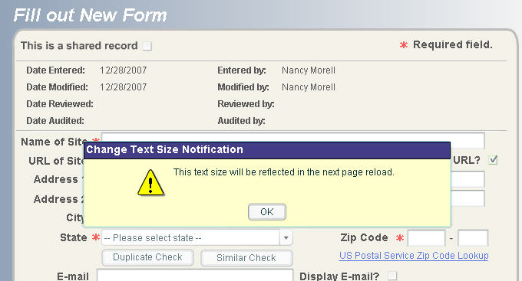

Figure 7‑21: Change Text Size Notification Message

## Deleting Records

Local Administrators and Reviewers may delete records from their area's database.

One method is to choose Site Records > Delete Records from the menu and navigate to the record you want to delete.

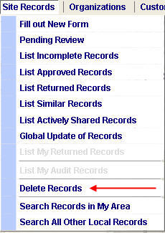

Figure 7‑22: Delete Records Menu

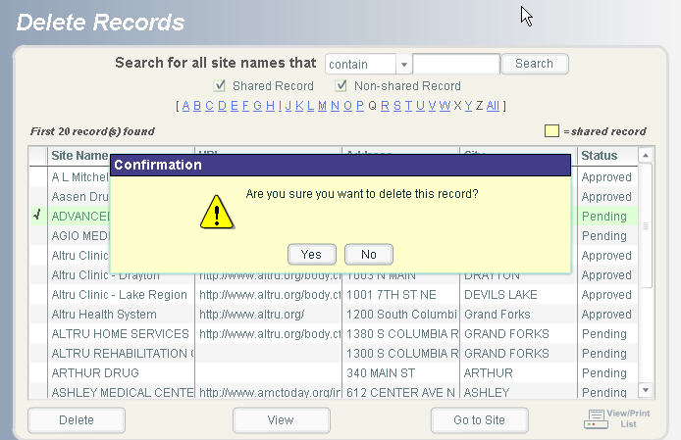

Figure 7‑23: Delete Record Confirmation

Records can also be deleted from the Similar Records display and the Pending Records queue. You can also delete records from the Search Results page (for example you can search for records with Available to Public as No and Reason Not to Display is Duplicate, then delete these records).

# Appendix 1: User Privileges *(Updated August 12, 2008)*

## User Privileges Listed by Menu Item

The following table represents user privileges based on each menu item listed in the Go Local menu bar.

**The codes used in the following table include:**

LA = Local Administrator  
R = Reviewer  
S = Selector

Table : User Privileges by Menu Item

| **Menu Item** | **Privilege** | **Edit** | **View** | **Delete** | **Upload image to file server** | **Enable** | **Disable** | **Copy** | **Download** | **Turnoff URL** | **Delete URL** | **Edit URL** | **Submit Verified URL** | **Get Report** | **Print Report** | **Submit for Featured Site** |
| --- | --- | --- | --- | --- | --- | --- | --- | --- | --- | --- | --- | --- | --- | --- | --- | --- |
| **Organizations** |  |  |  |  |  |  |  |  |  |  |  |  |  |  |  |  |
| **Add Organization** | LA |  |  |  |  |  |  |  |  |  |  |  |  |  |  |  |
| **List Organizations** | LA | LA | LA | LA |  |  |  |  |  |  |  |  |  |  |  |  |
| **Approve Organizations** | LA |  |  |  |  |  |  |  |  |  |  |  |  |  |  |  |
| **Customize** |  |  |  |  |  |  |  |  |  |  |  |  |  |  |  |  |
| **Header** | LA, R, S |  |  |  |  |  |  |  |  |  |  |  |  |  |  |  |
| **Promote Header Changes** | LA |  |  |  |  |  |  |  |  |  |  |  |  |  |  |  |
| **Footer** | LA, R, S |  |  |  |  |  |  |  |  |  |  |  |  |  |  |  |
| **Promote Footer Changes** | LA |  |  |  |  |  |  |  |  |  |  |  |  |  |  |  |
| **Color Schemes** | LA, R, S |  |  |  |  |  |  |  |  |  |  |  |  |  |  |  |
| **Promote Color Scheme Changes** | LA |  |  |  |  |  |  |  |  |  |  |  |  |  |  |  |
| **Image Management** | LA, R, S |  | LA, R, S | LA, R, S | LA, R, S |  |  |  |  |  |  |  |  |  |  |  |
| **About Us** | LA, R, S |  |  |  |  |  |  |  |  |  |  |  |  |  |  |  |
| **Promote About Us Changes** | LA |  |  |  |  |  |  |  |  |  |  |  |  |  |  |  |
| **Sponsorship** | LA, R, S |  |  |  |  |  |  |  |  |  |  |  |  |  |  |  |
| **Promote Sponsorship Changes** | LA |  |  |  |  |  |  |  |  |  |  |  |  |  |  |  |
| **Contact Us** | LA, R, S |  |  |  |  |  |  |  |  |  |  |  |  |  |  |  |
| **Promote Contact Us Changes** | LA |  |  |  |  |  |  |  |  |  |  |  |  |  |  |  |
| **Homepage** |  |  |  |  |  |  |  |  |  |  |  |  |  |  |  |  |
| **Add Google Event Calendar** | LA |  |  |  |  |  |  |  |  |  |  |  |  |  |  |  |
| **Add Announcement Link** | LA |  |  |  |  |  |  |  |  |  |  |  |  |  |  |  |
| **Edit Category Helper Texts** | LA, R, S | LA, R, S | LA, R, S |  |  |  |  |  |  |  |  |  |  |  |  |  |
| **Edit Featured Sites: Add Featured Site** | LA, R, S |  |  |  |  |  |  |  |  |  |  |  |  |  |  |  |
| **Edit Featured Sites: List Featured Sites** | LA, R, S | LA, R, S | LA, R, S | LA, R, S |  |  |  |  |  |  |  |  |  |  |  | LA, R, S |
| **View Homepage** | LA, R, S |  |  |  |  |  |  |  |  |  |  |  |  |  |  |  |
| **Promote Homepage Changes** | LA |  |  |  |  |  |  |  |  |  |  |  |  |  |  |  |
| **Admin** |  |  |  |  |  |  |  |  |  |  |  |  |  |  |  |  |
| **Accounts: Add User** | LA |  |  |  |  |  |  |  |  |  |  |  |  |  |  |  |
| **Accounts: List Users** | LA | LA | LA |  |  | LA | LA |  |  |  |  |  |  |  |  |  |
| **Accounts: Change Password** | LA, R, S |  |  |  |  |  |  |  |  |  |  |  |  |  |  |  |
| **Audit: Set Audit Profile** | LA |  |  |  |  |  |  |  |  |  |  |  |  |  |  |  |
| **Audit: Hide Audit Message** | LA |  |  |  |  |  |  |  |  |  |  |  |  |  |  |  |
| **Audit: Assign Audit Records** | LA |  |  |  |  |  |  |  |  |  |  |  |  |  |  |  |
| **Map: Map Organization** |  |  |  |  |  |  |  |  |  |  |  |  |  |  |  |  |
| **Map: GEO Text Link** | LA |  |  |  |  |  |  |  |  |  |  |  |  |  |  |  |
| **Language: Assign Top Languages** | LA |  |  |  |  |  |  |  |  |  |  |  |  |  |  |  |
| **Language: Set Language Public Display** | LA |  |  |  |  |  |  |  |  |  |  |  |  |  |  |  |
| **Language: Promote Language Public Display Setting** | LA |  |  |  |  |  |  |  |  |  |  |  |  |  |  |  |
| **Data Export: Add Export Profile** | LA, R, S |  |  |  |  |  |  |  |  |  |  |  |  |  |  |  |
| **Data Export: List Export Profile** | LA, R, S | LA, R, S | LA, R, S | LA, R, S |  |  |  | LA, R, S |  |  |  |  |  |  |  |  |
| **Data Export: Set XML Profile** | LA |  |  |  |  |  |  |  |  |  |  |  |  |  |  |  |
| **Data Export: Get XML File (once set & available)** | LA, R, S |  |  |  |  |  |  |  |  |  |  |  |  |  |  |  |
| **Data Import: Import** | LA |  |  |  |  |  |  |  |  |  |  |  |  |  |  |  |
| **Data Import: Error Reports** | LA |  | LA | LA |  |  |  |  | LA |  |  |  |  |  |  |  |
| **Reports: Link Checker Reports** | LA, R, S | LA, R, S | LA, R, S |  |  |  |  |  |  | LA, R, S | LA, R, S | LA, R, S | LA, R, S |  |  |  |
| **Reports: Web Stat** | LA, R, S |  |  |  |  |  |  |  |  |  |  |  |  | LA, R, S | LA, R, S |  |
| **Preview** |  |  |  |  |  |  |  |  |  |  |  |  |  |  |  |  |
| **Preview: Internal** | LA, R, S |  |  |  |  |  |  |  |  |  |  |  |  |  |  |  |
| **Preview: Public** | LA, R, S |  |  |  |  |  |  |  |  |  |  |  |  |  |  |  |

## User Privileges by Site Records Menu Functions

The following table represents user privileges based on each function found under the Site Records menu option.

**The codes used in the following table include:**

LA = Local Administrator  
R = Reviewer  
S = Selector

Table : User Privileges by Site Records Menu Functions

| **Site Records Menu Functions** | **Search** | **Clear** | **Edit Records** | **Copy Records** | **View Records** | **Go to Site** | **Delete Records** | **Add Comments** | **Submit Approved** | **Submit Returned** | **Audit Record** | **Split Record** | **Submit to Pending** | **Save as Incomplete** | **Export** | **Share** |
| --- | --- | --- | --- | --- | --- | --- | --- | --- | --- | --- | --- | --- | --- | --- | --- | --- |
| **Fill Out New Form** |  |  |  |  |  |  |  |  |  |  |  |  | LA, R, S | LA, R, S |  |  |
| **Pending Review Records** |  |  | LA, R, S | LA, R, S | LA, R, S | LA, R, S | LA, R | LA, R | LA, R | LA, R |  |  |  |  |  |  |
| **List Incomplete Records** |  |  | LA, R, S | LA, R, S | LA, R, S | LA, R, S |  |  |  |  |  |  |  |  |  |  |
| **List Approved Records** |  |  | LA, R, S | LA, R, S | LA, R, S | LA, R, S |  | LA, R |  |  |  |  |  |  |  |  |
| **List Returned Records** |  |  | LA, R, S | LA, R, S | LA, R, S | LA, R, S |  |  |  |  |  |  |  |  |  |  |
| **List Similar Records** |  |  | LA, R, S |  | LA, R, S |  | LA, R |  |  |  |  |  |  |  |  |  |
| **List Actively Shared Records** |  |  | LA, R, S |  | LA, R, S |  | LA, R |  |  |  | LA, R, S | LA |  |  |  |  |
| **Delete Records** |  |  |  |  | LA, R | LA, R | LA, R |  |  |  |  |  |  |  |  |  |
| **Global Update of Records** | LA | LA |  |  |  |  |  |  |  |  |  |  | LA | LA |  |  |
| **List My Returned Records  (Privilege is assigned by LA)** |  |  | LA, R, S | LA, R, S | LA, R, S | LA, R, S |  |  |  |  |  |  |  |  |  |  |
| **List My Audit Records  (Privilege is assigned by LA)** |  |  |  |  | LA, R, S | LA, R, S |  |  |  |  | LA, R, S |  |  |  |  |  |
| **Search Records in My Area** | LA, R, S | LA, R, S | LA, R, S | LA, R, S | LA, R, S | LA, R, S | LA |  |  |  | LA, R, S |  |  |  | LA, R, S |  |
| **Search All Other Local Records** | LA,R, S | LA, R, S |  | LA, R, S | LA, R, S | LA, R, S |  |  |  |  |  |  |  |  | LA, R, S | LA, R, S |

# Appendix 2: Selection Guidelines & Vocabulary Changes *(Updated September 25, 2008)*

## Selection Guidelines

Go Local sites link MedlinePlus users to health services in their local community and direct users of the Go Local site to MedlinePlus health topics. For example, users get medical information on diabetes from MedlinePlus and then link to a Go Local site for nearby health programs, services and providers. Go Local sites should collect services including: state and local health departments, medical centers and clinics, practitioners, libraries, local voluntary health agency chapters, and support groups. Go Local sites should not collect and index locally-created health information.

The guidelines below can serve as a starting point for Go Local sites to develop their own guidelines. Policy decisions such as whether or not to include services without Web sites and individual practitioners as well as group practices should be made by the project team or their advisory board. Examples of NLM guidelines and individual local guidelines are listed below.

### Authority of source

#### NLM Guidelines

* The sponsorship of the site is clear. The credentials or qualifications of the sponsors are provided or verifiable.
* There is a way to contact the site or service provider.
* Sites for an individual health care provider must include credential information or be verifiable.
* If the site is commercial, it acknowledges any commercial interest or personal point of view.

#### Local Guidelines

* We will verify professional credentials or licensing of facilities through state credentialing agencies.
* For services without a Web presence, we will verify professional credentials or licensing of facilities through credentialing agencies. We will verify contact information through telephone calls to the service.

### Content

#### NLM Guidelines

* Web pages contain a created, revised, or update date.
* Links on the site are reliable and relevant.
* The site does not contain inaccurate, erroneous, misleading or dangerous medical information, claims, or allegations.
* Most information on the site is available at no charge.
* Registration, an account, or password is not required to access site information.

#### Local Guidelines

* Due to continual changes in individual practitioners serving our area, we will not list links to individual practices unless they are located in an underserved county (defined as a county with fewer than 5 practitioners).
* Because many services in our area do not have web sites, we will not restrict selection to only those sources with a web presence. We will verify contact information through telephone calls to the service.
* If a large institution provides several individual services, we will check to see if they have separate telephone numbers or web pages. If the service has its own contact information, we will create a separate record for it.
* We may enter private or group practices with one or several physicians into the system if they have a generic name. Be sure to check for credentials of participants in the practices.
* When the appropriateness of a record is in question, check to see whether there is a Local Service Term for the resource. Add findings and questions to the Comments field, and a reviewer will determine if record should be included.

### Audience

#### NLM Guidelines

* Consumers or the general public is the intended audience of the site and services.

#### Local Guidelines

* Check that Web site is consumer-friendly and does not use overly technical language.

### Local Relevance

#### NLM Guidelines

* The site directs members of the public to a local or regional organization, service or activity.

#### Local Guidelines

* The site provides information about a local or regional organization, service, or activity.

### Other issues

(Thanks to the University of North Carolina for these suggestions.)  
  
How many records to create for a web site?

Consider:

* Ease of navigation, e.g., number of clicks necessary to move to the content on related pages; descriptiveness of links to related pages
* Distinctiveness of the related pages: is an additional local term or health topic necessary to describe the content?
* Quantity of information on the related pages
* Uniqueness of the information on the related pages: is this the only site of its type, or the only type in the region?

How many topics to assign to a web site?

Index to the most specific term available.

* If the web site is primarily concerned with breast cancer, the health topic chosen should be breast cancer.
* If the web site is for a cancer clinic which provides treatment for breast, ovarian, lung and prostate cancers, use the health topics: breast, ovarian, lung and prostate cancers as well as the general topic cancer.

## Requesting Changes to Vocabulary

As you use the system, you may find that there are things you'd like NLM to change. We will try to accommodate local requests if possible, but changes impact all Go Local areas using the NLM-supported system. The best way to discuss possible vocabulary changes is through the Go Local listserv.

#### Kinds of things we can change:

* Add a new see reference to a local service term
* Add a new suggested mapping from a local service term to a local health topic
* Change a mapping from suggested to automatic or vice versa
* Create a new health topic on MedlinePlus if there is a need for health information on a subject
* Add a new local service term, for example Complementary and Alternative Medicine Services was recently added in addition to existing specific services already in the vocabulary.

# Appendix 3: Style Guide *(Updated August 12, 2008)*

Each Go Local site should create its own style guide for site records.

Having a set of style rules not only makes your data visually consistent, but can also protect against duplicate records. Elements to consider in your style guide include punctuation and capitalization standards. Also, consider abbreviation standards for address elements, such as St. for Street, etc.

Creating standards for address fields is especially important to avoid record duplication. For example, if a selector enters a resource using St. in the address and another selector enters the same resource but uses Street, the system will treat these two records as unique and not as duplicate records.

Below are some examples of standards that MedlinePlus uses for establishing the names of organizations. These are provided for guidance in developing a style guide; you may choose to use other standards.

* Be sure you are using the name of the organization, not the same of the Web site (although in some instances they may be the same).
* Select the name as it appears on the site. In addition to the banner at the top of the page you should check the copyright statement at the bottom of the page and/or organization's homepage if a link is provided, for guidance on what the name "officially" is.
* When looking for the organization responsible for a web site, do not create organization names if the sponsorship is financial only. In cases of doubt, create a record using the name of the sponsoring organization.
  + Example: The home page of PsoriasisNet says that it is "an online patient education service of the American Academy of Dermatology, supported by an unrestricted grant from Fujisawa Healthcare, Inc." Fujisawa does not have any responsibility for content. Do not create an organization name for Fujisawa to associate with the record for PsoriasisNet.
* If there is both a spelled out form of a name and an acronym, use the spelled out form of the name as the standard form.
  + Always abbreviate the word Department to Dept., no matter how it appears on the page.

# Appendix 4: Future Enhancements to the Manual *(Updated May 6, 2008)*

This manual is designed to help people understand and use the Go Local input system. If there is something you can’t find or do not understand, please let NLM staff know.

## Planned additions for the future

* Trouble shooting section
* Helpful tips